Key Elements for ITSM Success

Do your homework
Consult and share with other higher ed institutions – wealth of experience available
Develop a common level of ITSM maturity among all IT staff – speak a common language
Know your procurement process
Pick the right tool for you
Features – what does your campus need? How do you know?
Right Size – will it support you now and into the future?
Sustainable – plan for support beyond implementation
Don’t forget the process – a fool with a tool…
Agree on the same basic process for all but… Leave room for local flavor
Be ready to adapt – willingness among all stakeholders to change and compromise is crucial
Tool will inform the process which will inform the tool … can’t consider the process or tool in a vacuum
Get your executive champions on board
Support for human and fiscal resources needed
Reinforce the goal, see ITSM as the strategic asset it is
Involve your campus partners and customers – what do they get out of this?
Communicate, communicate, communicate
Shared ownership of both process and tool – implementation group discusses everything, decides together
Shared governance – advisory group for shared production service decision-making
Regular implementation updates & training – new features, changes, involve all IT in testing
Get off to a good start
Invest in an implementation partner - Invaluable expertise, best practices, time savings
Dedicated, concentrated effort from the core team required – project management critical
Phased approach – quick wins and manageable chunks of work
It’s called Continuous Improvement because you’re never “done”
You won’t get it all right the first time
Thousands of decisions, big and small – be ready to change your mind based on actual experience
Review your metrics and listen to the staff who use the tool every day

Developing a Shared Vision in a Decentralized Organization

Are you ready for a change?
Need some basis for a collaborative venture, a culture of cooperation among IT teams
Executive sponsorship actively engaged and supportive of change
Investment in the process – both philosophically and fiscally
Inclusion is critical
From beginning to end and every step along the way – everyone has a voice
Take the time to truly understand the needs of all teams and audiences
Include campus partners, particularly those like HR and Admissions who might receive tickets
Don’t forget areas like Purchasing or Facilities who have similar needs and might have interest
Inclusion doesn’t end with implementation – establish ongoing governance that is also inclusive
Decisions are made together, at a representative table
It’s not a central IT initiative, it’s an all of IT initiative
Gain automatic buy-in from collective decision-making, as well as shared knowledge of the system
Builds a sense of community – we’re all in it together, we all share the same challenges and rewards
Understand and accept that this adds time to any implementation
Willingness to compromise
Consensus can’t be mandated, so it must be built – we have to choose to collaborate in a decentralized org
Teams must be willing to adapt their local processes to a more global one
Reasonable expectations are important – not trying to achieve perfection right out of the box
Your tool will have some things you love, and some things you don’t – focus on the things you love
Flexible process important
Understand current process and where gaps exist before recommending a new one
Be sure your unified process/tool is also adaptable to specific local needs
Truly continuous improvement – decisions made prior to implementation will change and evolve with use
Sell the value of ITSM to IT and to users
Consistent support experience for all users – shared process and tool allows IT to back each other up
Single pane of glass for IT and visibility for users into the work being done for them
Federated knowledge in one system, available to all - hugely important and beneficial for years to come

IT Service Management at Illinois State University

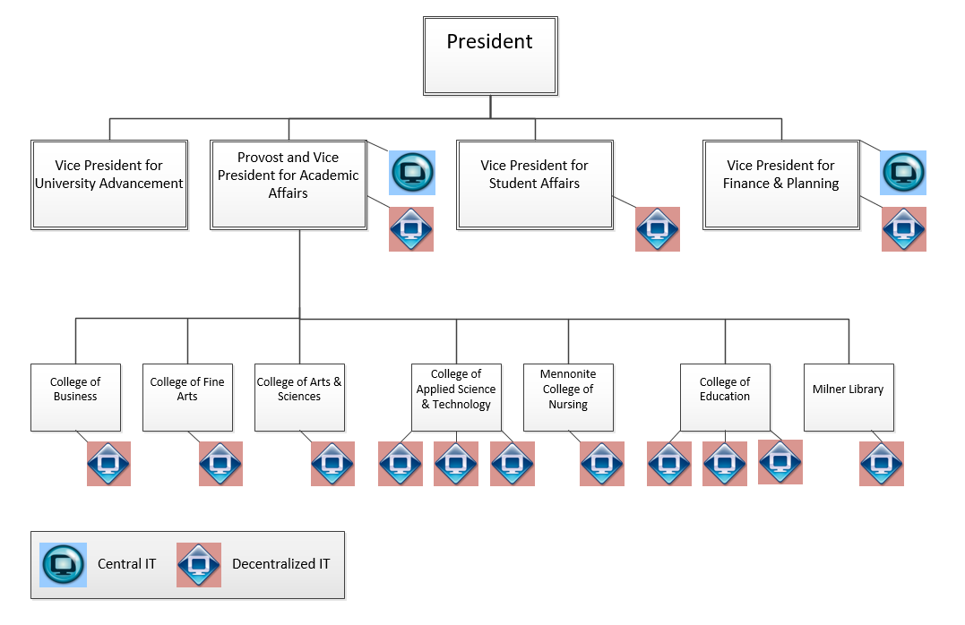

Three Years Ago
19 separate IT units, all with their own service management processes
Though some Incident Management process was established, other process areas were lacking or immature
3 ITSM Tools, and many ad-hoc or self-developed solutions for supporting Incident Management
No ability to route issues amongst different units/teams
Today
A single tool (Cherwell) was procured for all campus units to leverage for IT Service Management
All areas have adopted use of the tool and a unified incident management process was established
Service Request fulfillment was established as a separate service management process
Change Management process has been created and adopted for central IT
Phase I of a campus-wide CMDB was completed focusing on core systems and servers
Knowledge Management was centralized in the ITSM tool for both customers and IT staff
Service Level Standards were established campus-wide for incidents and requests
Single self-service portal established for all users
Currently in development: Release, Vendor, Project, Problem, Equipment Checkout, Mobile

