Workshop @ ELI
January 29, 2018
Go Big: Early Lessons from Scaling Adaptive Courseware

Time | Topic | Format | Presenter (s):
8:00 to 8:15 | Introductions |  | All
8:15 to 8:30 | Overview | Presentation | Karen Vignare  Dale Johnson
 | Technology & Opportunity: Getting Started—What are the Drivers? | Presentation | Megan Tesene  Julie Greenwood
8:45 to 9: 20 | Roundtable | Discussion | All—Tables
9:20 to 9:30 | BREAK
9:30 to 9:45 | Pedagogy: Faculty teaching practices | Presentation | Tonya Buchan  Ryan Luke
9:45 to 10:30 | Roundtable | Discussion | All--Tables
10:30 to 10:45 | Community: Building sustainable faculty communities | Presentation | Don Carter  Patti O’Sullivan
10:45 to 10:55 | Overcoming Barriers | Presentation | Johannes DeGruyter  Kevin Berg
10:55 to 11:00 | Wrap-up

Presenters:
First Name | Last Name | University/Organization | Email Address
Dale | Johnson | Arizona State University | dale.johnson@asu.edu
Tonya | Buchan | Colorado State University | tonya.buchan@colostate.edu
Stan | Kruse | Colorado State University | Stan.Kruse@colostate.edu
Alan | Bailey | Georgia State University | abailey47@gsu.edu
Megan | Tesene | Georgia State University | mtesene1@gsu.edu
Don | Carter | Northern Arizona University | don.carter@nau.edu
Julie | Greenwood | Oregon State University | julie.greenwood@oregonstate.edu
Johannes | DeGruyter | Portland State University | johannes.degruyter@pdx.edu
Kevin | Berg | Portland State University | kgb@pdx.edu
Ryan | Luke | University of Louisville | ryan.luke@louisville.edu
Patti | O’Sullivan | University of Mississippi | posulliv@olemiss.edu
Karen | Vignare | APLU | kvignare@aplu.org

Power Point slides used during workshop are uploaded to ELI Conference website.

Abstracts of University Proposals
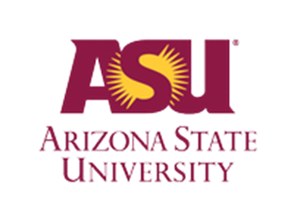 | ASU will accelerate the adoption of adaptive courseware in nine courses as part of a university-wide effort to implement a blended learning model in general education courses. The disciplines include biology, economics, history, mathematics, physics, and psychology. Units teaching these courses on all four ASU campuses will work together in the faculty development and implementation process. Based on ASU’s previous experience with adaptive courseware in blended learning classes, we will use peer mentoring, faculty led workshops, simulated classes, and personalized courseware training to prepare addition faculty members as we scale.
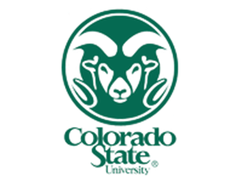 | CSU will integrate adaptive courseware in twenty-three courses: eleven in Year 1, five more in Year 2, and seven more in Year 3 of the grant term. These courses span seven departments/curricula (Chemistry; Economics; Languages, Literatures, & Cultures; Life Sciences; Mathematics; Physics, and Psychology). Most are high-enrollment; many have high D/F/W rates. Integrations will impact 31% of the total enrollments in general education courses for which approved adaptive courseware is available. Further, CSU will integrate adaptive platforms into disciplinary courses with another 25,000 enrollments.
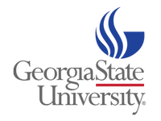 | GSU is dedicated to scaling adaptive courseware in high-enrollment, general education courses that have low completion rates. Deploying adaptive courseware in five gateway courses in Economics, Political Science, and Psychology, the project has the potential to make a significant and sustainable impact on retention and graduation rates at GSU, particularly for high risk populations (black, Hispanic, Pell eligible, first generation, and adult learners). Based on an approach that is data-driven and collaborative, the initiative is designed to support faculty members in the targeted departments as they explore, pilot, refine, and scale adaptive learning courseware across all sections of the identified courses—with more than 15,000 seats annually.
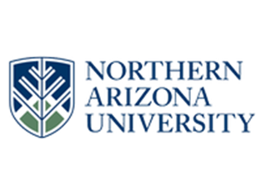 | NAU has identified fourteen candidate courses across the natural, social, and health sciences as well as the humanities and business that together account for about 20% of total general education enrollments. The University’s work will be facilitated by the fact that most of our candidate courses are members of the First Year Learning Initiative, a faculty-created program that ensures that key lower division courses are coordinated and utilize evidence-based pedagogy. NAU’s growing student population continues to diversify, requiring strategies that address individual learner’s needs.
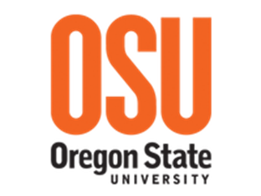 | OSU will scale adaptive courseware implementation rapidly and substantially in six of foundational general education courses in mathematics, psychology, and integrative biology. This initiative will directly support OSU’s institutional goals of raising the first-year retention rate at OSU from 83.8% to 90% and raising OSU’s six-year graduation rate from 63.1% to 70% for all undergraduate students, while eliminating achievement gaps for underrepresented, first-generation, or Pell-eligible students. The goal is to scale adaptive courseware implementation to over 25% of our undergraduate general education curriculum, while enhancing student success and strengthening the culture of innovation at OSU.
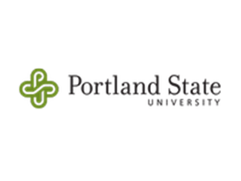 | PSU will accelerate the adoption of adaptive courseware in University Studies and four departments: Art+Design, Business, Chemistry, and Mathematics and Statistics. PSU anticipates that 13,153 general education course enrollments (15%) will benefit from adaptive courseware within the selected courses. At PSU, 43% of admitted full-time undergraduate students received a Pell Grant, approximately 60% of PSU’s undergraduate students transfer from local community colleges and other institutions, and nearly 50% of PSU students are the first in their families to attend college
 | UL embraces adaptive courseware as a personalized support mechanism that deepens learning, increases retention, and closes achievement gaps for underrepresented and underserved students. UL’s six-year graduation rate trails the national average and is the lowest among peer institutions in its regional conference, largely a result of high D/F/W rates in general education courses. Through this initiative, UL will train at least 22 faculty from two colleges and six departments to integrate adaptive courseware in 14 courses impacting over 25% of undergraduate student enrollments.
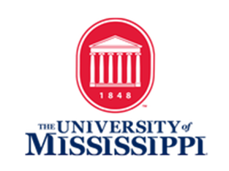 | UM will expand the use of adaptive courseware in general education and extend the benefits of personalized learning to thousands of students across 83,000 enrollments in 9 courses: Writing 101, Chemistry 101, Mathematics 115, Writing 102, Psychology 201, Mathematics 121, Economics 202, Chemistry 105, and Biology 102. In a typical semester, these courses represent up to 30% of all general education enrollments. UM’s six-year graduation rate for the 2008 cohort was 61.4%. For Pell recipients that graduation rate was 50.3%. Over the next five years, UM seeks to improve these rates to 65% for all students and 58% for Pell recipients.

