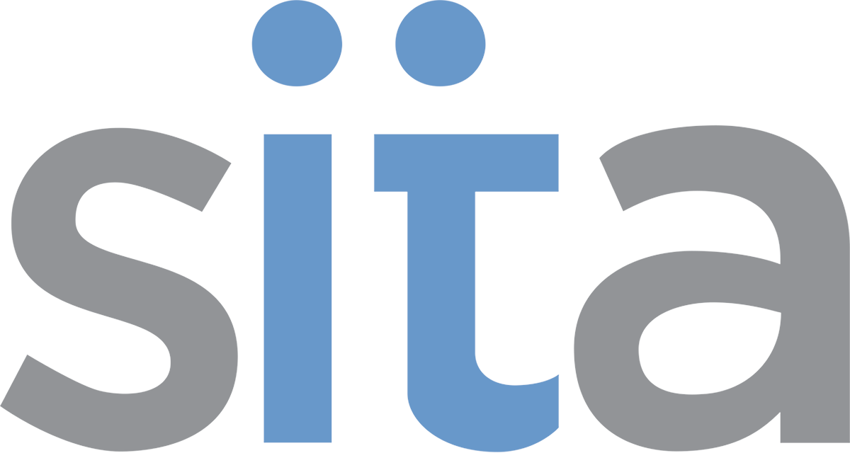

A Different Kind of Teaching and Learning Support

Who We Are
Student Instructional Technology Assistants (SITA) are a select group of graduate and undergraduate students that work collaboratively with faculty and teaching assistants. Our goal is to enhance classroom teaching and learning through the purposeful integration of instructional technologies. Through their work, SITAs also develop in-demand professional skills such as technological proficiency, leadership, resiliency, and problem solving.
We believe the student-learning environment extends well beyond the classroom. Given the opportunity and a context, students will rise to the occasion to both influence the campus culture and develop transferable skills.
SITAs come from many different backgrounds and areas of study across the University, such as Library Science, Engineering, Education, and Computer Science. SITA alumni have gone on to successful professional careers as well as selective masters and PhD programs.

What We Do
SITAs work alongside full-time staff at the Center for Teaching (CfT), the Office of Teaching, Learning & Technology (OTLT) and Information Technology Services (ITS) to meet instructors' teaching needs and goals. To that end, we provide a combination of consulting, training, and production assistance. For example, we:
- meet one-on-one with instructors to plan and implement learning technology projects
- arrange individual or group training on any services OTLT provides
- share and discuss best practices in teaching and technology
- build relationships with instructors based on authentic and meaningful interactions
- guide instructors toward other resources within OTLT and ITS, as well as other campus units that support student success through enhanced teaching and learning practices.

Our Philosophy
The SITA program's collaborative approach to supporting faculty’s integration of technology into instruction provides graduate and undergraduate students the opportunity to join a new kind of community of practice (Lave & Wenger, 1991). By valuing student input as critical to instructional innovation and faculty development, students not only network with and support the professoriate, but also develop valuable skills that are transferable to a variety of future opportunities within or outside of academia. This model breaks from the traditionally hierarchical structures in higher education where the role of teaching assistants is often an executor of the faculty’s plans. Instead, this program positions faculty and students as co-designers (Cook-Sather, Bovill, & Felton, 2014).

Our Funded Partnerships and Collaborations
Due to reputation of our program, SITA has partnered with two large-scale grant-funded initiatives. The Digital Bridges Humanistic Inquiry, funded by a $1.6 million Andrew W. Mellon grant, provides support for faculty members to enhance their digital skills and is a collaboration between Iowa and Grinnell College. Through this opportunity, several graduate SITA staff gained experience developing multi-day faculty professional development institutes and provided project management for a variety of innovative and collaborative projects.
Recently, SITA also began a collaboration with the NIH All of Us Research Program, a $3 million grant awarded to the Greater Midwest Region, National Network of Libraries of Medicine, housed in the Hardin Health Sciences Library on the University of Iowa campus. SITAs function as technological and educational design consultants and product creators.

Our Program by the Numbers
- 1610 total number of Faculty & TA contacts in 2016
  - Including direct consultation support, workshops, study halls, and classroom trainings
- 54 total number of graduate and undergraduate SITAs employed from 2007-2018
- Approximately 400,000 annual operating budget, mostly funded through student technology fees. We currently have some of this funding from the grant partnerships listed above.

Our Impact on SITAs’ Development (Priceless)
According to anonymous self-reported survey responses:
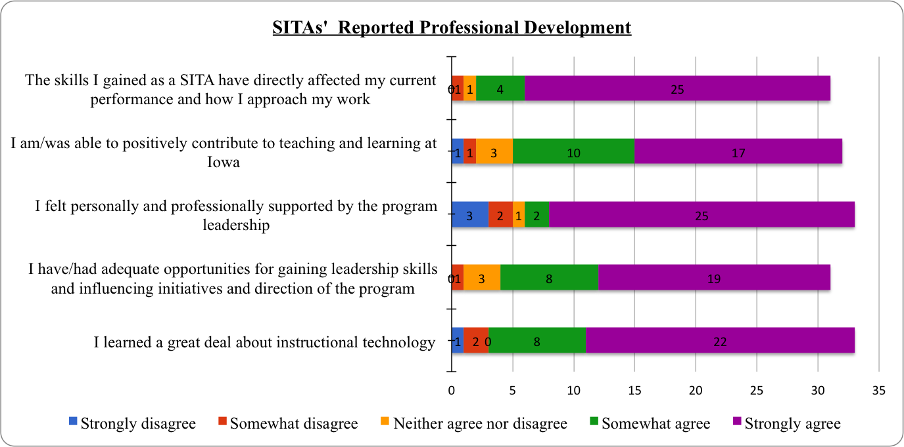
According to their own words:
- “Some of the most important skills I gained are skills I never knew I needed”
- “I discovered leadership skills that I never knew I had”
- “My skills as a creative and persistent problem-solver and as a collaborative teammate have grown tremendously since joining the SITA team.”
- “﻿﻿The program has definitely been one of the hallmarks of my education”

