 (Family)
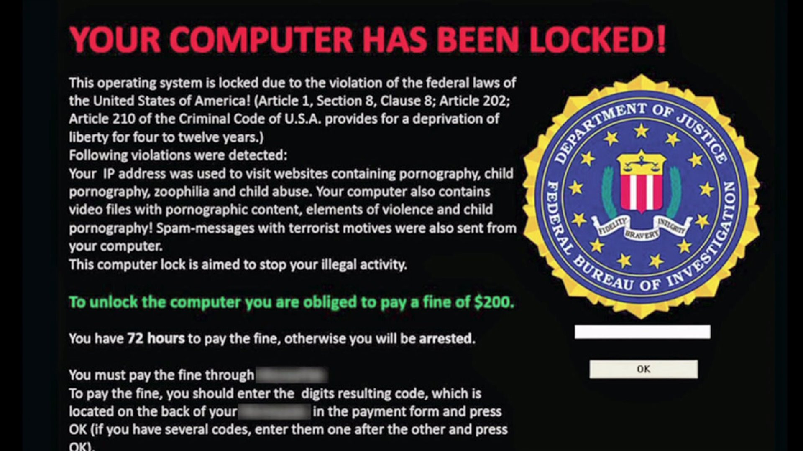

In case of Ransomware
On campus machines….
- Immediately disconnect from the network
  - Unplug network cable
  - Shut off wireless
- Call the Technology Services Desk at x4901
Personal Computers…
- Disconnect from the network
  - Unplug network cable
  - Shut off wireless
- Hopefully you have a backup.

