**The Pegasus Path: Academic Planning Reimagined!**

*dtl.ucf.edu/pegasuspath*

**The Pegasus Path** is a new, interactive advising and degree planning tool developed with the goals of helping students plan a schedule that works for them and focusing students toward graduation in four years. The Pegasus Path integrates with UCF’s myKnight Audit, suggesting courses in the student’s academic plan, identifying semester-by-semester academic milestones and essential signature academic experiences, and suggesting degree-relevant co-curricular opportunities.

**University of Central Florida**

**Location:** Orlando, Florida

**Carnegie Classification:** Doctoral University: Very High Research Active

**Total Enrollment (FA19):** **70,035**

**Undergraduate Enrollment:** **59,865**

**Key Enhancements** of the delivered product:

* Identification of challenge-course combinations
* Inclusion of critical alerts
* Inclusion of co-curricular learning experiences
* Developed Off-Track reports
* Developed as a mobile-friendly application

**UCF Performance Goals:**

**Graduation in 4 Years:**

**FTIC: 60% Transfer: 70%**

**FTIC 1st Year Retention: 92%**

**Graduation without Excess Hours: 80%**

**Lessons Learned**

1. **Have a champion**

An enterprise-level champion will set the priority; college, departmental, and program level champions will establish buy-in and serve as your program advocates.

1. **Conduct an intentional gap analysis**

What are your current student records system’s capabilities? What load is required by any new tool? What additional functionalities are needed?

1. **Reconcile *wishes* with *reality***

Establish a “must” of functionalities, select your vendor and tools carefully, and negotiate for what’s required among enhancements, contracts, and your implementation plan

1. **Clean up your data (you know you have to)**

If you already have bad or non-functional data in your student records system, this will impact the tool’s ability to function properly. Ensure data from existing systems that contributes to a new system is coded for use.

1. **Know your implementation date *will change***

Set and adjust for a realistic go-live date

1. **Ensure your technology integrates**

Ensure you test and validate your data against the technology

1. **Communicate, communicate, communicate**

Use end-user focus groups with students and advisors to ensure usability and functionality

1. **Create a buzz**

Use a marketing and communication strategy to promote and point users to your tool; share usage statistics

“I think this is a great idea.  
This made me realize I had more classes  
and credits to go through than I originally  
thought. I also liked that it shows me experience  
I should be considering outside the classroom.   
This tool has great potential.”

-UCF Student

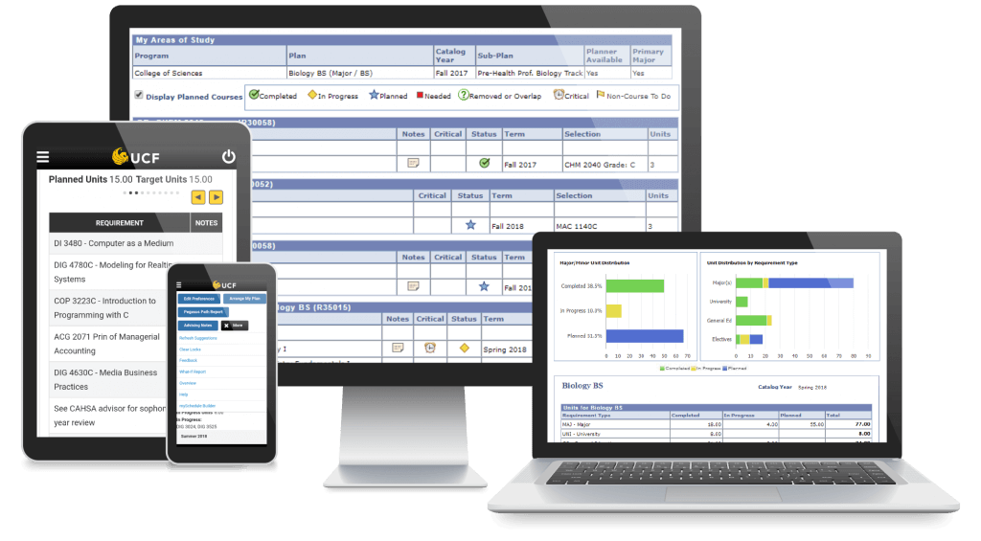

*8-month hits included:

74,333 opened PP

74,457 actions within PP

71,036 updates to PP

24,605 ran audit with courses

17,455 selected courses

11,835 changed preferences

6,251 arranged plans

4,591 removed courses

Paths are created for 2017/18 to present.

**126** Degrees Offered at UCF

**480** Pegasus Paths Available

(degree tracks, minors, certs)

**By the Numbers:**

In the first 8 months, over 74,000 hits* by almost **17,000** students.

In the first year, almost **22,000** students accessed their Pegasus Path.

“I really enjoy that when   
I am looking at my list of requirements  
that I can simply and quickly click the  
select button and choose a course that fits  
that requirement. Much easier than  
scouring the course catalog!”

-UCF Student

**Benefits**

* Interactive and personalized
* Updates in real time
* Integrates with myKnight Audit (degree audit)
* Advisor facing tools
* Shows plan to graduate on time
* Provides What-If Plans (major change view)
* Suggests research and co-curricular experiences to plan for involvement

**Dr. Harrison Oonge (Harrison.Oonge@ucf.edu) and Dr. Teresa Dorman (Teresa.Dorman@ucf.edu)**