Generation Y
- lower expectations of academic achievement (Johnson, 2015)
- Require more grit (perseverance of effort and consistency of interest) to succeed in higher education along with better institutional support (Cupitt and Golshan, 2015)
- Educators need to link their educational engagement and perseverance to long-term goals rather than short-term motivators (Cupitt and Golshan, 2015)
- Generation Y are more likely to exit an organisation due to lack of support, appreciation and flexibility than for any other factors (PWC 2013)
- Often called the “Everybody Gets a Trophy” generation (Battersby, 2017)
- Brought up working in teams with shared rewards and a desire to be coached or mentored
- tend to enjoy and encourage group work and group activities (Price, 2010)
- Action oriented teaching strategies work well with interactive activities and shorter segments. Generation Y students enjoy using technology regularly, educators need to be constantly changing their methods from lecture to discussion, to watching a video, to group work, in order to hold the attention of Millennials (Price, 2010)
- Generation Y need to feel challenged and have explicit development, supervision and support (Lavoie-Tremblay et al 2010).
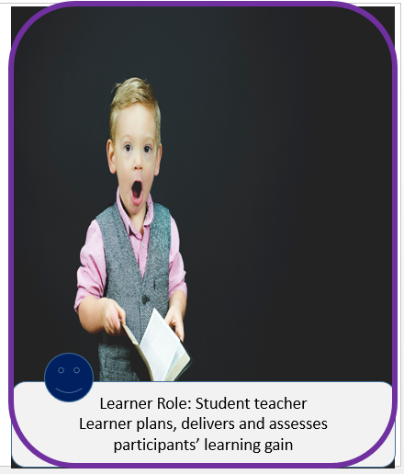
Battersby, L., 2017. Education strategies that best engage Generation Y students. Canadian Journal of Dental Hygiene, 51(3). Cupitt, C. and Golshan, N., 2015. Participation in higher education online: Demographics, motivators, and grit. In STARS Conference. Johnson, Genevieve M., 2015. On-Campus and Fully-Online University Students: Comparing Demographics, Digital Technology Use and Learning Characteristics, Journal of University Teaching & Learning Practice, 12(1),
Available at:https://ro.uow.edu.au/jutlp/vol12/iss1/4 Price C. 2010. “Why don’t my students think I’m groovy?” The new Rs for engaging Millennial learners. Essays Excellence Teach. 9:29–34. Price Waterhouse Cooper. 2013. PwC’S NextGen: A global generational study 2013. Evolving talent strategy to match the new workforce reality. [Online] Available from https://www.pwc.com/en_GX/gx/hrmanagement-services/pdf/pwc-nextgen-study-2013.pdf [Accessed 08 Jan 2019] Lavoie-Tremblay, M., Leclerc, E., Marchionni, C. and Drevniok, U. 2010. The needs and expectations of generation Y nurses in the workplace. Journal for nurses in professional development, 26 (1) 2-8.

