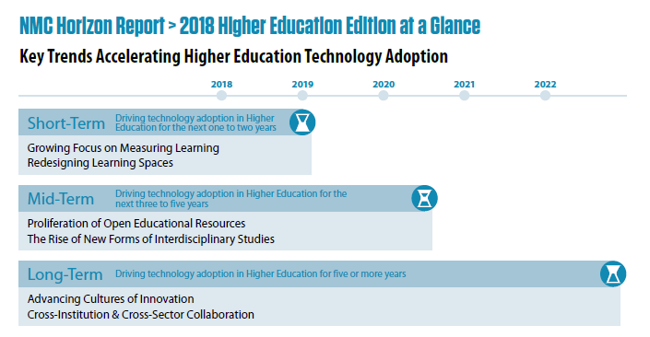
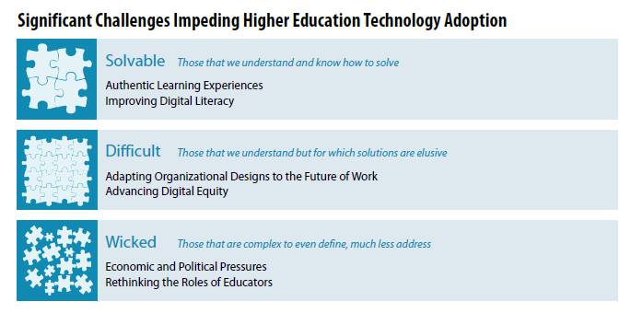
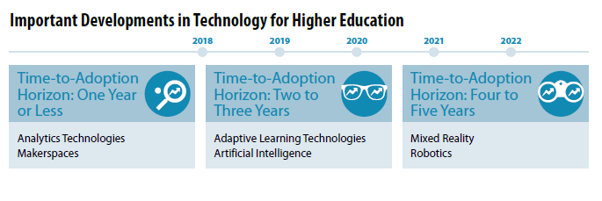

Example Summary Questions (How and What)

Persona Accounts:
How do employers want their voice to be heard in relation to X?
How can educators develop a more coaching/delegating/collaborative etc. approach?
What is the role of the pastoral support worker in relation to X?
How are students being heard and their recommendations acted upon in relation to X?

Organisational Strategies:
How can the organisational strategy of X be implemented fairly across the institution?
What can the organisation do to ensure that staff are properly prepared for a change in X?
How can the organisation better communicate it decisions about resource allocation in X?

Systems and Specifications:
How can we influence professional bodies to accept X?
How can we change our digital infrastructure to support X?
What IT laws are likely to influence future teaching in relation to X?

Theoretical Accounts:
What would the student experience be like if we implemented X model?
How would educators implement X framework?
What would be the impact of changing from X to Y?

Taxonomies and Ontologies:
How is X taxonomy applied, is it right for our students?
What new taxonomies could help to shape X?
How might a change in X impact on students career choices (Ontology)?
How might a change in X impact of students’ identities (Ontology)?

Practice Models:
How might a move to initial/diagnostic/peer assessment impact on student achievement?
How would X learning activities benefit next generation learners?
What is it crucial for educators/students to understand about this change to X?
How might we research the impact of X on the learning environment?

