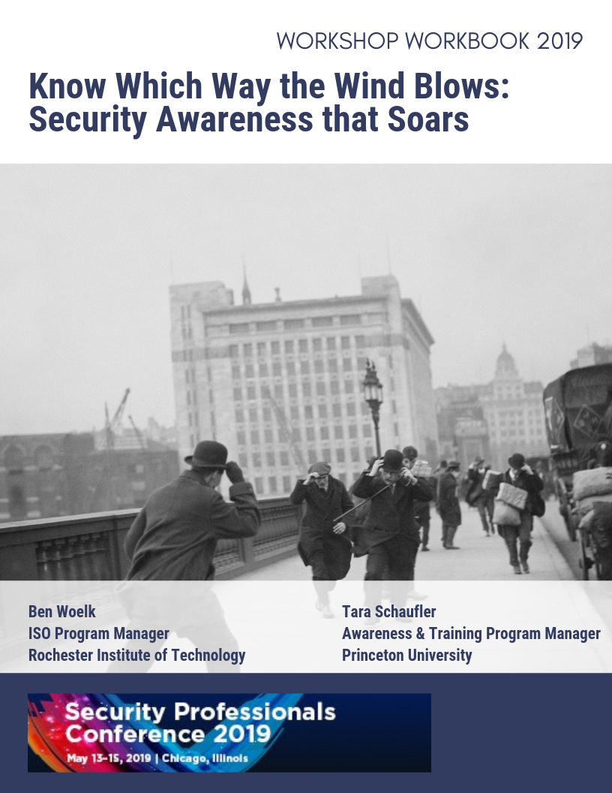

Table of Contents
Introduction 2
About the Workshop 2
Building Your High-Level Communication Plan 3
Step 1: Determine Goal 3
Audience Definition Worksheet 5
Audience Segmentation Worksheet 6
Step 3: Develop Messages 7
Considerations for Message Construction 8
Message Worksheet 10
Step 4: Select Communication Channels 11
Channel Worksheet 12
Step 5: Establish Partnerships 13
Harnessing the Power of Partnerships 13
Allies and Partners 13
Step 6: Define Metrics 15

Introduction
One of our biggest information security challenges is raising our educational community’s awareness so that they better recognize and defend against threats. It's a multiyear process but tackling security awareness strategically enables us to harden the community over time and help ensure they are protecting themselves and others.

About the Workshop
It takes time and persistence to create a security-aware culture. Security is often reactive and by creating a strong awareness program we can be proactive by educating our campus communities to recognize threats. This workshop will focus on equipping attendees to leverage a strategic security awareness plan. The agenda for this workshop is as follows:
- Lecture – A presentation will be given on understanding key elements and considerations in creating a security awareness plan.

- Hands-on participation
  - Workbook – Participants will answer the questions in this workbook to create high-level communication plans.
  - Spreadsheets – Participants will complete the provided Excel spreadsheet templates to create their own school-specific plans.

Content in this workbook is based on the W.H. Kellogg Foundation, Elements of a Strategic Communication Plan.
https://www.wkkf.org/resource-directory/resource/2006/01/template-for-strategic-communications-plan

Building Your High-Level Communication Plan

Step 1: Determine Goal

To initiate a successful and effective communication effort, start with an assessment of your current information security goals. Examine what your organization stands for—its mission, values, and beliefs. Look closely at your university or college community. This process will help narrow and sharpen the focus for your communication initiative(s).

What information security issue is most important to your organization right now? (Example: business email compromises, phishing, protecting sensitive information, etc.)

Who is most affected by the issue stated above (audience)?

Who makes decisions about the issue (possibly different audience)?

What is the overall goal you want to achieve? What change would you be able to observe? (Be specific.)

What tangible outcomes would you like to achieve through a awareness effort? How will you know you are achieving your goals? (Be specific. What would you see, hear, or have in-hand that would let you know you are making progress toward the goal?)

Step 2: Identify and Profile the Audiences

Once you’ve identified your key issues, it’s time to identify and profile specific audiences to target with a initiative.
The reason for taking the time to look this closely at your audiences is that this kind of background information is essential in choosing the most effective ways to communicate with the audiences.

Audience Definition Worksheet

Of the audience listed in Step 1, whose knowledge, attitudes, and behavior must be changed to meet your goal? (These groups now become your target audiences.)

Who else is affected if you succeed in your goal (secondary audience)?

Are there others who can help accomplish your goals? (You may see a role for these folks as “allies and partners” in Step 5: Establish Partnerships)

Now you are ready to complete worksheets for each of your audiences identified above.

Audience Segmentation Worksheet
(Note: you will probably need to make multiple copies of this worksheet.)

Audience:

Describe what you know about this audience’s knowledge, attitudes, and behaviors as they relate to your issue:

What are the barriers to this audience fully supporting or participating in you reaching your goal?

- What are the benefits if they do?

What are the characteristics of this audience?

- How do they spend their time?

- How technology-savvy are they?

- What are the language considerations?

- What or who are they influenced by?

- What makes new information credible for them?

- What or who could motivate change or action?

Step 3: Develop Messages

Your messages are closely tied to your goal and objectives. They deliver important information about the issue and compel the targeted audience to think, feel, or act. They can:
- Show the importance, urgency, or magnitude of the issue
- Show the relevance of the issue
- Put a “face” on the issue (personas)
- Be tied to specific audience values, beliefs, or interests
- Reflect an understanding of what would motivate the audience to think, feel, or act
- Be culturally relevant and sensitive
- Be memorable

The messages you develop by using the worksheet provided in this section can be used in many ways:
- As a set of high-level statements that you and your team agree upon to convey the key information for your initiative
- As underlying themes for your materials and activities
- As the basis for slogans/taglines
- As sets of talking points that members of your team will use in making presentations
- As the basis for video PSAs and posters, and may suggest topics for fact sheets, prepared articles, and even columns or editorials

Before turning to the Message Development Worksheet, take a few moments to read “Considerations for Message Construction.”

Considerations for Message Construction

Both the channel (the conduit for sending your message to the chosen target audience) and the purpose of the communication influence message design. Information may be designed to convey new facts, alter attitudes, change behavior, or encourage participation in decision-making. Some of these purposes overlap; often they are a progression. That is, for persuasion to work, the public must first receive information, then understand it, believe it, agree with it, and then act upon it. Regardless of the purpose, messages must be developed with consideration of the desired outcome. Factors that help determine public acceptance include:

- Clarity—Messages must clearly convey information to assure the public’s understanding and to limit the chances for misunderstanding or inappropriate action. Clear messages contain as few technical/scientific/bureaucratic terms as possible and eliminate information that the audience does not need in order to make necessary decisions (such as unnecessarily detailed explanations). Readability tests can help determine the reading level required to understand drafted material and help writers to be conscientious about their selection of words and phrases.

- Consistency—In an ideal world there would be specific consensus on the meaning of new findings, and all messages on a particular topic would be consistent. Unfortunately, consistency is sometimes elusive. Experts tend to interpret new data differently, making consensus among government, industry, and public interest groups difficult.

- Main points—The main points should be stressed, repeated, and never hidden within less strategically important information.

- Tone and appeal—A message should be reassuring, alarming, challenging, or straightforward, depending upon the desired impact and the target audience. Messages should also be truthful, honest and as complete as possible.

- Credibility—The spokesperson and source of the information should be believable and trustworthy.

- Public need—For a message to break through the “information clutter” of society, messages should be based on what the target audience perceives as most important to them; what they want to know, and not what is most important or most interesting to the originating agency.

Prior to final production, messages should be piloted with the target audiences (and in some cases with channel “gatekeepers”) to assure public understanding and other intended responses.

Based on: Making Health Communication Programs Work: A Planner’s Guide, Office of Cancer Communications, National Cancer Institute, National Institutes of Health (1992).

Message Worksheet
(one for each audience)
Note: Refer to your completed worksheets from Steps 1 & 2.

Audience:

What are the barriers and benefits to your audience thinking, feeling, or acting on your issue?

What change in attitude (the way they feel about the issue) do you want to motivate in your audience to meet your goal?

What change in the behavior (day-to-day actions) of your audience are you trying to achieve?

Now, based on what you know about what your audience needs to hear in order to think, feel or act, what are the three most compelling sentences you could use to motivate the audience? These are your messages.

Step 4: Select Communication Channels

Communication channels carry the messages to the target audiences. Channels take many forms and there is an infinite list of possibilities. Answering some key questions will aid you in identifying the most effective channels for reaching your audiences.

Sample Channels:
Messaging portals
Official campus emails
Campus television or radio stations
Newspapers
Student publications
Websites
Social media
Student unions/centers
Campus festivals
Student laundry facilities
Departmental offices
Bookstores
Parks
Libraries
Campus recreation centers (e.g. gyms)
Student clubs
Bus shelters
On campus restaurants/dining halls
Literature racks

Channel Worksheet
(one worksheet for each audience)
Note: Use the work you did in Step 2 to help you with these worksheets.

Audience:

Step 5: Establish Partnerships

Groups, organizations, or businesses may exist that would aid you in reaching your goal by providing funds, expertise, support, or other resources. Please list allies or partners who support or work with your audiences or share in your goals.

Harnessing the Power of Partnerships

Allies and Partners
Groups, organizations, or businesses may exist that would aid you in reaching your goal by providing funds, expertise, or other resources toward your communications. There are some practical steps you can follow that will focus your energies and resources where they will be most effective:
- Determine Your Needs—Identify what you need the most and prepare a wish list.

- Identify Potential Partners—Use your wish list to identify areas of need and to determine types of organizations that you may find helpful.

- Prioritize Your Contacts—You have chosen possible partners by areas of need—now look for personal contacts. After examining personal contacts, look for those organizations that would make “perfect partners,” i.e., organizations that have supported issues in the past. Move possible partners with whom you have no contacts at all and no apparent links to the bottom of the list.

- Make Your Proposal Strategic—Look for logical allies and mutual goals and put that information in your proposal. Make the proposal “mutually beneficial.” Always demonstrate the importance of the issue, the importance of the program in the community, specifically how the organization can help strengthen your efforts, and how the organization will benefit from its participation.

- Face-to-Face Follow-up—About a week after sending your proposal, call the contact to verify that he/she received the information.

- Make Your University Partners Part of Your Team—Don’t ask for something and then never contact the organization again! Keep a database of all donors and recognize them periodically with a personal note or newsletter. Keep them informed of what’s happening and continually offer opportunities for participation, including volunteering. Also, offer a chance for feedback so you can establish a two-way dialogue with your partners. Make them team members and they will continue to support you for years to come!

Step 6: Define Metrics
Measuring success for your security awareness program can be challenging. Below are some resources to get you started:
- SANS Security Awareness Metrics Matrix
  - https://www.sans.org/security-awareness-training/resources/security-awareness-planning-toolkit
- Measuring the Effectiveness of Security Awareness Programs
  - https://library.educause.edu/~/media/files/library/2013/12/erb1310-pdf.pdf

Key Questions to Ask
- What security awareness metrics do you have access to already? What metrics do your current awareness and training efforts provide? Are you gathering this data, and, if so, how are they being used?

- Does your organization already own a platform that could provide measurements on the consumption and—paired with other data—the effectiveness of your security awareness training?

- Do compliance drivers require some level of security awareness training?

- How will the metrics you gather tell a compelling story to management?

- Are you spending more for a solution just because it gathers metrics? Are they worth the extra cost? How are you balancing the cost/benefit?

- Have you investigated low-cost or free solutions that may provide metrics, such as an anti-phishing toolkit?

“Key Questions to Ask” was retrieved from McElroy, Lori, and Weakland, Eric. “Measuring the Effectiveness of Security Awareness Programs” (Research Bulletin). Louisville, CO: EDUCAUSE Center for Analysis and Research, December 16, 2013. https://library.educause.edu/~/media/files/library/2013/12/erb1310-pdf.pdf
Measuring your Success
- What can and should be measured?
  - Number of incidents?
  - Engagement?
  - Specific areas
    - Phishing
    - Compliance issues
    - BYOD or mobile device management
    - Data loss/leakage prevention
“Measuring your Success” is based on information retrieved from McElroy, Lori, and Weakland, Eric. “Measuring the Effectiveness of Security Awareness Programs” (Research Bulletin). Louisville, CO: EDUCAUSE Center for Analysis and Research, December 16, 2013. https://library.educause.edu/~/media/files/library/2013/12/erb1310-pdf.pdf

