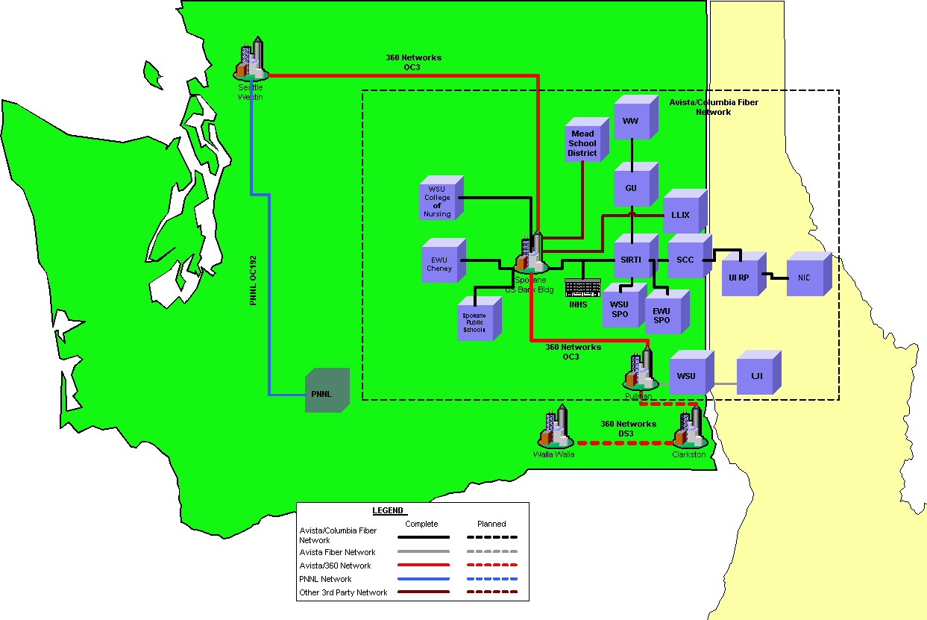



VPnet is powered by
VPNET NETWORK MAP

