Online Course Development Process Guide

Online course development can be perceived as a three-part process –planning and design; development and implementation; and the course delivery and management. Each part consists of several developmental steps. The following is a description of the stages and steps for online course development. The institutional support (personnel) that can be involved is also noted in the steps. This document is a work in progress based on the past practices and current directions of the college and research into current course design and quality assurance practices (see attached bibliography). Feel free to contact us for any input into this document or the course development process.

PART ONE – Course Design………………………………………………..…….p.2
Stage One – Identify Desired Results
Step 1 – Identifying Course Objectives
Step 2 – General Pedagogical Considerations

Stage Two – Determine Acceptable Evidence……………………………p.3
Step 3 – Identifying Course Assessment

Stage Three – Plan Learning Experiences and Instruction……………….p.4
Step 4 – Identifying Course Components
Step 5 – Designing Course Structure
Step 6 – Designing Instructional Strategies…………………………….p.5
Step 7 – Finding Online Resources (Library

The end product of this stage is a draft course syllabus which includes (but not limited to) the following components:
- list of topics to be covered
- student activity/assessment plan
- tentative course schedule

New components to be developed for the online course will also be identified.

PART TWO – Development and Implementation………………………………..p.5
Step 8 – Content Preparation
Step 9 – Creating the Course under a Course Management System (CMS)..p. 6
Step 10 – Testing the Course and Course Sign-Off

The end product of this stage is a complete online course site.

PART THREE – Course Delivery and Management………………………..……..p.7

The end product of this stage is the successful teaching of the course.

Bibliography…………………………………………………………………….p.8

PART ONE – COURSE DESIGN
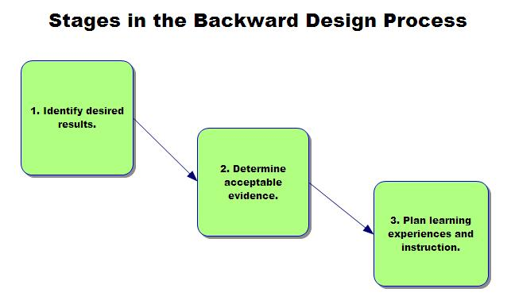
Stage One – Identify Desired Results

Step 1 – – Identifying Course Objectives
In this step, list the objectives of your course. The objectives could be listed as general class objectives and specific behavioral outcomes.

Institutional Support
Deans & Dept. Chair:
Provide existing program learning outcomes.
Instructional Designer:
Provide guidelines and templates for listing course objectives.

Step 2 -- General Pedagogical Considerations
In this beginning step, ask questions such as:

- What are the positive and negative aspects of your class?
- What instructional strategies did you use for your class? Were they effective?
- Will the same strategies work for online delivery?
- What would you like to do with your class? Can the new instructional media achieve it?
- What are the things that need to be done differently due to the nature of the new media?
- What is the difference between online and in-class students? How should the issue be addressed?

List goals that you would like to achieve and issues that you wish to address for your course.

Institutional Support
Instructional Designer:
Answer general questions regarding online instruction; solve problems regarding the difference between online and on-ground instruction; provide reference resource for existing online courses and planning principles.

Stage Two – Determine Acceptable Evidence

Step 3 – Identifying Course Assessments
In this step, the assessments of the course are identified. An assessment component may include student self-evaluation, quizzes, exercises, and exams. Creating assessment for your course involves several tasks:
- Identify textbooks and start gathering content materials and supplemental materials together from publishers that may be used in assessment (e.g., photos, graphics, print-based and Internet-based references, existing multimedia clips).
- Determine which assessment methods are appropriate for objectives
  - Essays
  - Exams
  - Discussion assessment
  - Self-assessment tools

Institutional Support
Instructional Designer:
Instruct faculty in the creation of assessment and use of publisher’s supplemental materials.

Stage Three – Plan Learning Experiences and Instruction

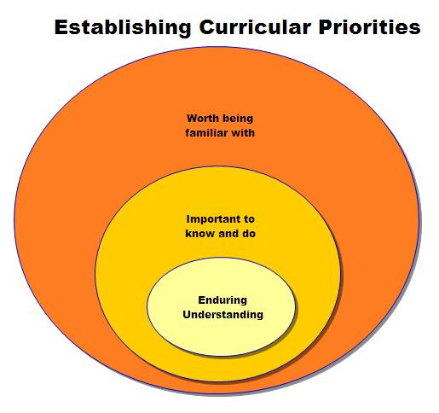
Step 4 – Identifying Course Components
In addition to the knowledge content that will be delivered to the students, identify the other components of the course that you would like to incorporate to facilitate the learning process. Some examples would be:
- A syllabus.
- A communication component which may include group discussion, e-mail communication, etc.
- A record keeping component to track student progress.
- Obtaining copyright clearance for the materials if necessary.
- Making a list of the content topics and supplemental materials that need to be developed.

Institutional Support
Instructional Designer:
Provide examples and suggestions of components that would be useful to the particular course.

Step 5 – Designing Course Structure
In this step, divide content materials and course components (where appropriate) into units. Then create a course structure for content material units. The structure would map out the organization and connection for individual units. Also, in this step, map out the relationship between content units and course component units (e.g., linking a quiz to a content unit). The organization maps for units can also be used as the organization maps for actual content files placement and storage. If the content files have a different organizational structure, create separate organization maps for the files in this step.

Institutional Support
Instructional Designer:
Provide advice on appropriate length of units, possible alternatives for structure design, and logical connection between units.

Step 6 – Designing Instructional Strategies
In this step, identify information delivery strategies (e.g., lecture notes or lecture notes plus video demonstration) and design activities for content units. Develop a comprehensive student activity/assessment plan which will allow you to achieve the stated course objectives. Combine course structure and activity/assessment plan to create a course schedule.

Institutional Support
Instructional Designer:
Demonstrating alternative delivery methods; helping to choose appropriate strategy and activities for different units; checking the feasibility of the delivery strategy.

Step 7 – Finding Online Resources (Library)
In this step, you may want to research online resources and materials that could be available for your students in your discipline. These materials may be journal articles, online books, freely available multimedia, tutorials, etc.

Institutional Support
Online Librarian: Syd O. Sullivan
The college library has a faculty member who is an online librarian. This librarian is available to any instructor looking for web-based course materials.

PART TWO – DEVELOPMENT AND IMPLEMENTATION

Step 8 – Content Preparation
In this step, convert all your content to Internet-ready format, i.e., HTML format, and gather images, sound files, and other multimedia.
This would include several tasks:
- Developing new materials (text, graphics, and multimedia files).
- Converting existing non-HTML files to HTML format.
- Develop or utilize computer-based supplemental materials if needed (materials to be mailed to students such as course reading packet or CD ROM).

Institutional Support
Distance Learning Coordinator
Set up accounts on the appropriate servers if needed.
Instructional Designer:
Provide advice on the appropriate software to use for development and conversion; help develop surveys and multimedia files; check the appropriateness of supplemental materials.
Multimedia Specialist:
File conversions. Upload content to appropriate servers. Help overcome technical difficulties encountered by instructor in content preparation; providing format and/or layout guidelines for the files;

Step 9 – Creating the Course under a Course Management System
After all the materials have been developed, the next step is to build the actual course in the CMS. This would involve several steps:
1. Creating a course site on the CMS.
2. Learning to use the CMS.
3. Transferring all content materials into the CMS.
4. Setting up course components in the course site.
5. Setting up class management options in the course site.
6. Making modifications if necessary.

Institutional Support
Distance Learning Coordinator:
Create course site in the CMS. Help manage any special problems in transferring course content to the CMS.
Instructional Designer:
Providing assistance in learning how to build a course site and use the CMS.

Step 10 – Testing the Course and Course Sign-Off
After the complete course has been built on the CMS, test all aspects of the course from the student’s perspective. Rubrics are available for all aspects of Step 9. Things to check include:
- Content accuracy
- Content display
- Internal and external links
- Functionality of individual course component

Institutional Support
Deans & Dept. Chair
Reviews course for meeting department and course objectives to ensure that there is no difference between the online and face-to-face course for academic rigor.
Distance Learning Coordinator:
Makes sure that the course has been added to the schedule and all the appropriate fees have been added so that students will be populated via integration.
Tests course with functional quality assurance process that answers such questions as:
- Is the course activated?
- Is there an initial announcement?
- Are essential first week components such as the syllabus available?
- Are the assignments linked to the grade book?
- Do the tests work?
Instructional Designer:
Tests course with functional quality assurance process that answers such questions as:
- Does the course teach to a wide range of learning modalities?
- What degree of interactivity does the course have?
- Does the course make good use of the tools available in the CMS?
- Is the course interactive?
Help test and QA the course.
Multimedia Specialist
Tests course with functional quality assurance process that answers such questions as:
- Are the media files associated with the course functioning correctly?
- Are they cross platform?
- If not, what links to support files should be provided?

PART THREE – COURSE DELIVERY AND MANAGEMENT
This stage takes place when the course is actually being offered. It involves managing all aspects of the course constantly. The tasks include:
- Communicating with students through announcements and e-mail
- Conducting online discussion with students
- Monitoring student discussion groups
- Collecting, grading, and returning assessments not automatically graded by the CMS
- Updating content
- Tracking and monitoring student progress
- Archiving course and other materials
- Collecting and analyzing feedback on the course for future use

Institutional Support
Distance Learning Coordinator:
Assist students and faculty with technical problems regarding access to course and materials.
Instructional Designer:
Help address concerns regarding delivery of the course. Training in use of the CMS and in the backing up course materials

Bibliography

Chickering, A. W. & Gamson, Z. F. (1991) “Seven Principles for Good Practice in
Undergraduate Education.” Grand Rapids Community College. Retrieved Nov. 10, 2006 from <http://web.grcc.cc.mi.us/CTL/7princip.htm>

Chickering, A.W. & Ehrmann, S.C. (1996) “Implementing the Seven Principles: Technology as
Lever” Teaching, Learning and Technology Group. Retrieved Nov. 10, 2006 from
< http://www.tltgroup.org/programs/seven.html>

Huitt, W. (2004). Bloom et al.'s taxonomy of the cognitive domain. Educational Psychology
Interactive. Valdosta, GA: Valdosta State University. Retrieved Nov. 10, 2006 from
<http://chiron.valdosta.edu/whuitt/col/cogsys/bloom.html>

Janicki and Liegle (2001). “Development and evaluation of a framework for creating web-based
learning modules: a pedagogical and systems perspective.” Journal of Asynchronous Learning Networks, 5(1). Retrieved Nov. 3, 2006 from <http://www.sloan-c.org/publications/jaln/v5n1/v5n1_janicki.asp>
McVay Lynch, M. (1998). Constructivism in instructional design for distance education. Computing Resources, Portland State University, Retrieved July 16, 2001, from <http://web.pdx.edu/~mmlynch/constructivist.html>

Muilenburg, L & Berge, Z. L. (2000) “A Framework for Designing Questions for Online
Learning” eModerators. Retrieved Nov. 9, 2006 from
< http://www.emoderators.com/moderators/muilenburg.html>

Roblyer, M. D. &. Ekhaml, L. (2000, Spring) “How interactive are YOUR distance courses? A
rubric for assessing interaction in distance learning.” Online Journal of Distance Education Administration, 3(2). Retrieved Nov. 13, 2006 from <http://www.westga.edu/~distance/roblyer32.html>.

Wiggins, G & McTighe, J (1998) Understanding by Design. Upper Saddle River, New Jersey:
Merril Prentice Hall.

