
Shift in Paradigm
1
Primary learning objectives shift from knowing to using and applying the course concepts.
2
Role and function of the teacher shifts from a ‘sage on the stage’ to a ‘guide on the side’.
3
Role and function of students shifts from being passive recipients of information to being responsible for the acquisition of information and then learning to apply the information in a variety of contexts and to variety of problems.
Team-Based Learning - TBL (Michaelsen, Knight & Fink, 2002) dramatically shifts the focus of classroom time from conveying course concepts by the instructor to application of course concepts by student groups. In the TBL process, students acquire their initial exposure to the content through readings and are held accountable for their preparation using a Readiness Assessment Process (RAP). Following the RAP, they practice in-class learning how to apply the content using a series of team application exercises.
Group Formation
Groups must be properly formed and managed.
- Separate subgroups
- Create teams with diverse skills and abilities
- Groups should be fairly large (5 to 7 members)
- Groups should be permanent

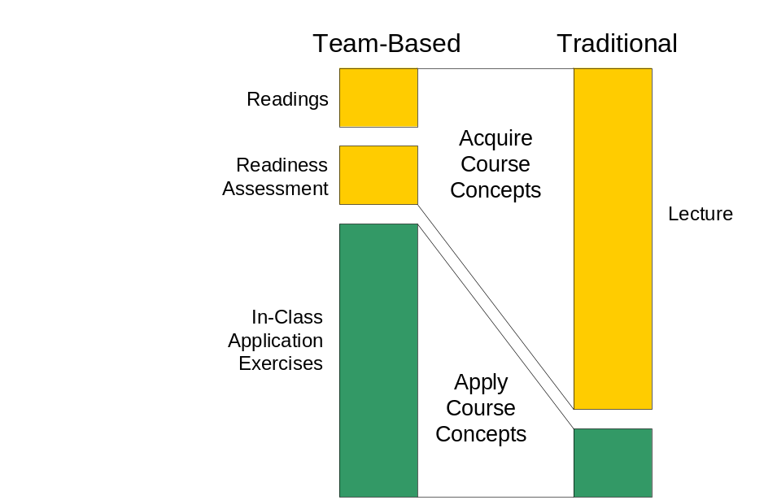

Four Key Principles for Success in TBL
Group Formation
Groups must be properly formed and managed. Instructors should:
- Separate subgroups
- Create teams with diverse skills and abilities
- Make groups that are fairly large (5 to 7 members)
- Make groups that are permanent

Accountability
Students must be made accountable
for:

- Individual pre-class preparation
- Contributions to team assignments
- Contributions to team functioning

This can be ensured by using a grading system that encourages accountability.

Assignment Quality
Good assignments promote learning and team development.

- Effective TBL assignments require teams to make complex, multi-faceted decisions and report in simple form.
- Most “problems” are the result of inappropriate assignments that don’t require group interaction.

Timely Feedback
Students must have frequent and timely performance feedback.

- The RAP informs individuals and groups on their quality of preparation.
- Intra and Inter-team discussions during application exercises provide rich opportunities for feedback.
For more information visit www.teambasedlearning.org

Instructional Sequence for Team-Based Learning

Readiness Assessment Process

The RAP occurs at the beginning of each major instructional unit. RAP ensures that students have completed pre-class reading assignments and are prepared for in-class team work. The process consists of a multiple choice test (15-20 questions) on key concepts from the readings. It is first taken individually and then immediately re-taken as a team. RAP typically consists of five elements:
Assigned Readings
Individual Testing and Feedback (Scantron)
Team Testing and Feedback (IF-AT sheets)
Discussions and Appeals
Mini-lecture/Instructor Feedback

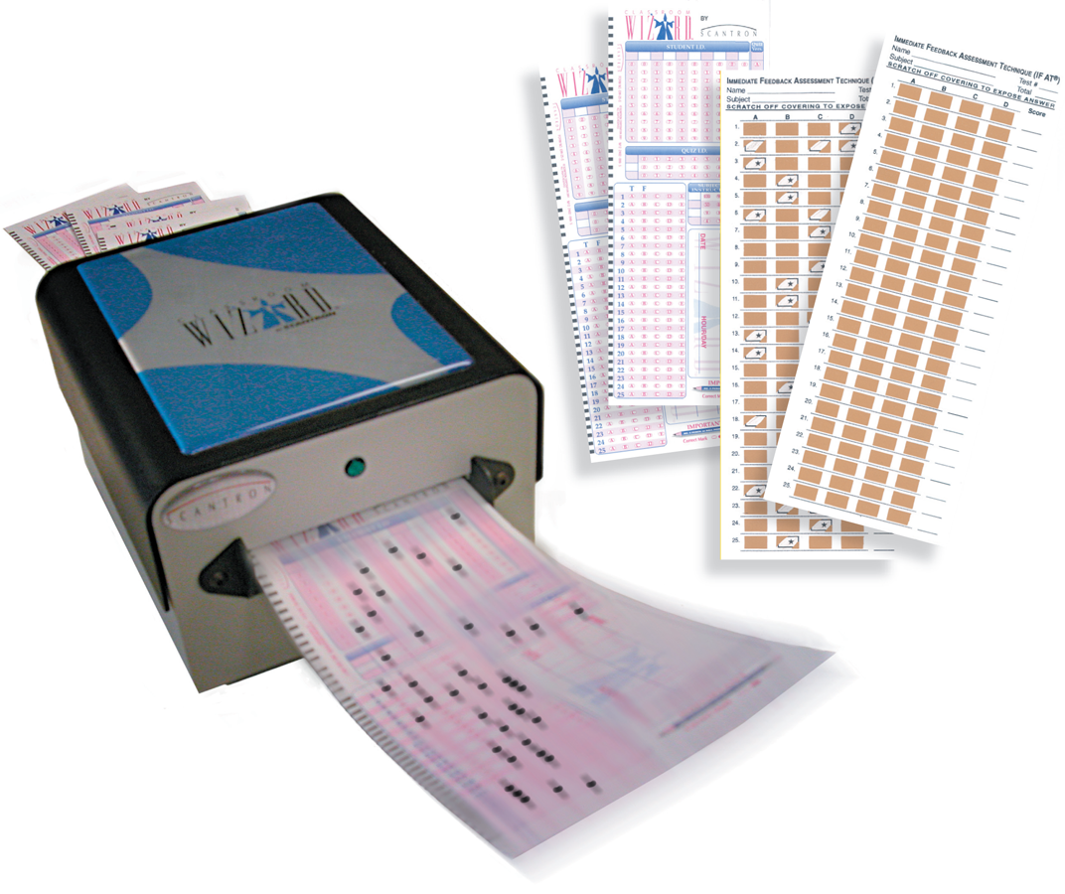

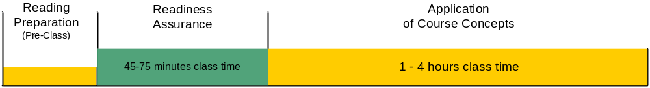
In-Class Application Exercises (3 S’s)

Same Problem. Individuals/groups work on the same problem, case or question.
Specific Choice. Individuals/groups must known and use course concepts to make a specific choice.
Simultaneous Report. Individuals/groups report their choices simultaneously. This makes the results of student thinking highly visible and provides opportunities to discuss contrasts in decision making and thinking.

Important Considerations for Effective TBL Exercises
Production of a tangible output
Impossible to complete without comprehension of course concepts
Sufficiently difficult to eliminate completion by an individual member
Majority of time engaged in activities
Applicable to real world issues or problems (pragmatic/applied)
Interesting and fun (ENERGY is the acid test for good exercises)


Contact Centre for Instructional Support Faculty of Applied Science University of British Columbia
Jim Sibley at 604.822.9241 or jim.sibley@ubc.ca

This document is based on the work and writings of Larry Michaelsen, Dee Fink, and Arletta Bauman Knight

