Example of a fully customized Library Course Page:
http://library.uwc.edu/lcp/?id=N00110101084

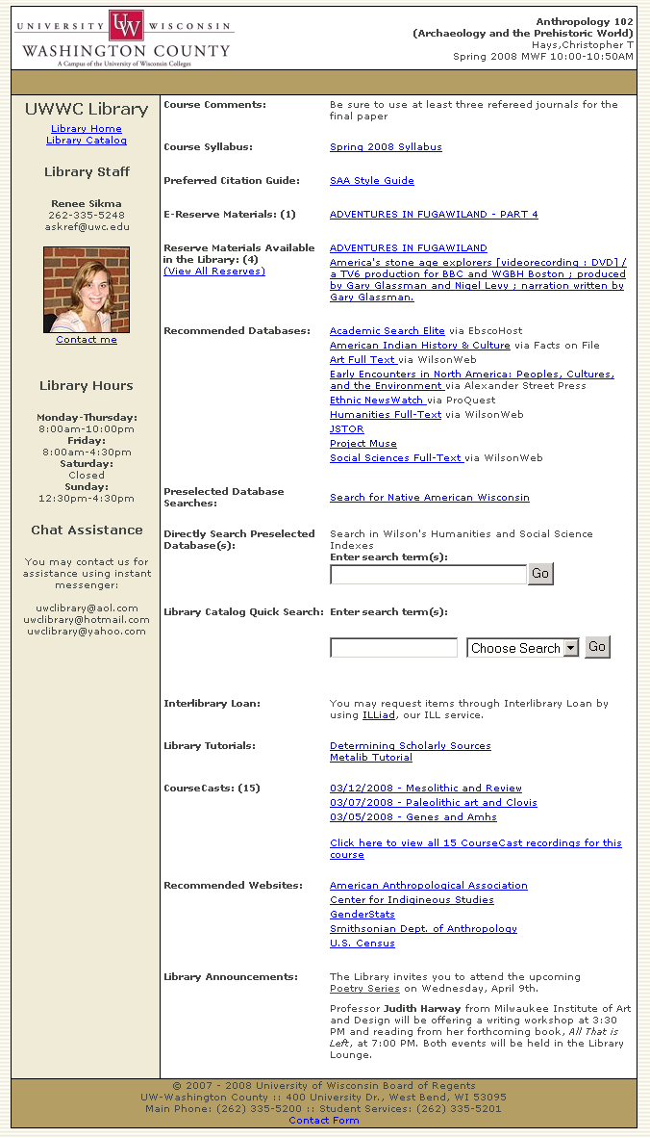

Example of a non-customized Library Course Page with only the departmental settings:
http://library.uwc.edu/lcp/?id=G00110131084

