Information Technology Fluency: Baseline Assessment

These days it seems as if every aspect of life is affected by computers and other forms of technology. Technology is woven into our language and our culture. “Google” has become a verb!

With this in mind, Simmons College is administering this survey to learn more about incoming students’ prior experience with technology. Note that, while some parts of this survey may look like a quiz, the intent is not to “grade” you. The following exercises are designed to help us understand the technology learning needs of first year Simmons College students.

Part I. Demographic Information: Prior Experience with Computers

Unless Advised Otherwise, Please Circle the Best Answer

- What is your age?
a. 16-18  b. 19-21  c. 22-24  d. 25-27 | e. 28-30  f. 31-33  g. 34-36  h. 37+

- Do you have an intended major?
a. yes
b. no
… if yes, what is your intended major? _______________

- Type of high school attended
a. public
b. private
d. home school
… other (please explain) _______________

- Did you take time off between high school and college?
a. yes
b. no

- On a scale of 1 (poor) to 10 (excellent), rate your information technology skills: _____

- Have you ever had a job that involved computer use?
a. yes
b. no
… if yes, circle type: administrative, publishing, web development, other ___________

- Does your household/family have a computer? How many?
a. yes
b. no
… if yes, how many? ___________
- Do you prefer to use a Mac or MS Windows operating system?
a. Mac
b. Windows (PC)
… other (please explain) _______________

- Does your household/family have Internet access at home?
a. yes
b. no
… if yes, circle type: dial-up, cable, DSL, don’t know, other ___________

- Before Simmons, did you have your own email account?
a. yes
b. no
… if yes, circle how often you check: monthly or less, weekly, daily, several times a day

- Have you ever sent an email message that includes an attachment?
a. yes
b. no

- Have you ever taken a course or training over the web (distance learning)?
a. yes
b. no
… if yes, tell us more (type of course, who taught it, what types of work you did online):

- Has your computer ever gotten a virus?
a. yes
b. no
c. don’t know

- Have you ever installed software on your own?
a. yes
b. no
c. don’t know

- Check all that apply. When you have a problem with your computer, have you ever done any of the following?
 called the hardware/software company’s tech support
 requested tech support via email
 consulted online documentation and/or FAQ’s
 consulted the printed manual
 asked a family member or friend for help
 worked through the problem without assistance
 none of the above
… other (please explain) _______________
- If you are a resident at Simmons, do you have a computer with you at school?
a. yes
b. no
c. I live off campus
- If you do not live on campus, do you have a computer where you live that you can use for your schoolwork?
a. yes
b. no
c. I live on campus
- Check all that apply. Have you used your Simmons email account?
 I have not checked my Simmons email
 I’ve checked my Simmons email using my web browser (Internet Explorer or Netscape)
 I’ve set up software to check Simmons email (Outlook Express, Eudora, etc.)
 I’ve set up Simmons email so that it forwards to another email address
 I’ve sent messages using Simmons email
 I’ve sent attachments using Simmons email
 Don’t know

- Check all that apply. Have you ever saved files on a
 file server
 USB microdrive
 don’t know
- Check all that apply. Have you ever published writing or artwork in a web site?
 no, none of my work has ever been published on the web
 my work has been included on someone else’s web site
 I publish things on my own web site
 don’t know

Part II. Assessing Fluency with Information Technology

- Check all that apply. You are working at your computer in your dorm room and decide to visit http://dictionary.com to look up the meaning of a word. You go to the site and get a “404 File Not Found” error message. What could be the problem?
 That website is down
 Your computer has a virus
 There’s a typo in the web address
 Your browser is not functioning properly
 I don’t know what could be the problem
- Check all that apply. Following up on the previous question, what steps would you take to troubleshoot the “404 File Not Found” problem?
 Try to access another site
 Turn your computer off, wait 10 seconds, and then try logging on again
 Assume that whatever isn’t working now is a passing thing – try again later
 I’m not sure what I should do to troubleshoot the situation
- If you send an email to a friend, how does your message get to her?
a. Bits of data are transmitted via satellite from your computer to hers
b. Bits of data are transmitted through a direct connection from your computer to hers
c. Bits of data are transmitted to a server, where it waits for her to access it
d. I’m not sure I know how email messages get from one computer to another

- Check all that apply. Which of the following can be used to spread computer viruses?
 Email
 Files downloaded from Web sites
 Files on Disk/CD
 Files in text-only format
 I don’t know which of these formats can spread computer viruses
- You’re creating a Web page and you want to include images from another site. What should you do?
a. Download the image and use graphics software to make a few changes – this way the image has been technically created by you.
b. If it’s for educational use or for your personal page (not a commercial site) you don’t need to ask permission to use the images.
c. Email or write the author or webmaster to request permission.
d. I don’t know what I should do.
- Which of the following would make the best password?
a. Your pet’s name
b. A random combination of numbers and letters
c. Your mother’s maiden name
d. Your favorite color
e. Not sure
- You are doing background research for a science project. In addition to perusing library sources, you decide to go online and see what’s available. You come across two web sites (see pictures on the last two pages of this survey). Which site do you think is more credible?
a. The Edible Vaccinations Site
b. The DHMO Site
c. Not sure

- Following up on the previous question, how did you decide which site to pick? What evidence helped you select the most credible site?

- If you are saving a MS Word file named “mypaper” on a Macintosh, how can you ensure that it can be viewed, as created, using MS Word on a computer running MS Windows?
a. Save it as a text-only file
b. Include the date and your initials in the file name
c. Save it as “mypaper.doc”
d. Save it as “mypaper.pcdoc”
e. I’m not sure what to do

- You are using an MS Windows computer and you receive a message from a friend who is a Macintosh user. The message has a file named “mypaper” attached that is supposed to open in MS Word, but it doesn’t open when you click on it. What should you do next?
a. Try opening it up in Notepad
b. Rename it to “mypaper.doc”
c. Rename it to “mypaper.macdoc”
d. Don’t click on the attachment again – it may contain a virus!
e. I’m not sure what to do
- Check all that apply. In what situations is communicating by email preferable to chat (instant message)?
 When you are sending professional, rather than a personal, correspondence
 When you just have a quick question
 When you don’t require an immediate response
 When you don’t know the person well
 When you want the person to get your message right away
 Don’t know

- You need to store hundreds of photos on your computer – it needs an upgrade. You have a limited budget…do you spend money to upgrade your computer’s RAM or hard drive space?
a. Upgrade RAM
b. Expand Hard Drive
c. Don’t Know

- True or False: You can say anything you want online – as long as it’s in email or on your personal Web page.
a. True
b. False
c. Not sure

- Entering numbers in the blanks in the left column, match the following file types with their proper file name extensions:
____ Web page | 1. .ppt
____ Photo | 2. .mp3
____ Video | 3. .jpg
____ Audio | 4. .mov
____ MS Word document | 5. .html
____ Excel spreadsheet | 6. .xls
____ PowerPoint presentation | 7. .pif
____ Adobe Acrobat | 8. .scr
 | 9. .pdf
 | 10. .doc

- You are on campus writing a term paper which you’ve already saved to your Simmons server space. What should you do to ensure that you can continue to work on the document when you’re off campus for the weekend?
a. Print out a copy
b. Nothing – you can access the file from your server space
c. Save it as a .pdf
d. Save it onto a USB key microdrive
e. I’m not sure which of these options is good

- Check all that apply. In which of the following circumstances are there legal and ethical issues to consider?
 Borrowing a friend’s laptop and writing a paper on it
 Downloading Metallica music files with Kazaa
 Copying and pasting extended passages from a web site into your term paper
 Buying software and letting your friends install it on their computers
 I’m not sure which of these options has legal and ethical implications

- Check all that apply. You receive an email message from your bank requesting that you click on a link to access their web site and verify your account information. What do you do?
 Do as they request
 Call the bank on the phone
 Ignore the email
 I’m not sure what to do
- You’re interested in career opportunities in nursing. What would you type into the Web search engine box to find the most information?
a. nurses or nursing opportunities
b. nurs* career*
c. career opportunities in nursing
d. “nursing jobs or careers”

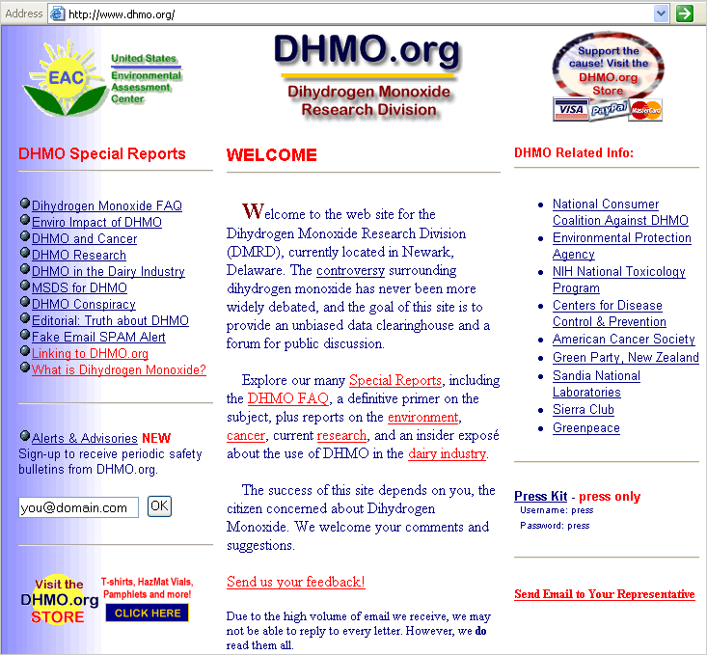

FIT Assessment Copyright Simmons College, 2005. This work is the intellectual property of the author. Permission is granted for this material to be shared for non-commercial, educational purposes, provided that this copyright statement appears on the reproduced materials and notice is given that the copying is by permission of the author. To disseminate otherwise or to republish requires written permission from the author.

