HIPAA Privacy and Security Rule – Systems Admin
Blackboard Training Guidelines

After you control-click on or type http://ecu.blackboard.com in Internet Explorer, follow these steps:

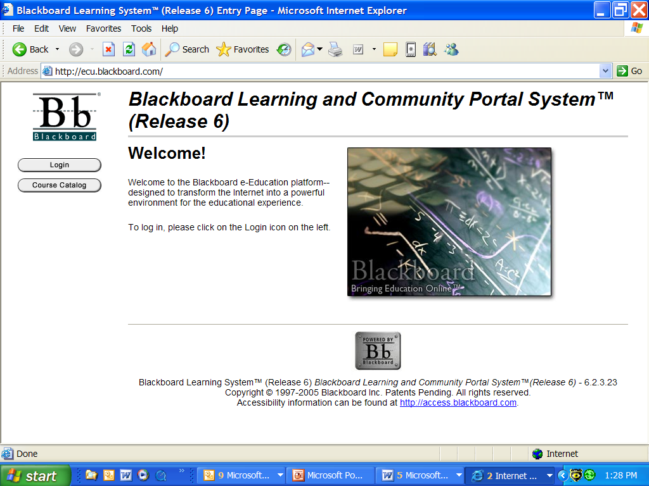

Click on Login
Follow these directions to assist you in completing this course:

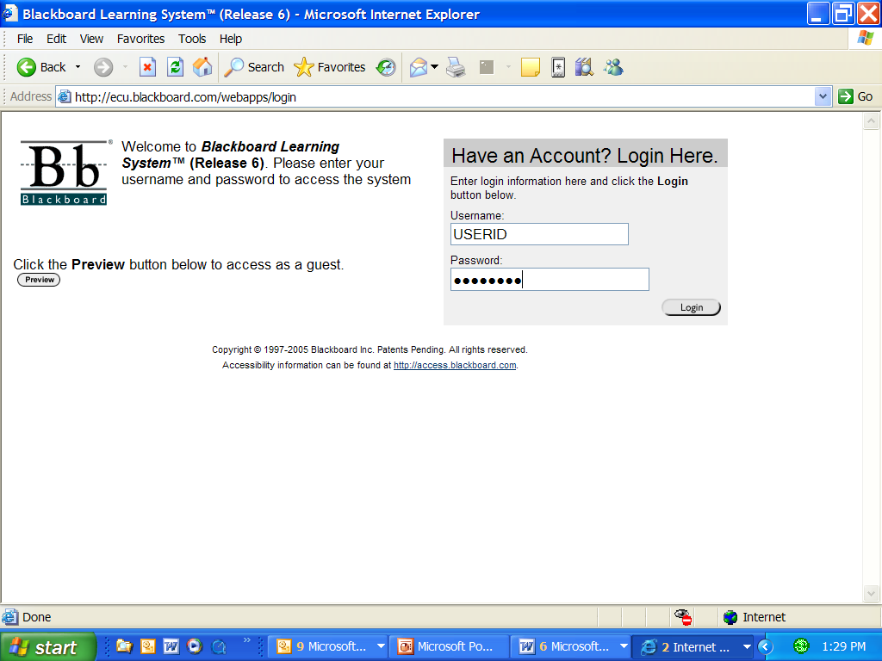

Type your USERNAME (PIRATEID)

Type your PASSWORD

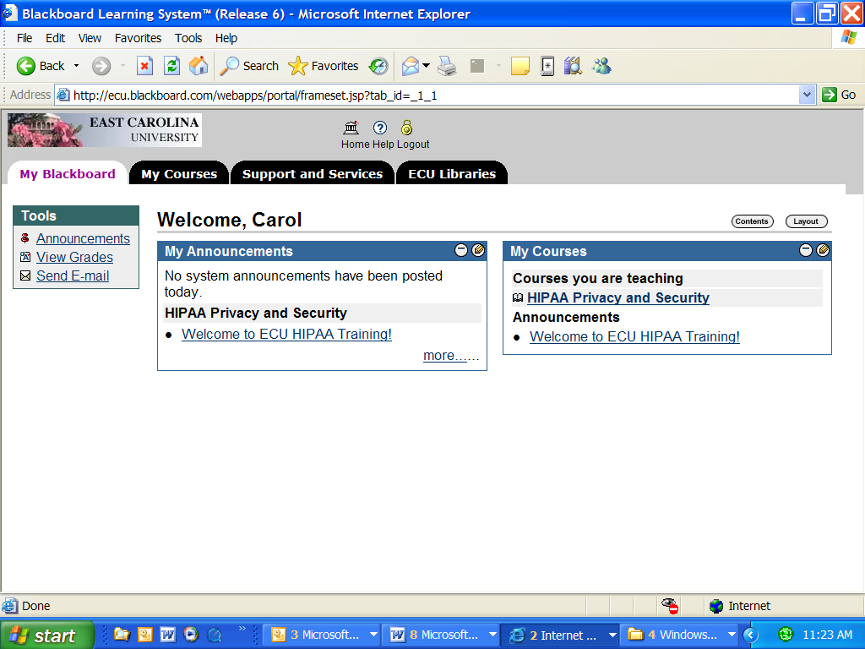
Click on HIPAA Privacy and Security to begin the course.

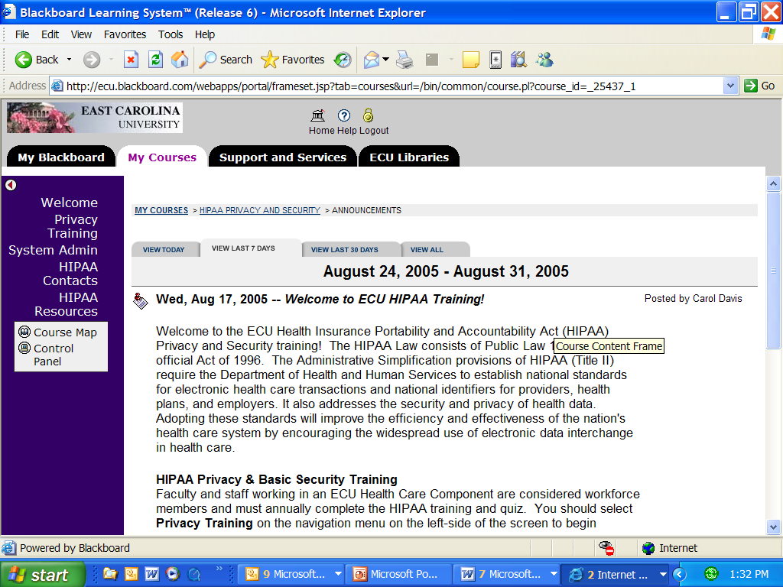

Review the Announcement

To begin the course:
Clinical Staff should complete the Privacy Training.
Click on System Admin if you provide technical support on systems with electronic protected health information (EPHI).

ECU HIPAA contacts and additional resources are available.
BACK

Click on System Admin Course Objectives to review this information.

Click on the BACK button to return.

Click on System Admin Course Materials & Quiz to complete the training requirements.

Once the training and quiz have been completed, please provide feedback by completing the survey.

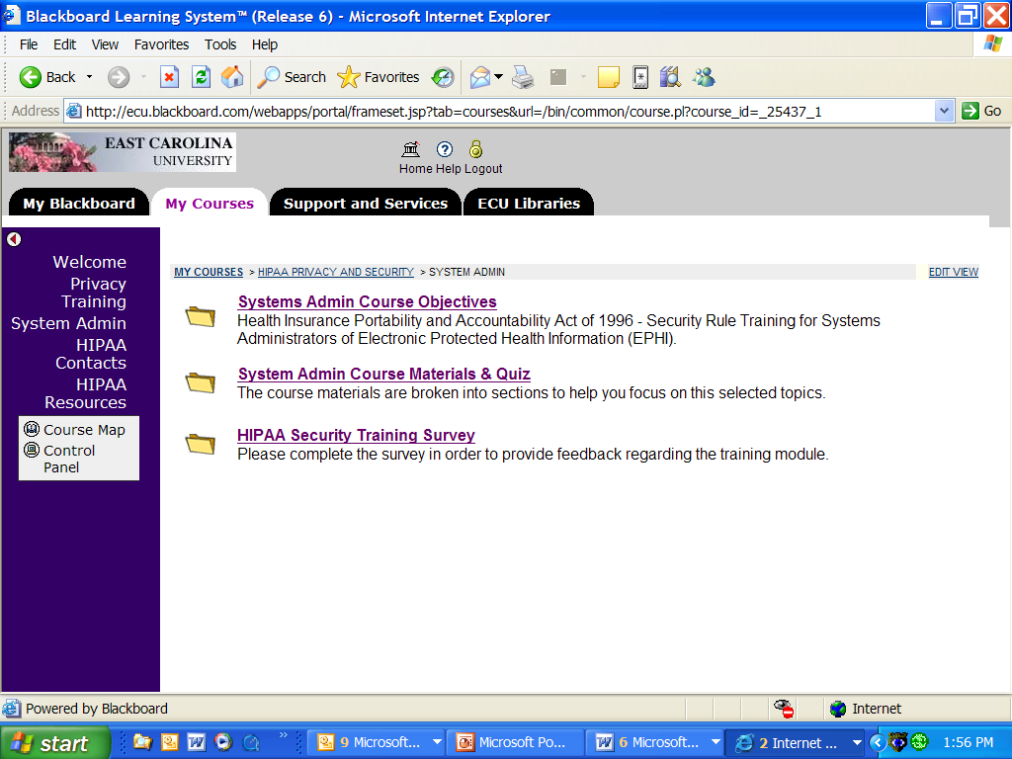

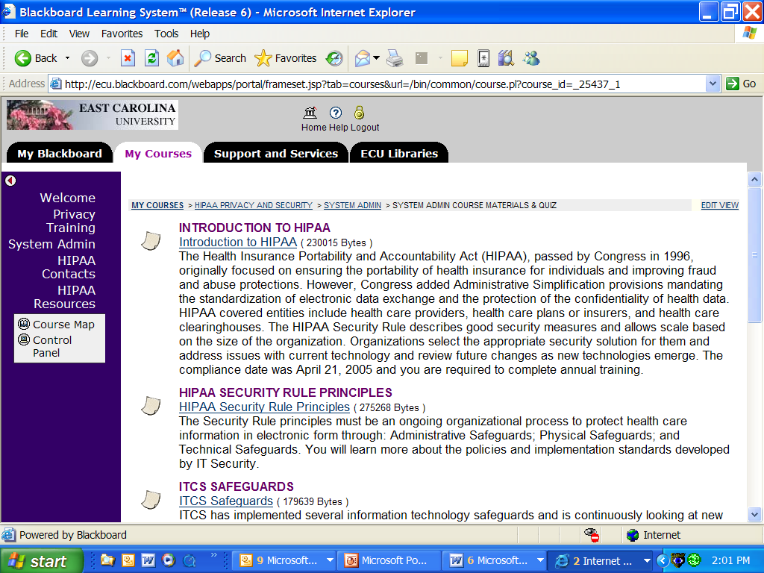

Click on INTRODUCTION to HIPAA

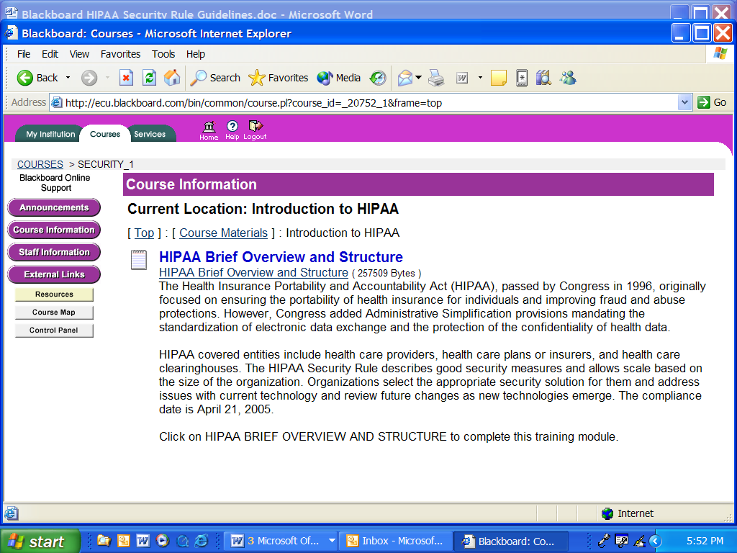

Review the information and click on HIPAA Brief Overview and Structure to complete this section

Course Preview Options:

Click on Slide Show to change to a full display. Press your right-mouse button to scroll through the presentation.
or
Click on the « or » to scroll through the slides
« Slide 1 of # »
or
Click on each numbered chart title to display in the window.

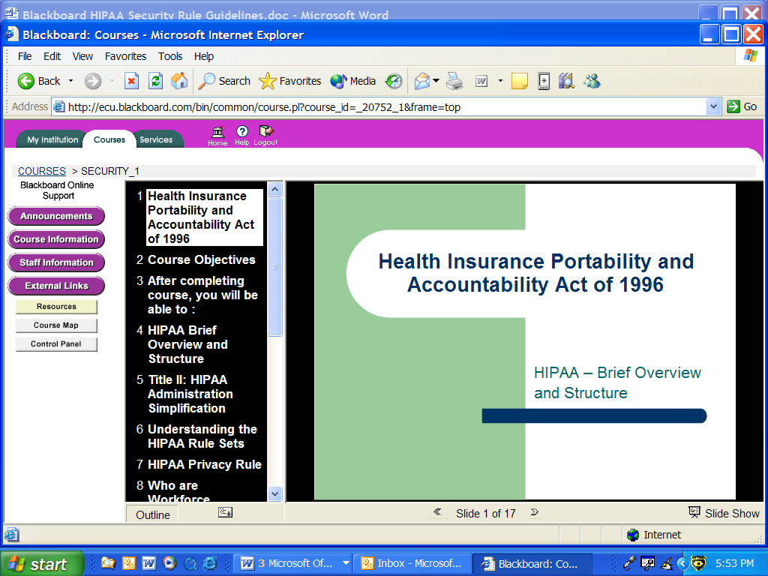
Slideshow

« Slide 1 of 17 »

BACK

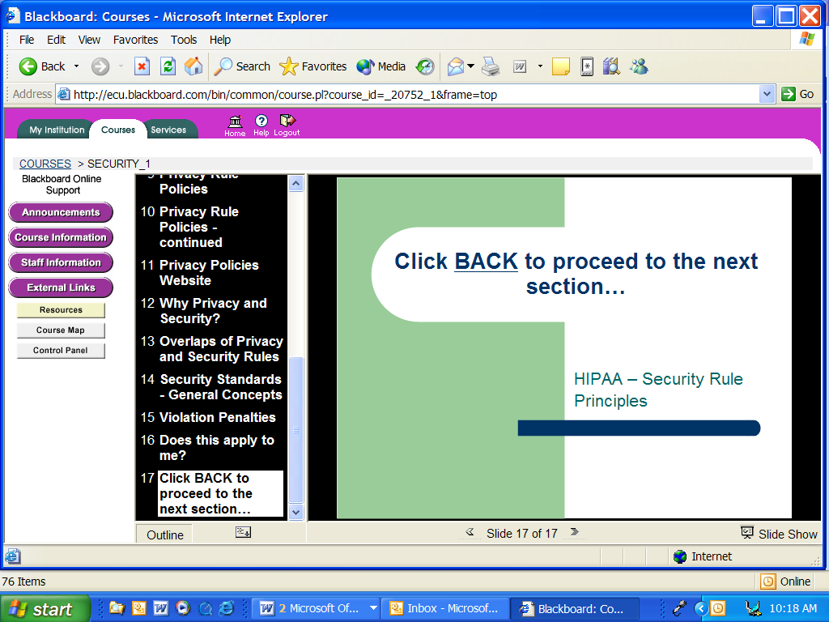

The last chart for each section will display, “Click on the BACK button to proceed to the next section…”

BACK is located on the button bar.

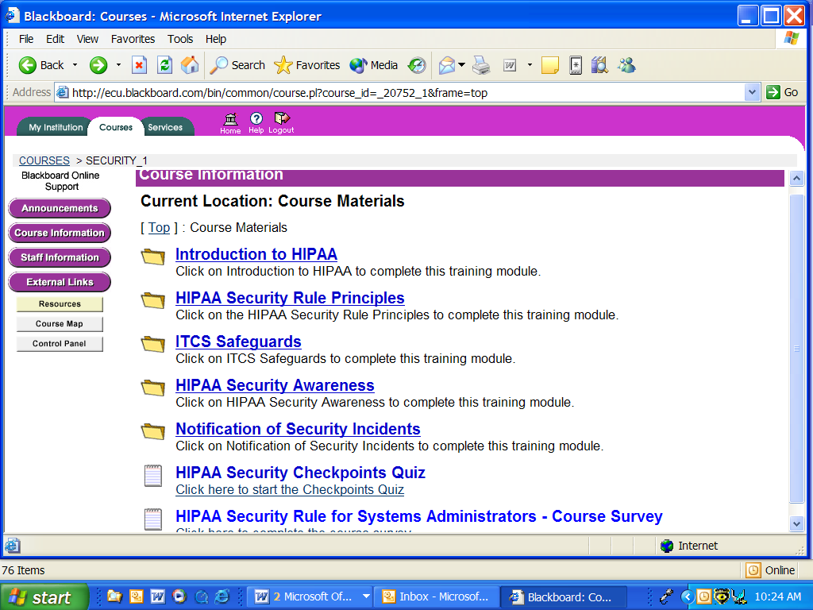

You are back at the Course Materials. Please proceed and complete all of the sections under Course Materials in the same manner, including the Checkpoints Quiz!

The quiz will help reinforce the course information. Feedback will be provided when you click SUBMIT. You are asked to complete the training again if you fail three questions.

Please provide feedback in the course survey.

Thank you for your participation!

One completed, you can close your browser.

If you experience any problems, please contact the Help Desk at 328-9866.

You may need to print each page separately due the printer memory and the number of graphical screenshots.

