Develop/Modify Training Plans
Ver.1.2 7/30/2026 Process Level: Organizational

Summary
Entry Criteria
New position in organization or an existing position lacks a training plan

Purpose
To allow for standardized planning and tracking of training for personnel

Exit Criteria
Completed Training Plan

Inputs  Master Task Listing  Position Descriptions  Process definitions  Work schedules  Workflow diagrams |  | Deliverables  Master Task Listing  Position task breakdown  Position training requirements  Positional training plan
Key Players  Trainees  Supervisors |  | Tools  Training requirement work sheet
1) Develop Master Task Listing by Position
The Master Task Listing (MTL) is the listing of all tasks that are accomplished by the person filling the position. This is the basis of the training plan. It will be used to identify the minimum job tasks that, when trained, makes a person qualified to do their job. The basis of a good Training Plan is that all training is based on identified requirements and that all requirements are based on actual tasks. While sources of training may, and frequently do change, the requirement for the training usually does not. The MTL is a listing of the major tasks involved in carrying out a job for a specific position.

1.1) Survey, Question, or Interview Personnel
The personnel filling the position are surveyed, questioned, and interviewed to gain information (the person who accomplishes a task has the best feel for the requirements of that task). Also query the supervisors – this will help validate the worker’s views and provide tasks that are future requirements for the position.

1.2) Review Existing Documentation
Review existing documentation that may help identify tasks by position. This would include; the MTL for the position, Position Descriptions, work schedules, workflow diagrams, process definitions.

2) Filter the List
Look for tasks that are administrative in nature, or are universal non-position tasks (a possible indicator is if a task is performed outside of, or throughout, the process lifecycle). These tasks should be removed from this listing since you are attempting to create a position specific MTL. The data can be saved by the work center to be included in their documentation.

3) Produce Task Breakdowns
The goal of this step is to break tasks down into the lowest level of task possible. At times this is too much. The best guidance to follow on how far to break down a task follows:
- List only the WHATs, not the HOWs
- If a new person filling the position could identify all the sub-tasks, that is low enough
- If the performance of a sub-task is intuitive, do not list it (under “conducting a meeting”, do not list “attend meeting”)

4) Find Logical Groupings for Tasks
Many times the tasks in the MTL can be grouped under a larger heading. This grouping is designed to equate to the type of course that fulfills the need. Many times minor tasks and sub-tasks are repeated in different processes. These commonalities are documented. If the commonalities occur in multiple areas, it indicates a possible new grouping. After grouping the tasks in a logical manner, the groupings are viewed in relationship to the lifecycle phases of their parent process. This can be accomplished through a table, shading in the phases where the tasks are performed.

5) Prioritize Tasks
The tasks are prioritized in the order that they should be satisfied. The tasks that are the most important to be trained on are identified and the groupings arranged accordingly. The priority of the groupings may mirror the lifecycle phases of the process for which they are needed.

6) Define Training Requirements
Using a table, list every major task identified and their breakdowns. Then for each task, determine the frequency of performance, complexity of task, complexity of learning the task, and the criticality. Each of these factors are rated low (L), medium (M), or high (H).
- Frequency
H= if you do the task daily
M= if you do the task weekly
L = if you do the task less frequently than weekly
b. Complexity of task
H= Extremely difficult to explain
M= Difficult to explain
L = Easy to explain

c. Complexity to learn (or teach)
H= Requires background info, a lot of time and effort
M= Requires some info, and a decent amount of time/effort
L = Easy to learn, can teach myself in less than an hour
d. Criticality
H= if the task must be done right the first time
M= if you can take 2-3 times to get it right
L = if you can take more than 3 tries to get it right

Based on the ratings given to each task, it will be classified as a training requirement or not. The ratings will also assist in determining a recommended method of delivery for training each task.

Training is required (Training Requirement = “Y”) if:
- the “Complexity of Task” or “Complexity to Learn” is high
- both “Complexity of Task” and “Complexity to Learn” are medium
The task is a knowledge training item if “Complexity of Task” or “Complexity to Learn” is high. Knowledge training items are tasks that are complex enough to require written documentation. It is not recommended to train as a hands-on only training task.

Tasks that are not determined to be a training requirement may still require job aids, or checklists, or other tools to help in the performance of the job, but they should not require formal/informal training.

7) Determine Delivery Method
The following list is a recommended minimum based on the ratings determined in the previous step:
Use a check list on the job if “Criticality” is medium or high. Checklists are enumerated lists of subtasks that must be done to complete the overall task. If there are dependencies they should be identified (x has to be done before y). If the ordering of the subtasks are important, they should also be identified. The best checklists will also identify if a subtask is optional or mandatory.
Use a quality check if “Criticality is high.” A quality check is when you have someone check your work to ensure it is correct. Not supervision, but a check – like having someone review a document before you send it out.
Use On-the-Job-Training (OJT) if “Complexity to Learn” is low and it is a training requirement. OJT is another way of saying in-house, informal, one-on-one training. It is not formal and does not indicate the use of printed material. Hands-on training.
Use written, thorough instructions if “Frequency” is low and it is a training requirement. The task requires thorough documentation on how to perform the task.
Use objectives and tests (formal training) if it is a training requirement and “Complexity to Learn” is above low. This can be done in-house, tutored, or online. It can also be accomplished through the more traditional classroom environment.

8) Develop Positional Training Plan
The Positional Training Plan (PTP) is developed from the MTL and other information gathered while building the MTL. Each functional area will have one MTL that may break out into multiple PTPs.

Training requirements can be classified further if it makes planning easier. Some suggested classifications are; Job Qualification Tasks, Professional Development Tasks, Ancillary Tasks, and Additional Training Tasks.

A sample template for a training plan is attached. It was developed in Excel and includes a visual mapping of the skill level of each trainee. It also includes a way to track skill and knowledge level evaluations and goals. One sheet is for training evaluation, the other is for scheduling and tracking training received. The use of the template is explained in the process definition for “Maintaining Training Plans.”

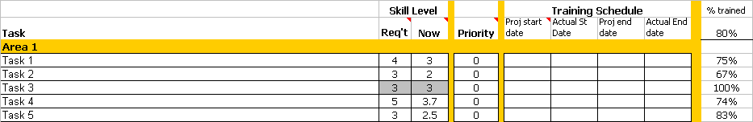

For evaluating skill/knowledge level

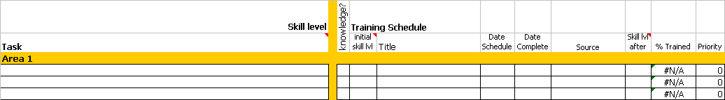

For tracking status of training scheduled/received

Sample of a chart for analysis of training evaluation

