
University of Kentucky College of Agriculture
Proposal
Managed Print Services
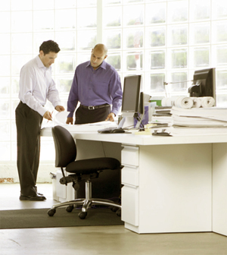
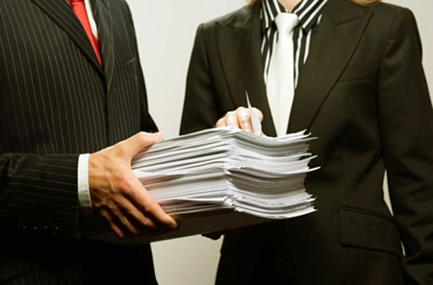


Submitted September 1, 2011
By IKON, A Ricoh Company
Table of Contents
Executive Summary 3
Detailed Summary 4
Current v. Proposed Comparison 13
Appendix 26
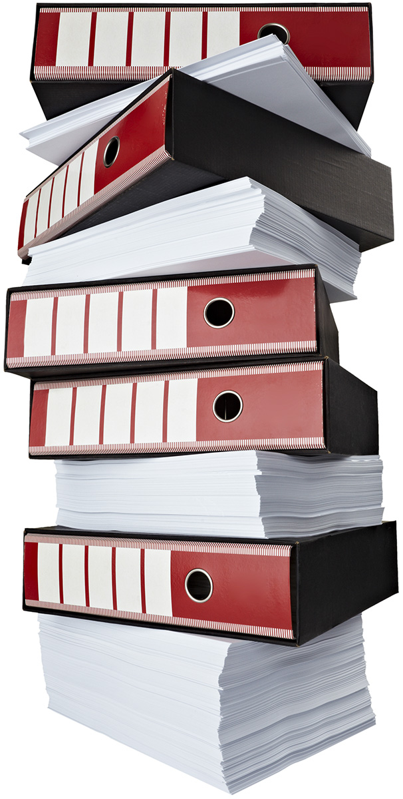
PROPRIETARY & CONFIDENTIAL INFORMATION: The enclosed materials are proprietary to Ricoh Americas Corporation, and Ricoh reserves all right, title, and interest in and to such materials. The terms, conditions, and information set forth herein are confidential to Ricoh and may not be disclosed in any manner to any person other than the addressee, together with its officers, employees, and agents who are directly responsible for evaluating the contents of these materials for the limited purpose intended. These materials may not be used in any manner other than for such limited purpose. Any unauthorized disclosure, use, reproduction, or transmission is expressly prohibited without the prior written consent of Ricoh. © 2011 Ricoh Americas Corporation. All rights reserved.

Executive Summary
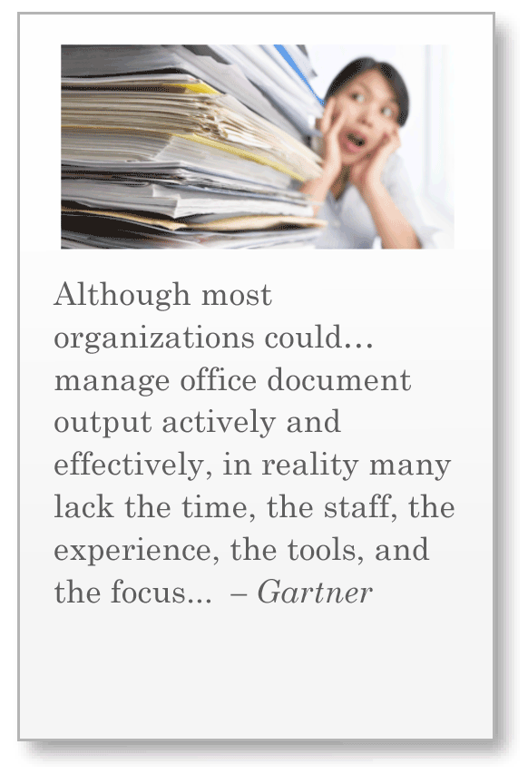
Many institutions struggle to identify existing document output and imaging expenditures. If inefficiently managed, these expenditures can eat away at the operating budget. This happens when there is:
  - Lack of a comprehensive document-related hardware inventory within the organization
  - Unreliable data regarding total print, copy, fax and outsourced document volumes
  - Limited knowledge of user practices and their corresponding financial and environmental impact
This report provides detailed information about the University Of Kentucky College of Agriculture’s current document output systems. The analysis was performed through manual and/or automated collection of device information, volume usage and end-user interaction. It reflects data gathered through interviews, special fleet management tools and also up-to-date trusted third-party (Gap Intelligence, Inc. - refer to Appendix for more info) data where internal cost information was not provided.
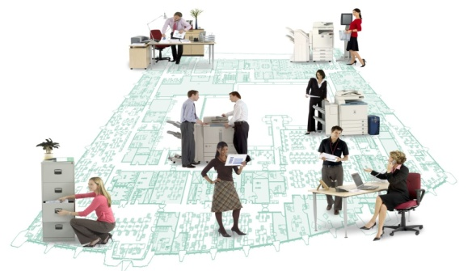
Current Strategy
We analyzed your existing 45 output devices and output volume of 33,125 pages per month (28,655 mono + 4,470 color). Based on these parameters, your organization's projected total cost for document output and imaging is $138,495 over the next 65 months or $2,131 per month. The estimated operational carbon footprint for your current devices is 38,857 lbs of CO2 over 65 months.
Proposed Strategy
After carefully evaluating your current situation - and a potential future output volume of 33,125 pages per month (28,655 mono + 4,470 color) - we propose a transition to 14 output device. The projected total cost is $71,465 over the next 65 months or $1,099 per month. The estimated operational carbon footprint for the proposed devices is 38,857 lbs of CO2 over 65 months.
By implementing this proposed strategy, the College of Agriculture can potentially:
Save $1,031 per month (48.4%)
Save $12,372 per year
Save $67,030 over 65 months
Save 48,763 lbs of CO2 emissions over 65 months

Detailed Summary
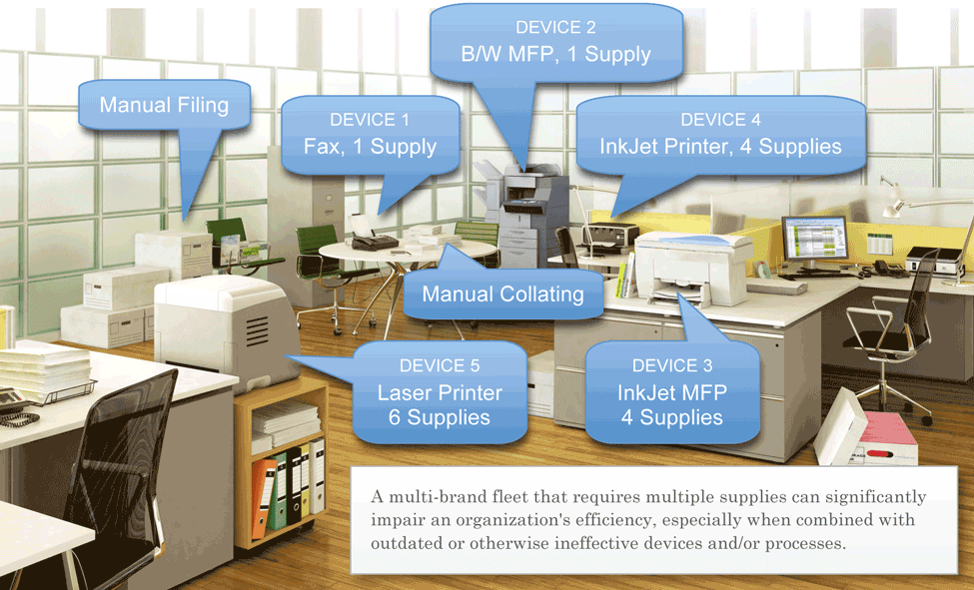
Document Output Systems
Below is a detailed assessment of the current v. proposed strategies for The College of Agriculture’s document output. As illustrated, we propose an optimization of the existing devices--as well as their associated supplies and--in order to enhance both your efficiency and effectiveness.
Note that a common scenario for inefficiency lies in a multi-brand fleet requiring multiple supply items. Simply put, the more brands you have, the more difficult it is to control costs and manage your fleet.

Products | Current | Proposed | Difference | % Change
Total Devices | 45 | 14 | 31 | 68 %
Unique Models | 31 | 10 | 21 | 67 %
Unique Supplies | 63 | 0 | 63 | 100 %
Device Brands | 6 | 4 | 2 | 33 %

Financial Impac
Current Environment – Quantities
The following locations were included in this analysis:
Location | Networked |  | Local/  Stand Alone | Total Devices | Makes | Model | B/W AMV | Color AMV
Agriculture Science Bldg Ground |  | 6 | 6 | 12 | 5 | 11 | 7,331 | 1,111
Agriculture Science Bldg 1st |  | 9 | 22 | 31 | 6 | 15 | 20,936 | 2,068
Agriculture Science Bldg 2nd |  | 1 | 1 | 2 | 2 | 2 | 388 | 1,291
Total |  | 16 | 29 | 45 | 6 | 25 | 28,655 | 4,470

Current Environment – Placement
The quantity and placement of output printing devices for the College of Agriculture are critical variables to consider when balancing employee efficiencies and budget constraints. The following floor plans identify the current output placements as well as the go-forward recommendation from Ricoh.

Agriculture Science Building – Ground Floor

Agriculture Science Building – 1st Floor
Agriculture Science Building – 2nd Floor

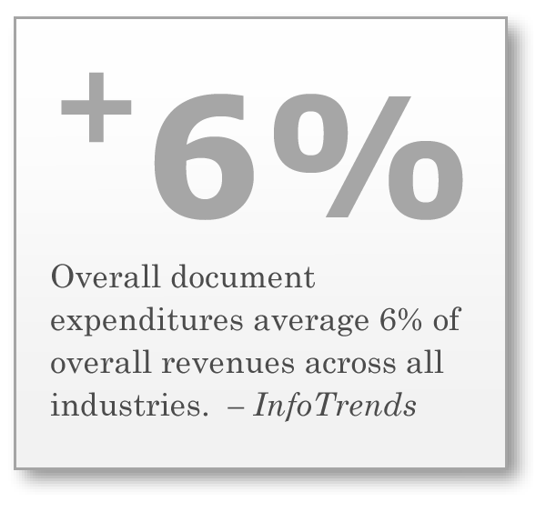
Financial Impact
The tables below reflect data provided by the College of Agriculture as part of this analysis. Missing values are provided by a trusted third-party data source (Gap Intelligence, Inc.--refer to the Appendix for more info) whose pricing was last updated in July, 2011. Considered costs can include products, service, consumables, electricity and paper.
To identify the most significant areas for potential improvement, refer to the Total Cost Per Page (TCPP). TCPP is calculated by adding the entire cost and dividing the results by the total volume produced.

Current Financial Details
 | Qty | Monthly Volume | Annual Volume | % of Volume | Cost Monthly | Cost Annual | % of Cost | TCPP
BW Printer | 19 | 4,927 | 59,124 | 15.00 % | $273 | $3,276 | 13.00 % | $0.0554
Color Printer | 5 | 1,199 | 14,388 | 4.00 % | $184 | $2,208 | 9.00 % | $0.1535
BW MFP | 13 | 19,671 | 236,052 | 59.00 % | $1,045 | $12,540 | 49.00 % | $0.0531
Color MFP | 6 | 6,978 | 83,736 | 21.00 % | $593 | $7,116 | 28.00 % | $0.0850
Inkjet Device | 1 | 250 | 3,000 | 1.00 % | $26 | $312 | 1.00 % | $0.1040
Fax | 1 | 100 | 1,200 | 0.00 % | $10 | $120 | 0.00 % | $0.1000
TOTAL | 45 | 33,125 | 397,500 | 100.00 % | $2,131 | $25,572 | 100.00 % | $0.0643

Proposed Financial Details
 | Qty | Monthly Volume | Annual Volume | % of Volume | Cost Monthly | Cost Annual | % of Cost | TCPP
BW Printer | 1 | 29 | 348 | 0.00 % | $1 | $12 | 0.00 % | $0.0345
Color Printer | 1 | 1,341 | 16,092 | 4.00 % | $91 | $1,092 | 8.00 % | $0.0679
BW MFP | 4 | 11,340 | 136,080 | 34.00 % | $284 | $3,408 | 26.00 % | $0.0250
Color MFP | 8 | 20,415 | 244,980 | 62.00 % | $722 | $8,664 | 66.00 % | $0.0354
Inkjet Device | 0 | 0 | 0 | 0.00 % | $0 | $0 | 0.00 % | $0.0000
Fax | 0 | 0 | 0 | 0.00 % | $0 | $0 | 0.00 % | $0.0000
TOTAL | 14 | 33,125 | 397,500 | 100.00 % | $1,098 | $13,176 | 100.00 % | $0.0331

Cost Types Over 65 Months
The following is an overview of the College of Agriculture’s future costs--and potential savings--by cost type based upon the current document output activity. Cost savings can be achieved by transitioning to Ricoh’s MPS service plan that: (a) offer a fixed cost per page; and (b) include toner and supplies, reducing the need to pay for additional consumables.
 | Cost Factors | Current Cost | Proposed Cost | Saving | Monthly Saving | Total Savings (65 Months)
 | Product | $59,375 | $0 | 100.00 % | $913 | $59,375
 | Service | $5,382 | $60,496 | -1,024.04 % | -$848 | -$55,114
 | Consumables | $60,072 | $0 | 100.00 % | $924 | $60,072
 | Electricity | $2,902 | $743 | 74.40 % | $33 | $2,159
 | Paper | $10,764 | $10,226 | 5.00 % | $8 | $538
 | Total Cost | $138,495 | $71,465 | 48.40 % | $1,031 | $67,030

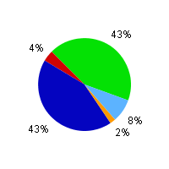 | 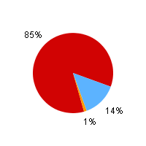
Current | Proposed

Cumulative Cost v. Number of Months
The chart below illustrates the cumulative costs over the projected time frame in the analysis.
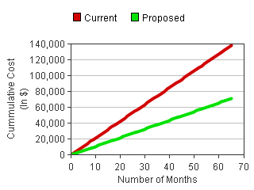
Monthly Cost v. Monthly Page Volume
Perpetual market fluctuations ensure that the only constant we can rely on is change. The following chart details projected cost comparison information should your volume decrease or increase by 50%.
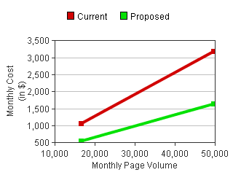

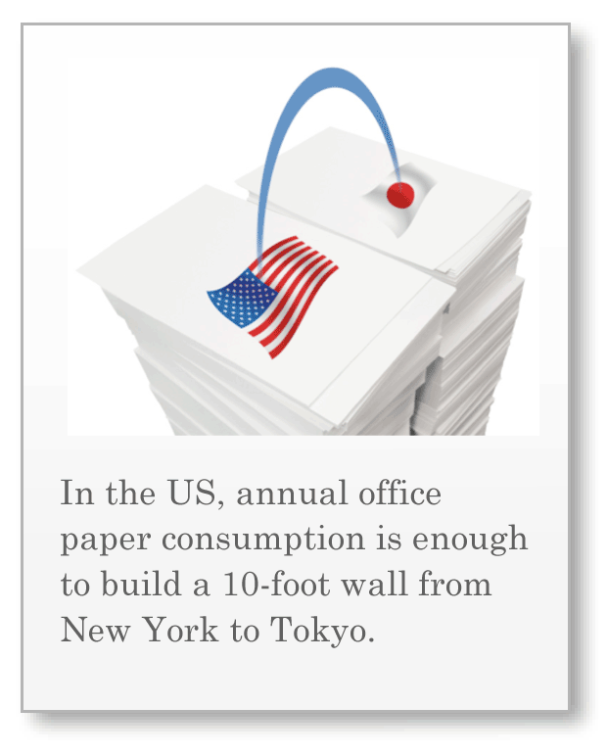
Environmental Impact
The tables below reflect the estimated operational carbon footprint for your output devices. It takes into account the CO2 that is indirectly emitted through the generation of electricity used and/or the manufacturing of paper consumed. Keep in mind that--when it comes to power and paper usage--reductions in environmental impact go hand-in-hand with reductions in economic impact...by reducing your carbon footprint, you also reduce your costs.
We minimize paper usage by employing features such as automatic duplexing, scanning and 2-up printing/copying. We optimize electricity consumption by replacing older devices (which typically consume much more electricity), or newer devices that are not Energy Star qualified and removing excess devices (a printer on everyone's desk)
The data below employs information published by the US Environmental Protection Agency (EPA) and the Department of Energy (DOE). For more details, see Carbon Footprint Methodology in the Appendix.

Current Environmental Impact
 | Qty | Electricity CO2 | Paper CO2 | % Total CO2 | Trees Needed to Offset CO2 | Paper Cost | Electricity Cost
BW Printer | 19 | 15,261 | 3,522 | 21 | 248 | $1,601 | $693
Color Printer | 5 | 9,111 | 857 | 11 | 130 | $389 | $413
BW MFP | 13 | 24,408 | 14,065 | 44 | 507 | $6,392 | $1,108
Color MFP | 6 | 15,156 | 4,989 | 23 | 266 | $2,268 | $688
Inkjet Device | 1 | 0 | 179 | 0 | 2 | $81 | $0
Fax | 1 | 0 | 72 | 0 | 1 | $33 | $0
TOTAL | 45 | 63,936 | 23,684 | 100 | 1,154 | $10,764 | $2,902

Proposed Environmental Impact
 | Qty | Electricity CO2 | Paper CO2 | % Total CO2 | Trees Needed to Offset CO2 | Paper Cost | Electricity Cost
BW Printer | 1 | 602 | 21 | 2 | 8 | $9 | $27
Color Printer | 1 | 0 | 911 | 2 | 12 | $414 | $0
BW MFP | 4 | 5,416 | 7,703 | 34 | 174 | $3,501 | $246
Color MFP | 8 | 10,338 | 13,866 | 62 | 319 | $6,302 | $470
Inkjet Device | 0 | 0 | 0 | 0 | 0 | $0 | $0
Fax | 0 | 0 | 0 | 0 | 0 | $0 | $0
TOTAL | 14 | 16,356 | 22,501 | 100 | 513 | $10,226 | $743

Current v. Proposed Comparison
Technological advancements over the last several years have yielded an array of output technologies to meet the diverse needs of the personal and business consumer. Furthermore, these technological enhancements have started to blur the lines between devices designed to meet the needs of the personal and business consumer. With such a variety of device types available, an institution can soon find itself with devices that don't match their department needs.
The section below summarizes the different types of output devices and their associated costs and volumes.
Fleet Statistics
Number of Units by Device Type
By consolidating the types of devices--focusing only on those that actually meet their business needs--an organization can streamline costs while creating greater document output efficiencies.
Current Units
 | Device Type | Current Units | Proposed Units
 | Mono MFP | 13 | 4
 | Mono Printer | 19 | 1
 | Color MFP | 6 | 8
 | Color Printer | 5 | 1
 | Inkjet MFP | 0 | 0
 | Inkjet Printer | 1 | 0
 | Fax | 1 | 0
 | Total | 45 | 14

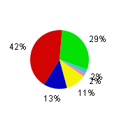
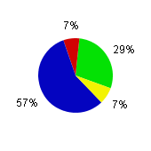

Proposed Units

Monthly Cost by Device Type
Certain device types may carry a higher cost due to more intense service and supply needs. For example, when devices that are designed to support a Small Office Home Office (SOHO) environment, are actually used in a department workgroup environment the result is often additional costs due to lost productivity combined with shorter product and supply lifecycles.
 | Device Type | Current Cost | Proposed Cost
 | Mono MFP | $1,045 | $284
 | Mono Printer | $273 | $1
 | Color MFP | $593 | $722
 | Color Printer | $184 | $91
 | Inkjet MFP | $0 | $0
 | Inkjet Printer | $26 | $0
 | Fax | $10 | $0
 | Total | $2,131 | $1,098

Total Cost Per Page (TCPP) by Device Type
Analyzing the TCPP of each device type helps to identify those device types that do not provide a favorable return on investment (ROI). By reducing the number of devices that have a higher TCPP--or shifting volumes to devices that have a lower TCPP--we can greatly reduce the overall costs of document production within the institution. TCPP may include output costs, such as hardware, service, supplies, paper and electricity.
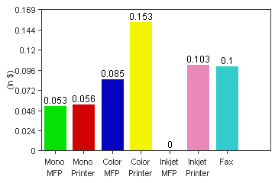 | 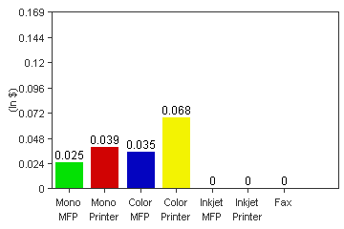
Current TCPP | Proposed TCPP

Total Volume by Device Type Over 65 Months
In order to create additional savings, it's ideal for an institution to shift document volume to devices that are more cost-effective. Although initial monthly volume and cost projections may seem modest, calculating them over a longer time frame can reveal the opportunity for substantial savings.
 | Device Type | Current Volume | Proposed Volume
 | Mono MFP | 1,278,615 | 737,100
 | Mono Printer | 320,255 | 1,885
 | Color MFP | 453,570 | 1,326,975
 | Color Printer | 77,935 | 87,165
 | Inkjet MFP | 0 | 0
 | Inkjet Printer | 16,250 | 0
 | Fax | 6,500 | 0
 | Total | 2,153,125 | 2,153,125

Devices by Output Speeds
The following chart illustrates the breakdown of the fleet by output speed. Faster devices can help to maintain productivity in a busy workgroup environment and can deliver a lower cost per page. On average, slower devices typically deliver a higher cost per page and increase overall cost.
 | Output Speed | Current Mono Units | Proposed Mono Units | Current Color Units | Proposed Color Units
 | 1-15 ppm | 2 | 0 | 2 | 0
 | 16-30 ppm | 17 | 4 | 2 | 3
 | 31-45 ppm | 10 | 1 | 9 | 6
 | 46-60 ppm | 3 | 0 | 0 | 0
 | 61-75 ppm | 0 | 0 | 0 | 0
 | 76-90 ppm | 0 | 0 | 0 | 0
 | 91+ ppm | 0 | 0 | 0 | 0
 | Undefined | 0 | 0 | 0 | 0
 | Total | 32 | 5 | 13 | 9

Device Details
This section provides a detailed snapshot of the future costs associated with each Current and Proposed device over the next 65 months. Migrating volume to devices with the lowest possible Total Cost Per Page (TCPP) should be an organization's objective when striving to contain output costs.
Current Model Model | Qty | Volume - All Units |  | TCPP | 65 Month Total Cost | Avg Monthly Cost | Product Cost | Service Cost | Consumables Cost | Consumables CPP |  | Paper Cost | Electricity Cost
Current Model Model | Qty | Total | %Color |  |  |  |  |  |  | Mono | Color | Paper Cost | Electricity Cost
Brother DCP 8060 | 1 | 22,555 | 0 | 0.0496 | $1,119 | $17 | $449 | $0 | $485 | 0.0215 | 0 | $113 | $72
Brother DCP 8080DN | 1 | 31,395 | 0 | 0.0359 | $1,128 | $17 | $263 | $0 | $628 | 0.02 | 0 | $157 | $80
Canon imageRUNNER 5000 | 1 | 312,195 | 0 | 0.0392 | $12,238 | $188 | $8,700 | $1,873 | $0 | NA | NA | $1,561 | $104
Canon imageRUNNER 5055 | 1 | 252,785 | 0 | 0.0582 | $14,722 | $226 | $11,690 | $1,517 | $0 | NA | NA | $1,264 | $251
Dell 1815dn MFP | 2 | 75,010 | 0 | 0.0357 | $2,679 | $41 | $599 | $0 | $1,583 | 0.0211 | 0 | $375 | $122
Dell 3110CN | 1 | 17,225 | 67 | 0.1122 | $1,932 | $30 | $374 | $0 | $1,406 | 0.0187 | 0.1129 | $86 | $66
Dell 3115cn MFP | 6 | 453,570 | 49 | 0.0849 | $38,519 | $593 | $3,056 | $0 | $32,507 | 0.0196 | 0.1251 | $2,268 | $688
Dell 5100CN | 1 | 18,655 | 62 | 0.1113 | $2,076 | $32 | $749 | $0 | $1,114 | 0.0111 | 0.0899 | $93 | $120
HP Fax 1040 | 1 | 6,500 | 0 | 0.1005 | $653 | $10 | $74 | $0 | $546 | 0.084 | 0 | $33 | $0
HP Color LaserJet 3550 | 1 | 16,380 | 95 | 0.1907 | $3,123 | $48 | $566 | $0 | $2,401 | 0.0318 | 0.1523 | $82 | $74
HP LaserJet 1320 | 1 | 17,940 | 0 | 0.078 | $1,400 | $22 | $757 | $0 | $520 | 0.029 | 0 | $90 | $33
HP LaserJet 3380 | 2 | 63,830 | 0 | 0.048 | $3,063 | $47 | $674 | $0 | $1,991 | 0.0312 | 0 | $319 | $79
HP LaserJet 4050 | 2 | 6,760 | 0 | 0.2751 | $1,860 | $29 | $1,649 | $0 | $122 | 0.018 | 0 | $34 | $55
HP LaserJet 4345 MFP | 1 | 185,055 | 0 | 0.0352 | $6,522 | $100 | $2,438 | $0 | $3,016 | 0.0163 | 0 | $925 | $143
HP LaserJet 5n | 1 | 5,460 | 0 | 0.056 | $306 | $5 | $199 | $0 | $67 | 0.0122 | 0 | $27 | $13
HP LaserJet P1505 | 1 | 6,695 | 0 | 0.0835 | $559 | $9 | $192 | $0 | $313 | 0.0468 | 0 | $33 | $21
HP LaserJet P3005 | 3 | 113,490 | 0 | 0.0422 | $4,784 | $74 | $1,555 | $0 | $2,508 | 0.0221 | 0 | $567 | $154
Lexmark E 321 | 1 | 17,940 | 0 | 0.047 | $843 | $13 | $224 | $0 | $502 | 0.028 | 0 | $90 | $27
Lexmark T 520 | 1 | 14,885 | 0 | 0.0639 | $951 | $15 | $524 | $0 | $320 | 0.0215 | 0 | $74 | $33
Lexmark T 640 | 1 | 17,940 | 0 | 0.0604 | $1,084 | $17 | $562 | $0 | $373 | 0.0208 | 0 | $90 | $59
Lexmark X 364dn MFP | 1 | 73,255 | 0 | 0.039 | $2,855 | $44 | $413 | $0 | $2,000 | 0.0273 | 0 | $366 | $76
Ricoh Aficio MP 5000SPF | 1 | 138,450 | 0 | 0.1112 | $15,389 | $237 | $13,303 | $1,315 | $0 | NA | NA | $692 | $79
HP Color LaserJet 4650 | 1 | 25,610 | 72 | 0.1706 | $4,370 | $67 | $1,698 | $0 | $2,457 | 0.0261 | 0.1237 | $128 | $87
HP LaserJet 1320 | 1 | 10,335 | 0 | 0.074 | $765 | $12 | $378 | $0 | $302 | 0.0292 | 0 | $52 | $33
Dell 1720 | 1 | 34,255 | 0 | 0.0325 | $1,112 | $17 | $149 | $0 | $750 | 0.0219 | 0 | $171 | $42
Dell 3110CN | 1 | 65 | 0 | 6.7846 | $441 | $7 | $374 | $0 | $1 | 0.0187 | 0.1129 | $0 | $66
HP LaserJet 1320 | 1 | 2,470 | 0 | 0.2004 | $495 | $8 | $378 | $0 | $72 | 0.0292 | 0 | $12 | $33
Lexmark E 250d | 1 | 520 | 0 | 0.4596 | $239 | $4 | $179 | $0 | $18 | 0.0352 | 0 | $3 | $39
HP LaserJet 4+ | 1 | 16,250 | 0 | 0.0265 | $431 | $7 | $150 | $0 | $187 | 0.0115 | 0 | $81 | $13
HP DeskJet 720c | 1 | 16,250 | 60 | 0.1027 | $1,669 | $26 | $90 | $0 | $1,498 | 0.0451 | 0.1236 | $81 | $0
HP LaserJet 1300 | 1 | 16,120 | 0 | 0.056 | $903 | $14 | $299 | $0 | $493 | 0.0306 | 0 | $81 | $30
Dell 2230D | 1 | 35,295 | 0 | 0.0484 | $1,707 | $26 | $104 | $0 | $1,373 | 0.0389 | 0 | $176 | $54
Dell 2230D | 1 | 3,900 | 0 | 0.0846 | $330 | $5 | $104 | $0 | $152 | 0.0389 | 0 | $20 | $54
Brother MFC 7820N | 1 | 11,245 | 0 | 0.058 | $652 | $10 | $180 | $0 | $367 | 0.0326 | 0 | $56 | $49
Canon imageRUNNER 3245 | 1 | 112,840 | 0 | 0.0671 | $7,576 | $117 | $6,282 | $677 | $0 | NA | NA | $564 | $53
Total | 45 | 2,153,125 | 11.57 | 0.0643 | $138,495 | $2,131 | $59,375 | $5,382 | $60,072 | 0.0128 | 0.1245 | $10,764 | $2,902

Proposed Model | Qty | Volume - All Units |  | TCPP | 65 Month Total Cost | Avg Monthly Cost | Product Cost | Service Cost | Consumables Cost | Consumables CPP |  | Paper Cost | Electricity Cost
Proposed Model | Qty | Total | %Color |  |  |  |  |  |  | Mono | Color | Paper Cost | Electricity Cost
Ricoh Aficio MP C3501 | 1 | 321,555 | 6 | 0.0283 | $9,106 | $140 | $0 | $7,543 | $0 | NA | NA | $1,527 | $36
Ricoh Aficio MP C2551 | 1 | 325,130 | 14 | 0.0332 | $10,790 | $166 | $0 | $9,221 | $0 | NA | NA | $1,544 | $25
Ricoh Aficio MP C2051 | 2 | 415,740 | 6 | 0.0285 | $11,829 | $182 | $0 | $9,789 | $0 | NA | NA | $1,975 | $65
Ricoh Aficio MP 2851SP | 2 | 591,890 | 0 | 0.0249 | $14,758 | $227 | $0 | $11,838 | $0 | NA | NA | $2,811 | $109
Lexmark X738 | 1 | 40,040 | 29 | 0.042 | $1,681 | $26 | $0 | $1,491 | $0 | NA | NA | $190 | $0
Lexmark C734DN | 1 | 87,165 | 72 | 0.0682 | $5,944 | $91 | $0 | $5,530 | $0 | NA | NA | $414 | $0
Dell 3115cn MFP | 3 | 224,510 | 57 | 0.0604 | $13,552 | $208 | $0 | $12,142 | $0 | NA | NA | $1,066 | $344
Dell 1815dn MFP | 1 | 37,505 | 0 | 0.0264 | $989 | $15 | $0 | $750 | $0 | NA | NA | $178 | $61
HP LaserJet 4050 | 1 | 1,885 | 0 | 0.0393 | $74 | $1 | $0 | $38 | $0 | NA | NA | $9 | $27
Lexmark X 364dn MFP | 1 | 107,705 | 0 | 0.0255 | $2,742 | $42 | $0 | $2,154 | $0 | NA | NA | $512 | $76
Total | 14 | 2,153,125 | 18.4 | 0.0332 | $71,465 | $1,099 | $0 | $60,496 | $0 | 0 | 0 | $10,226 | $743

Consumable Details
The consumable Cost Per Page (CPP) is based upon the supply cost divided by the manufacturer's published supply yields. Manufacturer supply yields are based upon a page coverage that can range from 3%-5%. The CPP by default assumes 8% coverage for mono pages and 30% for color pages. If actual page coverage information is provided by the customer, those coverage percentages are used when calculating CPP rates. The actual coverage used to calculate the CPP is listed in the attached table.
The CPP rates in the attached table include only supplies and maintenance kits, not supply inclusive service contracts. Thus, devices with a supply inclusive contract are not listed. A supply inclusive contract protects organizations from unpredictable costs due to variable page coverage. The goal is to maintain a constant and predictable cost over time, helping organizations plan and stay within budget.
CPP Rates of Current Devices
Current - Consumable Items | Mono Yield | Color Yield | Price | Mono CPP | Color CPP
Brother DCP 8060 ( Avg. Page Coverage: Mono 8% )
DR-520 - Black Drum | 25,000 | 0 | $119 | 0.0047 | 0
TN-580 - Black Toner | 7,000 | 0 | $73 | 0.0167 | 0
Total |  |  |  | 0.0215 | 0
Brother DCP 8080DN ( Avg. Page Coverage: Mono 8% )
DR620 - Black Drum | 25,000 | 0 | $93 | 0.0037 | 0
TN650 - Black Toner | 8,000 | 0 | $81 | 0.0163 | 0
Total |  |  |  | 0.02 | 0
Dell 1815dn MFP ( Avg. Page Coverage: Mono 8% )
PF658 310-7945 - Black Toner | 5,000 | 0 | $66 | 0.0211 | 0
Total |  |  |  | 0.0211 | 0
Dell 3110CN ( Avg. Page Coverage: Mono 8% , Color 30%)
XG721 310-8092 - Black Toner | 8,000 | 8,000 | $94 | 0.0188 | 0.0176
XG722 310-8094 - Cyan Toner | N/A | 8,000 | $170 | 0 | 0.0318
XG723 310-8096 - Magenta Toner | N/A | 8,000 | $170 | 0 | 0.0318
XG724 310-8098 - Yellow Toner | N/A | 8,000 | $170 | 0 | 0.0318
Total |  |  |  | 0.0187 | 0.1129
Dell 3115cn MFP ( Avg. Page Coverage: Mono 8% , Color 30%)
XG721 310-8395 - Black Toner | 8,000 | 8,000 | $98 | 0.0196 | 0.0184
XG722 310-8397 - Cyan Toner | N/A | 8,000 | $190 | 0 | 0.0356
XG723 310-8399 - Magenta Toner | N/A | 8,000 | $190 | 0 | 0.0356
XG724 310-8401 - Yellow Toner | N/A | 8,000 | $190 | 0 | 0.0356
Total |  |  |  | 0.0196 | 0.1251
Dell 5100CN ( Avg. Page Coverage: Mono 8% , Color 30%)
310-5814 - Transfer Roller | 35,000 | 35,000 | $23 | 0.0006 | 0.0006
H7028 310-5807 - Black Toner | 9,000 | 9,000 | $42 | 0.0075 | 0.007
H7029 310-5810 - Cyan Toner | N/A | 8,000 | $141 | 0 | 0.0264
H7030 310-5808 - Yellow Toner | N/A | 8,000 | $141 | 0 | 0.0264
H7031 310-5809 - Magenta Toner | N/A | 8,000 | $141 | 0 | 0.0264
H7032 310-5811 - CMYK Drum | 35,000 | 35,000 | $105 | 0.003 | 0.003
Total |  |  |  | 0.0111 | 0.0899
HP Fax 1040 ( Avg. Page Coverage: Mono 8% , Color 30%)
C6614DN - Black Ink | 500 | 0 | $26 | 0.084 | 0
Total |  |  |  | 0.084 | 0
HP Color LaserJet 3550 ( Avg. Page Coverage: Mono 8% , Color 30%)
Q2670A - Black Toner | 6,000 | 6,000 | $111 | 0.0296 | 0.0278
Q2671A - Cyan Toner | N/A | 4,000 | $109 | 0 | 0.0408
Q2672A - Yellow Toner | N/A | 4,000 | $109 | 0 | 0.0408
Q2673A - Magenta Toner | N/A | 4,000 | $109 | 0 | 0.0408
Q3655A - Fuser Maint. Kit | 60,000 | 60,000 | $59 | 0.001 | 0.001
Q3658A - Transfer Maint. Kit | 60,000 | 60,000 | $71 | 0.0012 | 0.0012
Total |  |  |  | 0.0318 | 0.1523
HP LaserJet 1320 ( Avg. Page Coverage: Mono 8% )
Q5949X - Black Toner | 6,000 | 0 | $109 | 0.029 | 0
Total |  |  |  | 0.029 | 0
HP LaserJet 3380 ( Avg. Page Coverage: Mono 8% )
C7115X - Black Toner | 3,500 | 0 | $68 | 0.0312 | 0
Total |  |  |  | 0.0312 | 0
HP LaserJet 4050 ( Avg. Page Coverage: Mono 8% )
C4118-67909 - Fuser Maint. Kit | 200,000 | 0 | $136 | 0.0007 | 0
C4127X - Black Toner | 10,000 | 0 | $108 | 0.0173 | 0
Total |  |  |  | 0.018 | 0
HP LaserJet 4345 MFP ( Avg. Page Coverage: Mono 8% )
Q5945A - Black Toner | 18,000 | 0 | $171 | 0.0152 | 0
Q5998A - Fuser Maint. Kit | 225,000 | 0 | $238 | 0.0011 | 0
Total |  |  |  | 0.0163 | 0
HP LaserJet 5n ( Avg. Page Coverage: Mono 8% )
92298X - Black Toner | 8,800 | 0 | $60 | 0.0109 | 0
C3916-67912 - Fuser Maint. Kit | 200,000 | 0 | $253 | 0.0013 | 0
Total |  |  |  | 0.0122 | 0
HP LaserJet P1505 ( Avg. Page Coverage: Mono 8% )
CB436A - Black Toner | 2,000 | 0 | $59 | 0.0468 | 0
Total |  |  |  | 0.0468 | 0
HP LaserJet P3005 ( Avg. Page Coverage: Mono 8% )
Q7551X - Black Toner | 13,000 | 0 | $179 | 0.0221 | 0
Total |  |  |  | 0.0221 | 0
Lexmark E 321 ( Avg. Page Coverage: Mono 8% )
12A7405 - Black Toner | 6,000 | 0 | $105 | 0.028 | 0
Total |  |  |  | 0.028 | 0
Lexmark T 520 ( Avg. Page Coverage: Mono 8% )
12A6835 - Black Toner | 20,000 | 0 | $255 | 0.0204 | 0
99A2420 - Fuser Maint. Kit | 250,000 | 0 | $265 | 0.0011 | 0
Total |  |  |  | 0.0215 | 0
Lexmark T 640 ( Avg. Page Coverage: Mono 8% )
40X0100 - Fuser Maint. Kit | 300,000 | 0 | $229 | 0.0008 | 0
64015HA - Black Toner | 21,000 | 0 | $262 | 0.02 | 0
Total |  |  |  | 0.0208 | 0
Lexmark X 364dn MFP ( Avg. Page Coverage: Mono 8% )
40X5400 - Fuser Maint. Kit | 120,000 | 0 | $120 | 0.001 | 0
E260X22G - Black Drum | 30,000 | 0 | $23 | 0.0008 | 0
X264H11G - Black Toner | 9,000 | 0 | $144 | 0.0255 | 0
Total |  |  |  | 0.0273 | 0
HP Color LaserJet 4650 ( Avg. Page Coverage: Mono 8% , Color 30%)
C9720A - Black Toner | 9,000 | 9,000 | $130 | 0.0232 | 0.0217
C9721A - Cyan Toner | N/A | 8,000 | $176 | 0 | 0.033
C9722A - Yellow Toner | N/A | 8,000 | $176 | 0 | 0.033
C9723A - Magenta Toner | N/A | 8,000 | $176 | 0 | 0.033
Q3675A - Transfer Maint. Kit | 120,000 | 120,000 | $177 | 0.0015 | 0.0015
Q3676A - Fuser Maint. Kit | 150,000 | 150,000 | $206 | 0.0014 | 0.0014
Total |  |  |  | 0.0261 | 0.1237
HP LaserJet 1320 ( Avg. Page Coverage: Mono 8% )
Q5949X - Black Toner | 6,000 | 0 | $109 | 0.0292 | 0
Total |  |  |  | 0.0292 | 0
Dell 1720 ( Avg. Page Coverage: Mono 8% )
GR332 310-8700 - Black Toner | 6,000 | 0 | $77 | 0.0206 | 0
MW685 310-8703 - Black Drum | 30,000 | 0 | $38 | 0.0013 | 0
Total |  |  |  | 0.0219 | 0
Dell 3110CN ( Avg. Page Coverage: Mono 8% , Color 30%)
XG721 310-8092 - Black Toner | 8,000 | 8,000 | $94 | 0.0187 | 0.0176
XG722 310-8094 - Cyan Toner | N/A | 8,000 | $169 | 0 | 0.0318
XG723 310-8096 - Magenta Toner | N/A | 8,000 | $169 | 0 | 0.0318
XG724 310-8098 - Yellow Toner | N/A | 8,000 | $169 | 0 | 0.0318
Total |  |  |  | 0.0187 | 0.1129
HP LaserJet 1320 ( Avg. Page Coverage: Mono 8% )
Q5949X - Black Toner | 6,000 | 0 | $109 | 0.0292 | 0
Total |  |  |  | 0.0292 | 0
Lexmark E 250d ( Avg. Page Coverage: Mono 8% )
E250A11A - Black Toner | 3,500 | 0 | $75 | 0.0342 | 0
E250X22G - Black Drum | 30,000 | 0 | $28 | 0.0009 | 0
Total |  |  |  | 0.0352 | 0
HP LaserJet 4+ ( Avg. Page Coverage: Mono 8% )
92298X - Black Toner | 8,800 | 0 | $60 | 0.0109 | 0
C2037A-PNO - Fuser Maint. Kit | 200,000 | 0 | $113 | 0.0006 | 0
Total |  |  |  | 0.0115 | 0
HP DeskJet 720c ( Avg. Page Coverage: Mono 8% , Color 30%)
51645A - Black Ink | 930 | 930 | $26 | 0.0451 | 0.0423
C1823D - CMY Ink | N/A | 620 | $34 | 0 | 0.0813
Total |  |  |  | 0.0451 | 0.1236
HP LaserJet 1300 ( Avg. Page Coverage: Mono 8% )
Q2613X - Black Toner | 4,000 | 0 | $76 | 0.0306 | 0
Total |  |  |  | 0.0306 | 0
Dell 2230D ( Avg. Page Coverage: Mono 8% )
DM631 330-4133 - Black Drum | 30,000 | 0 | $27 | 0.0009 | 0
P579K 330-4131 - Black Toner | 3,500 | 0 | $83 | 0.0381 | 0
Total |  |  |  | 0.0389 | 0
Dell 2230D ( Avg. Page Coverage: Mono 8% )
DM631 330-4133 - Black Drum | 30,000 | 0 | $27 | 0.0009 | 0
P579K 330-4131 - Black Toner | 3,500 | 0 | $83 | 0.0381 | 0
Total |  |  |  | 0.0389 | 0
Brother MFC 7820N ( Avg. Page Coverage: Mono 8% )
DR350 - Black Drum | 12,000 | 0 | $75 | 0.0062 | 0
TN350 - Black Toner | 2,500 | 0 | $41 | 0.0264 | 0
Total |  |  |  | 0.0326 | 0

Carbon Footprint
Today, many institutions seek ways to help reduce their impact on the environment. In order to lower their environmental impact while raising their environmental image, these institutions are exploring ways to limit carbon emissions. Electricity consumption related to document output and document imaging can produce a substantial amount of carbon.
The estimated electricity consumption and resulting carbon emissions detailed below are based upon the Typical Electricity Consumption (TEC) of output devices and the manufacturing of the paper that's used in the printing/copying process. Due to limited TEC data, Inkjet products -- and standalone fax machine are excluded. For more details on carbon emissions see the Carbon Footprint Methodology in the Appendix.
CO2 Emissions From Electricity and Paper (65 Months)
The chart below highlights the carbon emissions from electricity and paper. The overall objective is to reduce CO2 emissions in each category by using devices that consume less electricity and have efficient paper-saving features such as duplexing (two-sided printing) and/or 2-Up printing (two originals on the same single side of output)
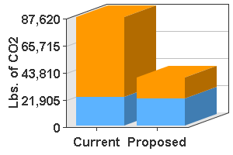 | 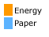
CO2 Emissions By Device Type (65 Months)
The chart below highlights the carbon emissions for each device type. Certain devices may use more electricity than others or have fewer paper-saving measures thus increasing their CO2 emissions. The overall strategy is to reduce the total fleet CO2 emissions.
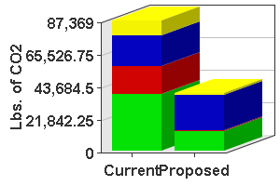 | 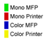
Carbon Footprint Details
The estimated electricity consumption and resulting carbon emissions detailed below is based upon Typical Electricity Consumption (TEC) of the output devices and the manufacturing of the paper. The table attached also illustrates the number of trees required to both (a) offset the subsequent emissions produced and (b) produce the paper consumed in the production process.
Current Models | Qty | 65 Month Total CO2 Emissions (lbs) (All Units) | 65 Month Electricity Impact |  |  | 65 Month Paper Impact
Current Models | Qty | 65 Month Total CO2 Emissions (lbs) (All Units) | CO2 Emissions (lbs) | # of Trees To Offset CO2 Emissions | Electricity (kWh) | CO2 Emissions (lbs) | # of Trees To Offset CO2 Emissions | Sheets of Paper | Duplex % Output | # of Trees To Make Paper
Brother DCP 8060 | 1 | 1,835 | 1,587 | 21 | ~1,044 | 248 | 3 | 22,555 | 0% | 3
Brother DCP 8080DN | 1 | 2,101 | 1,756 | 23 | 1,155 | 345 | 5 | 31,395 | 0% | 4
Canon imageRUNNER 5000 | 1 | 5,735 | 2,301 | 30 | ~1,514 | 3,434 | 45 | 312,195 | 0% | 37
Canon imageRUNNER 5055 | 1 | 8,305 | 5,524 | 73 | 3,634 | 2,781 | 37 | 252,785 | 0% | 30
Dell 1815dn MFP | 2 | 3,512 | 2,687 | 35 | ~1,768 | 825 | 11 | 75,010 | 0% | 9
Dell 3110CN | 1 | 1,645 | 1,456 | 19 | 958 | 189 | 2 | 17,225 | 0% | 2
Dell 3115cn MFP | 6 | 20,145 | 15,156 | 200 | 9,971 | 4,989 | 66 | 453,570 | 0% | 54
Dell 5100CN | 1 | 2,854 | 2,649 | 35 | ~1,743 | 205 | 3 | 18,655 | 0% | 2
HP Fax 1040 | 1 | 72 | 0 | 0 | 0 | 72 | 1 | 6,500 | 0% | 1
HP Color LaserJet 3550 | 1 | 1,803 | 1,623 | 21 | ~1,068 | 180 | 2 | 16,380 | 0% | 2
HP LaserJet 1320 | 1 | 917 | 720 | 9 | ~474 | 197 | 3 | 17,940 | 0% | 2
HP LaserJet 3380 | 2 | 2,448 | 1,746 | 23 | ~1,149 | 702 | 9 | 63,830 | 0% | 8
HP LaserJet 4050 | 2 | 1,279 | 1,205 | 16 | ~793 | 74 | 1 | 6,760 | 0% | 1
HP LaserJet 4345 MFP | 1 | 5,192 | 3,156 | 42 | ~2,076 | 2,036 | 27 | 185,055 | 0% | 22
HP LaserJet 5n | 1 | 343 | 283 | 4 | ~186 | 60 | 1 | 5,460 | 0% | 1
HP LaserJet P1505 | 1 | 545 | 471 | 6 | 310 | 74 | 1 | 6,695 | 0% | 1
HP LaserJet P3005 | 3 | 4,642 | 3,394 | 45 | 2,233 | 1,248 | 16 | 113,490 | 0% | 14
Lexmark E 321 | 1 | 800 | 603 | 8 | ~397 | 197 | 3 | 17,940 | 0% | 2
Lexmark T 520 | 1 | 889 | 725 | 10 | ~477 | 164 | 2 | 14,885 | 0% | 2
Lexmark T 640 | 1 | 1,492 | 1,295 | 17 | ~852 | 197 | 3 | 17,940 | 0% | 2
Lexmark X 364dn MFP | 1 | 2,476 | 1,670 | 22 | 1,099 | 806 | 11 | 73,255 | 0% | 9
Ricoh Aficio MP 5000SPF | 1 | 3,260 | 1,737 | 23 | 1,143 | 1,523 | 20 | 138,450 | 0% | 17
HP Color LaserJet 4650 | 1 | 2,209 | 1,927 | 25 | ~1,268 | 282 | 4 | 25,610 | 0% | 3
HP LaserJet 1320 | 1 | 834 | 720 | 9 | ~474 | 114 | 2 | 10,335 | 0% | 1
Dell 1720 | 1 | 1,310 | 933 | 12 | ~614 | 377 | 5 | 34,255 | 0% | 4
Dell 3110CN | 1 | 1,457 | 1,456 | 19 | 958 | 1 | 0 | 65 | 0% | 0
HP LaserJet 1320 | 1 | 747 | 720 | 9 | ~474 | 27 | 0 | 2,470 | 0% | 0
Lexmark E 250d | 1 | 862 | 856 | 11 | 563 | 6 | 0 | 520 | 0% | 0
HP LaserJet 4+ | 1 | 462 | 283 | 4 | ~186 | 179 | 2 | 16,250 | 0% | 2
HP DeskJet 720c | 1 | 179 | 0 | 0 | 0 | 179 | 2 | 16,250 | 0% | 2
HP LaserJet 1300 | 1 | 832 | 655 | 9 | ~431 | 177 | 2 | 16,120 | 0% | 2
Dell 2230D | 1 | 1,587 | 1,199 | 16 | 789 | 388 | 5 | 35,295 | 0% | 4
Dell 2230D | 1 | 1,242 | 1,199 | 16 | 789 | 43 | 1 | 3,900 | 0% | 0
Brother MFC 7820N | 1 | 1,211 | 1,087 | 14 | 715 | 124 | 2 | 11,245 | 0% | 1
Canon imageRUNNER 3245 | 1 | 2,398 | 1,157 | 15 | 761 | 1,241 | 16 | 112,840 | 0% | 14
Total | 45 | 87,620 | 63,936 | 841 | 42,066 | 23,684 | 313 | 2,153,125 | 0% | 258

Proposed Models | Energy Star Qualified v 1.1 | 65 Month Total CO2 Emissions (lbs) (All Units) | 65 Month Electricity Impact |  |  | 65 Month Paper Impact
Proposed Models | Energy Star Qualified v 1.1 | 65 Month Total CO2 Emissions (lbs) (All Units) | CO2 Emissions (lbs) | # of Trees To Offset CO2 Emissions | Electricity (kWh) | CO2 Emissions (lbs) | # of Trees To Offset CO2 Emissions | Sheets of Paper | Duplex % Output | # of Trees To Make Paper
Ricoh Aficio MP C3501 | 1 | 4,146 | 786 | 10 | 517 | 3,360 | 44 | 305,477 | 10% | 37
Ricoh Aficio MP C2551 | 1 | 3,944 | 546 | 7 | 359 | 3,398 | 45 | 308,874 | 10% | 37
Ricoh Aficio MP C2051 | 2 | 5,771 | 1,427 | 19 | 939 | 4,344 | 57 | 394,953 | 10% | 47
Ricoh Aficio MP 2851SP | 2 | 8,587 | 2,402 | 32 | 1,580 | 6,185 | 82 | 562,295 | 10% | 67
Lexmark X738 | 1 | 418 | 0 | 0 | 0 | 418 | 6 | 38,038 | 10% | 5
Lexmark C734DN | 1 | 911 | 0 | 0 | 0 | 911 | 12 | 82,807 | 10% | 10
Dell 3115cn MFP | 3 | 9,925 | 7,579 | 100 | 4,986 | 2,346 | 31 | 213,284 | 10% | 26
Dell 1815dn MFP | 1 | 1,736 | 1,344 | 18 | ~884 | 392 | 5 | 35,630 | 10% | 4
HP LaserJet 4050 | 1 | 623 | 602 | 8 | ~396 | 21 | 0 | 1,885 | 0% | 0
Lexmark X 364dn MFP | 1 | 2,796 | 1,670 | 22 | 1,099 | 1,126 | 15 | 102,320 | 10% | 12
Total | 14 | 38,857 | 16,356 | 216 | 10,760 | 22,501 | 297 | 2,045,563 | 10% | 245

Appendix
Gap Intelligence, Inc. -- Third-Party Data Provider
Gap Intelligence's core market intelligence services are widely regarded as the most timely, comprehensive, and easy-to-use solutions for helping manufacturers in the digital imaging space keep a close eye on the market. With Gap Intelligence's daily market information and insightful analytical reports and tools, Gap Intelligence provides the data to support business decisions and the insight to keep ahead of the competition.
Up-to-Date Information
Gap Intelligence's printer database is updated on a weekly basis. Pricing and calculations are based on the latest hardware and supplies available, typically no more than 1 week after that information becomes available in the indirect channel. Also, copier based MFP product and supplies database is updated as new products become available in the market. Actual equipment and supply costs paid by University of Kentucky was used whenever possible.
Printer Hardware and Supplies Pricing
Gap Intelligence collects and publishes printer hardware and supplies street pricing each week from four main channels: 1) Direct-Response or Ecommerce; 2) In-Store Retail; 3) Retail.com or Delivery; 4) Manufacturer Web Direct.
All prices are net AFTER REBATE (mail-in and instant) and, unless overridden, by default reflect the most frequent net price across all four channels.
Printer Yields
Gap Intelligence collects consumables yield information direct from each manufacturer at time of device introduction. Gap Intelligence does not test or validate manufacturer yield claims. Instead all calculations are based on manufacturer-stated yields to reflect how each product is conveyed and positioned to customers. 8% black and white toner yield and 30% color toner yields were used in calculating current costs.
Printer Service Pricing
Printer service pricing is represented as a manufacturer-branded extended warranty pack in increments of 1 to 5 years. When possible, Onsite Next-Business Day service is used as a benchmark. If such a service plan is not available then the analysis looks at Exchange or Return to Depot service. All service pricing comes from manufacturer Web sites, or if unavailable, as MSRP quoted by channel dealers. The University of Kentucky does not have purchase printer warranty beyond the initial standard one year warranty period.
MFP (Copier Based) Hardware and Supplies Pricing
Gap Intelligence copier hardware and contract street pricing information is updated on a quarterly basis and is collected from several sources including: Manufacturer Price Sheets; Dealer Price Sheets; Active SMB, Enterprise and Gov't Contracts. Target street pricing for hardware, supplies and options reflects representative street pricing as quoted in thousands of sample contracts collected and analyzed by Gap Intelligence.
Service Pricing Definition
CPP is specific to the contract type, segment and page volume commitment (if applicable). Each data point represents the median CPP price across all contracts that have specified prices for the given machine. For example, a Ricoh MP C2500 with a Committed B&W Mid Volume contract would have a price that is the median of all contract prices collected that meet these specific criteria. A typical median CPP is derived from a sample of approximately four contract price points.
Carbon Footprint Methodology
Electricity Impact
Electricity consumption for imaging devices is based upon data published by the US Environmental Protection Agency (EPA), the device manufacturer and as gathered by Gap Intelligence, Inc. It follows the Typical Electricity Consumption (TEC) approach developed by the EPA as part of the Energy Star program. In order to achieve an Energy Star Qualification, the TEC value of a product must fall within a certain range. The acceptable range is based upon the imaging technology, speed of the device and expected 'average office' usage. The TEC value is expressed in kilowatt hours (kWh) per week.
Typical Electricity Consumption (TEC)
The TEC value is derived from measuring each model's electricity consumption in a lab that is setup to represent the 'average office' environment and thus does not reflect actual electricity consumption. The EPA's TEC approach provides a valuable and consistent method of measuring imaging equipment and comparing electricity consumption performance. Detailed information, including the methodology, can be found in the ENERGY STAR Qualified Imaging Equipment Typical Electricity Consumption Test Procedure available at:
http://www.energystar.gov/index.cfm?fuseaction=products_for_partners.showCopiers
Specific product models that do not have a published TEC value due to non Energy Star qualification are estimated based upon an average of similar Energy Star Qualified models by speed, functionality, product type (printer, copier, MFP, etc) and year over year energy efficiency expectations as stated by the Japan Business Machine and Information System Industry Association.
CO2 Emission
CO2 emission is calculated from the TEC (kWh per week) of the imaging device and is based upon average US carbon emissions for electricity generation as per EPA Climate Change Action Plan for 2009 (1.54 lbs of CO2 per kWh).
Paper Impact
As published by the US EPA, the production and distribution of paper requires energy that in turn produces carbon emissions. The CO2 emission from paper production and distribution assumes 100% virgin (non-recycled) paper and does not factor in the potential CO2 absorption loss from trees cut down for paper. More information regarding paper production and distribution CO2 emissions can be found at:
http://www.epa.gov/climatechange/wycd/waste/downloads/greengas.pdf
CO2 Offset
Carbon emission from electricity and paper can be sequestered (absorbed) by trees. Carbon sequestration rates are based upon published data by the US and the Department of Energy (DOE). More information regarding carbon sequestration rates can be found at:
http://www.energystar.gov/ia/business/bulk_purchasing/bpsavings_calc/Calc_MFDs_bulk.xls
Ricoh Americas Corporation makes no warranty or representation as to the factual accuracy of information provided by or utilized by third-party manufacturers or methodologies supplied by the US EPA with regard to the energy consumption, paper impact, or CO2 Offset of any products manufactured or distributed by any third-party or published by the US EPA or DOE.
Ricoh, Savin and Lanier are registered trademarks and brands owned by Ricoh Americas Corporation.
Ricoh Americas Corporation reserves the right to update, modify or suspend this carbon footprint methodology statement in its sole discretion without notice.



