**A Collaborative Approach to Quality Online Course Design**

Donna H. Ziegenfuss ([donna.ziegenfuss@utah.edu](mailto:donna.ziegenfuss@utah.edu), 801-585-0542)  
Qin Li ([qin.li@utah.edu](mailto:qin.li@utah.edu), 801-585-3358)  
Erik Hjorten (erik.hjorten@utah.edu, 801-581-8801)

**Background**

The University of Utah has a distributed teaching and learning support system. Multiple campus units provide help for designing and developing online courses. With each unit having a different reporting structure and different teaching and learning traditions, there existed different terminologies, multiple frameworks and approaches. This created an unfortunate situation where (1) instructors didn’t know who provide what services and didn’t know where to go for help, (2) work and services were often repeated, and (3) it was difficult to provide effective support or follow through with instructors when they needed to work with several departments.

**Solution**

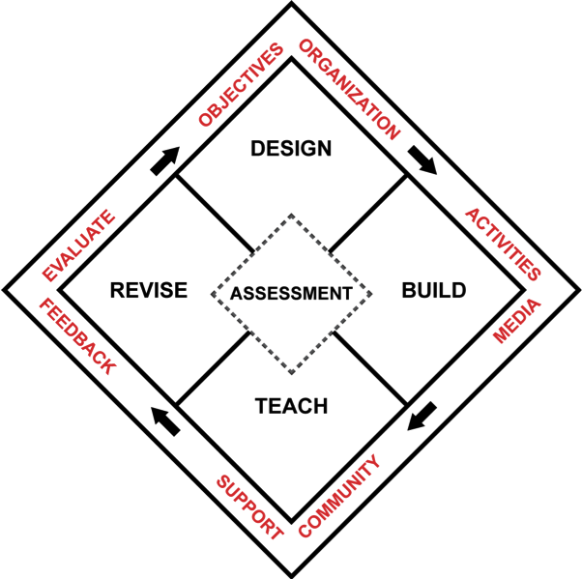

*CTLE*

*CTLE*

*TLT*

*TLT*

To tackle these support challenges, several campus support units, Teaching & Learning Technologies (TLT), Center for Teaching & learning Excellence (CTLE), Distance Education (DE), and the Library Scholarship and Educational Services (SES), created the Quality Course Framework (QCF) they can all commit to through a collaborative process based on the L. Dee Fink model of creating significant learning experiences (2003). This framework has six core elements that are integrated to an easy and transparent 4-step process where instructors can enter at any place to get the support they need in the course design process. By sharing a university-wide approach and process, the units now collaborate in a more coherent manner to help faculty design and develop better quality courses. Synergies were created to provide foundations for continued collaboration.

**Institutional Impact**

QCF has been successfully integrated with several initiatives for improving course quality across campus at University of Utah. To highlight some projects:

* Online and hybrid course development grant process in which several departments work collaboratively to help instructors utilize resources for writing up the proposals as well as designing/developing the courses that have been funded.
* NSF grant proposal pending for designing and developing “flipped” hybrid STEM courses that is grounded in the Quality Course Framework Model. This grant is a collaboration between TLT, CTLE, SES, and Electrical Engineering.
* A for-credit course for graduate students and faculty that focuses on online course design called Cyber Pedagogy that is based on the Quality Course Framework.

**Evaluation**

To collect some feedback on how the grant process works, we conducted a survey to the grant recipients who have developed and finished teaching the course as well as invited them in to show their courses and share their experience with the course. We have got very positive feedback on the collaborative process. Most of them like our collaborative support and think the transition from one department to another is seamless. In addition, most of the courses developed are good quality with the six essential elements in place.

Resources:

* Quality Course Framework website – <http://qcf.utah.edu>
* TLT course development grant – <http://tlt.utah.edu/hybrid-courses-funding/>; <http://tlt.utah.edu/online-programs-courses-funding/>

**Feedback**

1. What do you think about the QCF model?
2. What is the support situation like at your institute? Could this model be adapted to create a support process for your institute?

----

**Feedback**

1. What do you think about the QCF model?
2. What is the support situation like at your institute? Could this model be adapted to create a support process for your institute?