***Sample Templates***

***Crafting Action Plans and Strategies***

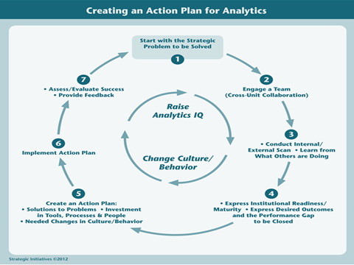

***The templates on the following pages follow the steps in this graphic, plus a series of templates on turning analytics into a major change initiative on your campus.***

***1. Start with Strategic Problem to be Solved***

|  |  |
| --- | --- |
| ***Strategic Problem(s) to be Solved*** | ***Description*** |
|  |  |

***2. Engage a Team (Cross-Unit Collaboration Highly Desirable))***

|  |  |  |
| --- | --- | --- |
| ***Individual/Group*** | ***Role in Analytics Planning*** | ***How to Engage in Analytics Initiative*** |
| ***President/Chancellor*** |  |  |
| ***Cabinet/Executive Team*** |  |  |
| ***CIO/IT Directors*** |  |  |
| ***Institutional Research/Institutional Effectiveness/University Planning*** |  |  |
| ***Academic Affairs/Student Affairs*** |  |  |
| ***Strategic Enrollment Management*** |  |  |
| ***Colleges/Academic Department – Deans, Dept Chairs, Administrators*** |  |  |
| ***Budget/Finance/Administration*** |  |  |
| ***Big Data and Analytics Expertise from Colleges*** |  |  |
| ***Advancement/University Relations/Communication*** |  |  |
| ***Others (Diversity/Affirmative Action)*** |  |  |
| ***External Groups – State Coordinating Boards, Others*** |  |  |

***3. Conduct an External Scan/Learn from What Others Are Doing***

|  |  |
| --- | --- |
| ***SWOT Analysis (Internal and External Scan)*** | ***Description*** |
| ***Strengths*** |  |
| ***Weaknesses*** |  |
| ***Opportunities*** |  |
| ***Threats*** |  |
| ***What Are Other Institutions Like Mine Doing?*** | * Check Toolkit Case Studies * Check other EDUCAUSE Case Studies like **The Change Makers** |
| ***What Are Answers to FAQs About Analytics?*** | * Toolkit FAQs |

***4a. ECAR Institutional Readiness/Maturity (We have provided 4 options for item #4)***

|  |  |
| --- | --- |
| ***Maturity Categories*** | ***Current Score***  ***1-----2-----3-----4----5*** |
| ***Culture/Process***  Senior leaders who are interested in and committed to using data to make decisions  Our administration largely accepts the use of analytics  We have a culture that accepts the use of data to make decisions; we are not reliant on anecdote, precedent, or intuition  We have identified the key outcomes we are trying to improve and better use of data  We have a process for moving from what the data say to making changes and decisions  Our faculty largely accept the use of analytics  **Overall Score** |  |
| ***Data/Reporting/Tools***  Our data are of the right quality and are clean  We have the right kind of data  Our data are standardized to support comparisons across areas  Reports are in the right format and show the right data to inform decisions  We have the right tools and software for analytics  **Overall Score** |  |
| ***Investment***  We have an appropriate amount of funding for analytics  Funding for analytics is viewed as an investment in future outcomes rather than an incremental expense  We have an appropriate number of analysts for analytics  **Overall Score** |  |
| ***Expertise***  We have IR professionals who know how to support analytics  We have dedicated professionals who have specialized analytics training  We have business professionals who know how to apply analytics to their areas  **Overall Score** |  |
| ***Governance/Infrastructure***  Our information security policies and practices are sufficiently robust to safeguard the use of data for analytics  We have sufficient capacity to store, manage, and analyze increasingly large volumes of data  We have policies that specify rights and privileges regarding access to institutional and individual data  We have IT professionals who know how to support analytics  **Overall Score** |  |

***4b. Desired Performance Leaps for Optimizing Student Success (Using Norris/Baer Framework)***

|  |  |  |
| --- | --- | --- |
| ***Element*** | ***Current Performance*** | ***Desired Future Performance*** |
| **1. Manage the Student Pipeline** |  |  |
| **2. Eliminate the Impediments to Retention and Student Success** |  |  |
| **3. Utilize Dynamic, Predictive Analytics** |  |  |
| **4. Evolve Learner Relationship Management Systems** |  |  |
| **5. Create Personalized Learning Environments and Learning Analytics** |  |  |
| **6. Engage in Large-Scale Data Mining** |  |  |
| **Extend Student Success to Include Learning, Workforce and Life Success** |  |  |

***4c. Desired Performance Leaps (Using Davenport/Harris Template)***

|  |  |  |
| --- | --- | --- |
| ***Types Of Analytics, Reporting, and***  ***Data Governance*** | ***Current Performance*** | ***Future Performance*** |
| **Optimization** |  |  |
| **Predictive Modeling** |  |  |
| **Forecasting/Extrapolation** |  |  |
| **Statistical Analysis** |  |  |
| **Alerts (Real Time)** |  |  |
| **Query/Drill Down, Real Time** |  |  |
| **Ad Hoc Reports** |  |  |
| **Standard Reports** |  |  |
| **Data Governance, Data Stewardship, Data Quality** |  |  |

***4d. Express Desired Outcomes and the Performance Gap to be Closed***

***(This is Very Detailed: Individual Elements Can be Selected for Detailed Treatment, Others Can Be Eliminated)***

|  |  |  |
| --- | --- | --- |
| ***Element of Organizational Capacity*** | ***Current Capacity/Performance*** | ***Desired Future Performance*** |
| ***I.Technology Infrastructures, Solutions, and Services***  **a. Sources of Data**  Administrative ERP (Student, Fin Aid, Human Resources, Financials, Alumni/Donor, Grants, Management, Procurement)  Academic Systems (Learning Management System, Learner Relationship Management System, Personalized Learning System, Special Systems for Continuing Education, Portfolio, Gradebook, Assessments/Surveys, Content Management, Library)  Transaction Systems (Facilities Management, Parking Management, Food Service, Student/Security Card, Procurement, Grants Management, Scheduling)  External Data Sources (State and Federal sources, peer institutions, open learners, other sources of assessment/certification)  **b. Data, Information, Analytics Capabilities**  Elements of Analytic Applications (Reporting, ETL, DW/OLAP, BI) embedded in particular systems or standalone  Extensibility and Scalability of Data in Warehouses  Query And Analysis Capabilities (Eight Elements of Davenport Typology)  Optimization  Predictive Modeling  Forecasting/Extrapolation  Statistical Analysis  Alerts (Real Time)  Query/Drlll Down (Real Time)  As Hoc Reports (Real Time)  Standard Reports (Real Time)  **c. Data Stewardship and Management**  Data Dictionary  Data Stewardship/Data Governance  Data Quality |  |  |

***4d. Express Desired Outcomes and the Performance Gap to be Closed (Continued)***

|  |  |  |
| --- | --- | --- |
| ***Element of Organizational Capacity*** | ***Current Capacity/Performance*** | ***Desired Capacity/Performance*** |
| ***II. Policies, Processes, Practices***  **a. Policies Supporting Data, Information and Analytics, FIRPA, Others**  **b. Current Processes and Practices Supporting Student Success**  Manage the Student Pipeline  Eliminate Impediments to Retention and Success  Utilize Dynamic, Predictive Analytics to Respond to At-Risk Behavior  Evolve Learner Relationship Management Systems  Create Personalized Learning and Learning Analytics  Engage in Large-Scale Data Mining  Extend Student Success to Include Learning, Workforce and Life Success  **C, Other Processes Important to Student Success – how are data and analytics used?**  Strategic Planning (Information rich?)  Institutional accountability and evidence-based decision making through  metrics, and dash boarding  Alignment of analytics planning to other core planning/accountability  Processes (Strategic Planning, Budget/Resource Allocation,  Accreditation/Program Review, Institutional Effectiveness) |  |  |
| ***III. Values and Skills of Executive Leadership/Middle Managers/Staff/Faculty***  **a. Analytics IQ” and Developed/Trained skills in use of analytics**  Executive leadership  Middle managers  Rank and File Faculty and Staff  Power Users  **b. Who Are the” Power Users?” Power users are highly skilled users who must master rules and techniques with BI tools and analytics to use them.**  **c. Do you have “Analytics for the masses?” Data and analytics access that are user obvious and available? What do you need?**  **d. Are Data, Reporting, and Analytics used pervasively by executive leadership?** |  |  |

***4d. Express Desired Outcomes and the Performance Gap to be Closed (Continued)***

|  |  |  |
| --- | --- | --- |
| ***Elements of Organizational Capacity for Analytics*** | ***Current Condition*** | ***Desired Future Condition*** |
| ***IV. Describe Your Organizational Culture Regarding Data and Analytics***  **a. Basic use of data**    **b. Culture of Reporting** 🡪 **Evidence-based Decision Making** 🡪**Performance Measurement and Improvement**  **c. Decision-Making Behaviors of Institutional Leadership and Student Success behaviors of front-line faculty and staff** |  |  |
| ***V. Leadership***  **a.Leadership involvement and commitment to analytics and student success**  **b. Level of active engagement**  **c. Level of resources made available to data, reporting, analytics**  Infrastructure and tools, processes and policies, analytics staff |  |  |
| ***VI, Capacity for Collaboration, Sharing, Partnership***  **a. What are your collaborations with technology providers, other institutions, federated solutions?**  **b. Do you utilize Hosted solutions, shared solutions? Have you considered in-the-cloud services?** |  |  |

***5. Develop Action Plan***

|  |  |
| --- | --- |
| ***Elements*** | ***Description/Metrics/Targets*** |
| ***Solutions to Problems/Initiatives*** |  |
| ***1.*** |  |
| ***2.*** |  |
| ***3.*** |  |
| ***4.*** |  |
| ***5.*** |  |
| ***Investments in Tools, Processes and People*** |  |
| ***Desired Changes in Culture/Behaviors*** |  |

***6. Implement Action Plan***

|  |  |  |
| --- | --- | --- |
| ***Initiatives/Actions*** | ***Implementation Efforts*** | ***Timeline and Responsibilities*** |
| **1.** |  |  |
| **2.** |  |  |
| **3.** |  |  |
| **4.** |  |  |
| **5.** |  |  |
| **Investments** |  |  |
| **Behavior/Culture Changes** |  |  |

***7. Assess/Evaluate Success/Feedback***

|  |  |  |
| --- | --- | --- |
| ***Initiatives/Actions*** | ***Assessment/Metrics*** | ***Evaluate Success and Feedback*** |
| **1.** |  |  |
| **2.** |  |  |
| **3.** |  |  |
| **4.** |  |  |
| **5.** |  |  |
| **Investments** |  |  |
| **Behavior/Culture Changes** |  |  |

***Overall: Build Analytics IQ/Change Organizational Culture***

|  |  |  |  |
| --- | --- | --- | --- |
| ***Actions/Options*** | ***Project Plan & Launch*** | ***Year 1*** | ***Year 2-3*** |
| **1. Off-campus Training through Professional Association (EDUCAUSE, AASCU, AACC)** |  |  |  |
| **2. Campus Symposium/Retreat on Analytics/Student Success** |  |  |  |
| **3. Campus Workshops/Webinars based on Toolkit Resources** |  |  |  |
| **4. Online Community of Practice on Student Success** |  |  |  |
| **5. Develop Strategy for Leveraging Analytics, Aligned with University Strategies** |  |  |  |
| **6. Early Win Projects, Demonstrable Outcomes from Changed Behaviors** |  |  |  |
| **7. Benchmarking Against Leading Institutions** |  |  |  |
| **8. Demonstrate ROI from Investing in Analytics to Support Student Success** |  |  |  |
| **9. Augment Existing Talent Pool through Partnerships with Solution Providers, Federated Solutions, Collaborations, Consultations** |  |  |  |

***Prelude to Developing Strategy:***

***Engage Team and Articulate Leveraging Analytics as a Major Change Strategy***

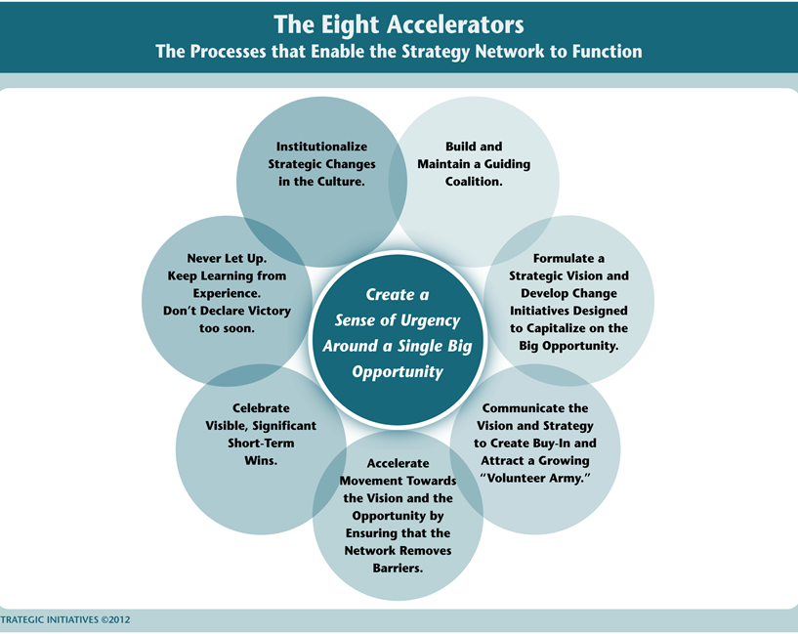

***Leveraging Analytics as a Major Strategy***

|  |  |
| --- | --- |
| ***Step/Stage*** | ***Description*** |
| **Establish a Sense of Urgency Around Analytics**   * Identify market and competitive realities * Identify and discuss crises, real and potential, and major opportunities |  |
| **Form a Powerful Guiding Coalition Around Analytics**   * Assemble a group with enough power to lead the change effort * Encourage the group to work together as a team |  |
| **Create a Vision for Leveraging Analytics to Optimize Student Success**   * Create a vision to help direct the change effort * Develop the strategies for achieving that vision |  |
| **Communicate the Vision**   * Use every vehicle possible to communicate the vision * Develop Communication and Engagement Plans * Change the systems and structures that seriously undermine the vision * Encourage risk-taking, nontraditional ideas, activities and actions |  |

***Leveraging Analytics as a Major Strategy (Continued)***

|  |  |
| --- | --- |
| ***Step/Stage*** | ***Description*** |
| **Empower Others to Act on That Vision**   * Get rid of obstacles * Change systems or structures that seriously undermine the vision |  |
| **Plan for and Create Short-Term Wins**   * Plan for visible performance improvements * Create those improvements * Recognize and reward employees involved in those improvements |  |
| **Consolidate Improvements and Produce Still More Changes**   * Use increased credibility to change systems, structure, and policfies that don’t fit the vision * Hiring, developing, and promoting employees who can implement this vision * Reinvigorate the process with new projects, themes, and change agents |  |
| **Institutionalize New Approaches, Embed in the Culture**   * Articulate the connections between the new behaviors and institutional success * Develop the means to ensure leadership development and succession |  |