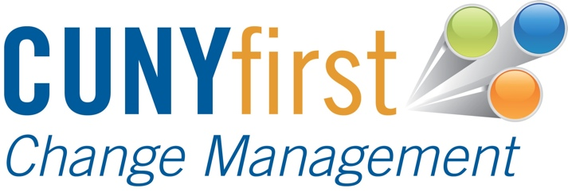
Wave 2 End User Experience Focus Groups

Overview
The CUNYfirst Project Team has found that useful insight is gained about campus implementations through focus groups help within a few months of go-live events. Through the use of these sessions, campus and project leadership are able to identify many key successes and shortcomings of implementations, address concerns rapidly before they become more pervasive, improve adoption and plan for future implementations of CUNYfirst or other local campus initiatives.
The method to be utilized during this analysis involves four sixty-minute focus groups at each wave 2 college. Those groups will be comprised of:
- Financial aid department (below director level),
- Staff that frequently use campus solutions such as registrar, scheduling, departmental support, special services such as veterans or transfer evaluation
- Faculty including adjuncts if available
- Students
The goal of these sessions will be to allow employees to give voice to their experience and provide recommendations including near term campus actions and future CUNYfirst implementations. Specifically we are seeking information from the users on the go-live experience (training, communications, helpdesk, etc), any remediation recommendations that can be implemented prior to the fall semester (targeted training, policy clarifications, etc.) and early indications of adoption in the critical area of financial aid services that can be compared at a later date to determine relative readiness for subsequent launches of native financial aid at each college. Campus executives would use the results of the analysis to improve adoption, increase campus team efficiency and smooth the way for future implementations. The CUNYfirst core team and Process Owners would use the information to guide future implementation planning and support plans.
At the beginning of each session core team members will collect answers to a short survey rating the experience in key service areas; training, communications, problem resolution, system functionality and system performance. This survey will allow cross campus comparison of these service areas. As per our standard methodology we will be collecting anonymous comments throughout the session that will be grouped by service area and will provide these comments at the end of each campuses analysis.
Each face-to-face session would run 60 minutes with sufficient time between them in case discussion runs long and to allow the CUNYfirst team to have a break. In the case of faculty sessions, it may be more convenient to recruit faculty that, while unable to attend a group session over the summer due to conflicting schedules. The project team will schedule one-on-one conversation (by phone or in person) with these faculty members that would likely last 10-15 minutes.
Three CUNYfirst staff members will participate in each face-to-face session; one to facilitate and two to transcribe comments. The transcription process will be used to decrease any concern that the commentary would be recorded for future retaliation while still capturing the specific language used during the session.
Each Campus Executive would be expected to recruit approximately 10 panelists (perhaps fewer for faculty due to scheduling) for each session with the involvement of the campus team and appropriate campus leadership (Provosts, VP of Student Affairs, etc.).
Comments will be selected and assigned to a theme category as follows:
Categories
Business Ownership
Business Process
Coordination
Quality Control
Communication
Data
Conversion
General Comments
Suggestions
Leadership
Performance
Security
System Design
Testing
Training

Select verbatim for all focus groups will be found at the end of each document.

Verbatim
Category | Comment

