**Operational Excellence: The Proactive Process**

|  |
| --- |
|  |

Service:

* 1. S

1. Service = something that gives the customer value without them sharing in any of the direct costs or risks.
2. Expectations of repeatability, reliability, availability.
3. E.g., Email, Web, Learning Management

**People**

**Roles and Responsibilities**

|  |  |  |  |  |  |
| --- | --- | --- | --- | --- | --- |
| **Person** | **Responsible** | **Accountable** | **Support** | **Consulted** | **Informed** |
| *Use Title or Role* | *one or very few* | *one or very few* | *Many* | *many, 2 way conversation* | *many, 1 way conversation* |
|  |  |  |  |  |  |
|  |  |  |  |  |  |
|  |  |  |  |  |  |
|  |  |  |  |  |  |
|  |  |  |  |  |  |
|  |  |  |  |  |  |
|  |  |  |  |  |  |

**Stakeholder expectations** – Come to a understanding about cost and quality

|  |  |  |  |
| --- | --- | --- | --- |
| Yearly Cost Metrics | Best-in-Class | Industry Average | Laggards |
| Business interruption Events | .9 | 3 | 3.5 |
| Time per business interruption event (hours) | 1.3 | 4.7 | 8.4 |
| Total disruption (hours) | 1.2 | 14.1 | 29.4 |
| Average cost per hour of disruption |  |  |  |
| Total cost of business interruption events |  |  |  |
| Total Cost of Service |  |  |  |

-Aberdeen Group, 2010

**Support**

Include people from the above list that are in the “Support” role.

**Performance Management:**

**Coaching:**

Weekly check-in, protégé reviews schedule, deliverables and communications with mentor. Have regular meetings of mentor-protégé pairs as a group to review progress. Visits to external organization identified as centers of excellence.

|  |  |  |
| --- | --- | --- |
| **Person** | **Center of Excellence** | **Mentor** |
|  |  |  |
|  |  |  |
|  |  |  |
|  |  |  |

**Training:**

Think about technical skills, organizational values and people skills.

|  |  |  |
| --- | --- | --- |
| **Person** | **Learning Style** | **Training Goal** |
|  |  |  |
|  |  |  |
|  |  |  |
|  |  |  |

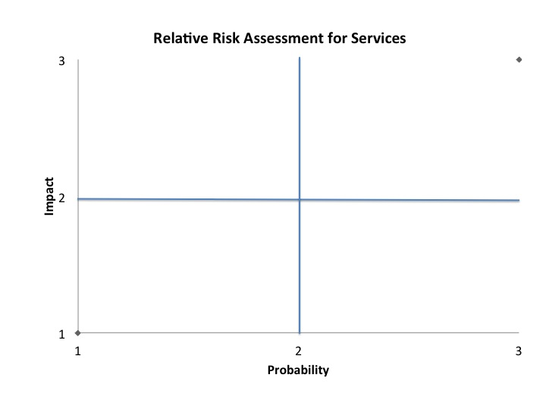

|  |  |
| --- | --- |
| 1. **Remote -** Event could occur in rare circumstances. 2. **Possible -** Event could occur at some time. 3. **Almost Certain -** Event could occur in most circumstances. | 1. **Minor -** Unlikely to have a permanent or significant effect on the institution’s reputation or achievement of its strategic objectives. 2. **Moderate -** Likely to have a significant impact on the institution, but can be managed without major impact. 3. **Major -** Likely to have a significant effect on the institution, requiring a major effort to manage and resolve the occurrence, as well as its ramifications. |

**Process**

**Know Your Configuration**

**Inventory and Monitoring**

Authoritative inventory of things involved in delivering the service and have a standard Monitoring practice, a standard baseline for each thing involved in delivering the service. Responsible support person from above should be ultimately alerted on applicable metrics.

|  |  |  |
| --- | --- | --- |
| Item | Support Person | Monitoring Metrics |
|  |  |  |
|  |  |  |
|  |  |  |
|  |  |  |
|  |  |  |

Organization Standard Monitoring Tool:

Choose a metric from above that needs to be trended. Choose a person from the above RASCI chart in the “Support” role for the “Support Person”.

|  |  |  |
| --- | --- | --- |
| Trend | Escalation Time | Support Person |
|  |  |  |
|  |  |  |
|  |  |  |
|  |  |  |

**Manage Change**

A Change Request process, Change Advisory Board and Change Window are the foundation of operational excellence.

**Change Request Form:**

**Change Manager:**

**Change Window:**

**Change Advisory Board –** Default position is that changes are not approved.

|  |  |
| --- | --- |
| Functional Area | Representatives |
|  |  |
|  |  |
|  |  |

**Operational Planning**

An operational planning meeting focused on only the health of this service needs to happen regularly for critical services even when there is no change to the service planned. The business calendar needs to be considered. Below is an example of operational plans produced by a monthly 15 minute meeting on this service:

Where/when will the meeting take place?

Where will the plan be recorded?

**November 2012**

Business calendar events to be considered:

Events from Last Month:

Activities:

**December 2012**

Business calendar events to be considered:

Events from Last Month:

Activities:

**Strategic Service Review**

## How or if this service should be delivered?

The Outsourcing Decision Matrix helps you consider two important factors in outsourcing a task:

1. How strategically important is the task to your business? Strategically important tasks are sources of competitive advantage.
2. 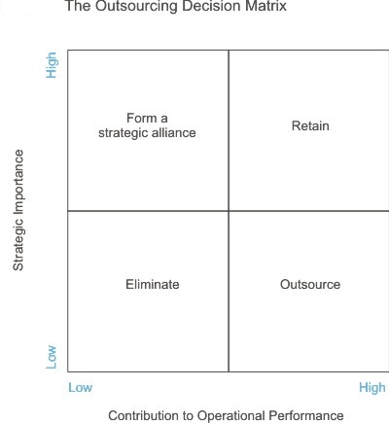What is the task's impact on your organization's operational performance? Tasks which have a high impact on operational performance are those which, if done well, contribute greatly to the smooth running of the organization or, if done badly, greatly disrupt it.  
   *The outsourcing decision matrix*. (n.d.). Retrieved from <http://www.mindtools.com/pages/article/newSTR_45.htm>

How often will the Service Be Reviewed?