FACEBOOK
Go to the Facebook page > Admin Panel > Insights > See All > Export Data
Select Page level data, enter the date range, and click download. Repeat for Post level data.
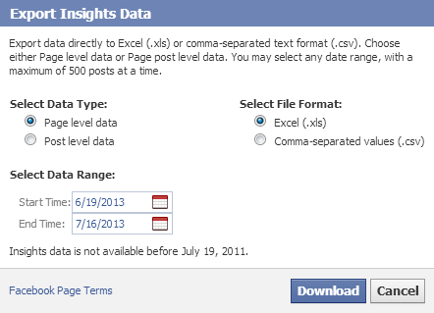
Report:
- Facebook page or group url
- Total likes or group members
  - Pages
    - Insights Page Level spreadsheet
    - Key metrics tab
    - “Lifetime total likes” on the last day of the month
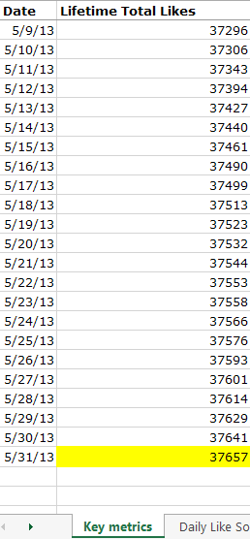
  - Groups
    - Go to your group on the last day of the month and record the number of members. Take a screen capture or save the page as a pdf.
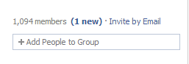
- New Likes or group members
  - Subtract the previous month’s total likes from the month you are reporting on
- Reach
  - Pages
    - Insights Page Level spreadsheet
    - Key metrics tab
    - “28 day total reach” for the last day of the month
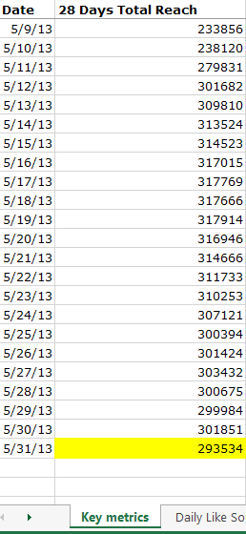
  - Groups
    - Not applicable
- Engagement: number of likes
  - Pages
    - Insights Post Level spreadsheet
    - “Lifetime Post Stories by action type” tab
    - Sum of “Like” column
  - Groups
    - Optional
    - Count manually

- Engagement: number of comments
  - Pages
    - Insights Post Level spreadsheet
    - “Lifetime Post Stories by action type” tab
    - Sum of “Comment” column
  - Groups
    - Optional
    - Count manually
- Engagement: number of shares
  - Pages
    - Insights Post Level spreadsheet
    - “Lifetime Post Stories by action type” tab
    - Sum of “Share” column
  - Groups
    - Optional
    - Count manually
- Engagement: Interactions in group
  - Pages
    - Not applicable
  - Groups
    - Manually count the number of posts group members have made to the group during the month

TWITTER
- Twitter handle
- Total followers
  - Go to your Twitter account on the last day of the month and record the number of followers. Take a screen capture or save the page as a pdf.
- New followers
  - Subtract the previous month’s total likes from the month you are reporting on
- Number of Interactions
  - Go to ads.twitter.com and log in with your twitter credentials. Look for the drop down analytics menu and choose “Timeline Activity.” Download the CSV for the month you are reporting on and record the total number of Favorites, Retweets, and Replies
- Number of clicks
  - On ads.twitter.com on the Timeline Activity screen, manually count the number of clicks your tweets received
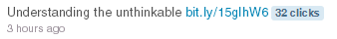
  - OR sign up for a free (or paid) Hootsuite account. Use Hootsuite to shorten ALL urls on Twitter. Go to the analytics tab and create an Ow.ly click summary. Record the total number of clicks for the month.
  - OR sign up for a free bitly account. Use this bitly account to shorten ALL urls on Twitter. On the last day of the month, sign in to bitly, click on the stats tab, and record the total number of clicks over the past 30 days.

YOUTUBE
- Channel url
- Videos uploaded
  - Go to the dropdown menu next to “Upload” and select “Video Manager.”
  - Count the number of videos uploaded during the month
- Total views
  - Go to the dropdown menu next to “Upload” and select “Analytics”
  - Set the date range to the month you are reporting on
  - Save the page as a pdf or take a screen capture
  - Enter total views
- Interactions
  - From the analytics screen, total the number of likes, dislikes, comments, shares, and favorites
BLOGS
- Blog url
- Using google analytics, find the absolute unique visitors for the month you are reporting on
- Interactions: count up the number of comments your content received during the month

OTHER
For any other platform, report the total number of followers/subscribers/fans as of the last day of the month, the follower/subscriber/fan growth over the month, and the number of interactions with your content.
MONITORING
Each time a post or comment on any social media platform requires a response, the sentiment of that comment should be logged. Report the total number of posts requiring a response on Facebook, Twitter, all other social media platforms and how many total posts were positive, negative, and neutral.

