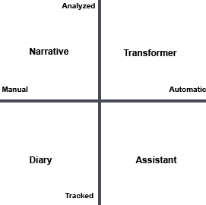

1. **What behaviors are important for student success?**

Study Time, Co-Curricular Activities, Research, Group Work

1. **What data points are associated with those behaviors?**

Amount of time, location, who were they with, how did they feel when they were done

1. **How can you get this data?**

Student Information System, Learning Management System, Self-Track, Registrar

1. **How do you motivate students to self-track?**

Extra Credit, Make it an assignment, more data after participation