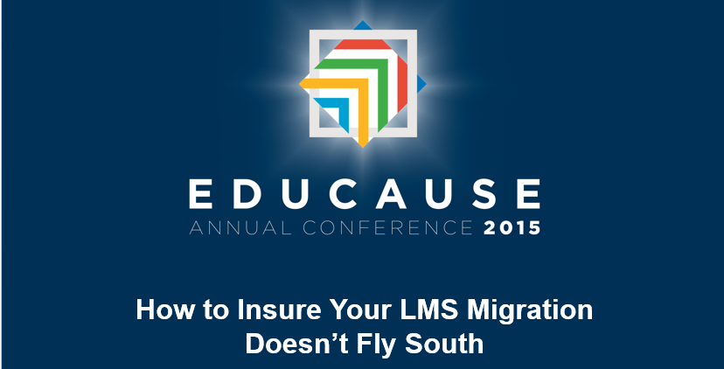

Vicki Westergard – St. Petersburg College   
[Westergard.Vicki@spcollege.edu](mailto:Westergard.Vicki@spcollege.edu)

Whether you are just thinking about a migration, in the midst of one or finished with one and interested in helping improve the process for your colleagues, you are welcome to join us as we discuss:

* + - * Best practices/Worst practices
      * Timelines & timing
      * Resources you can leverage
      * Faculty viewpoint
      * Student satisfaction and success
      * What can you do, even in the midst of your process, to make the transition smoother?