Institutional Analysis Worksheet
Understanding the institutional structures, stakeholders, and agenda-setting agents that impact and/or are impacted by a pilot project is key to its success. Stakeholders might include (but are not limited to): students and student groups; the faculty as a whole, school/program faculty, and individual faculty members; Teaching and Learning Center, Library, and Academic Services units; IT units, e.g., computer support, classroom tech support, and learning technologies.
Agenda Setting Agents are those individuals and campus groups that have authority to establish, promote, and fund campus-wide initiatives.

Stakeholders | Agenda Setting Agents

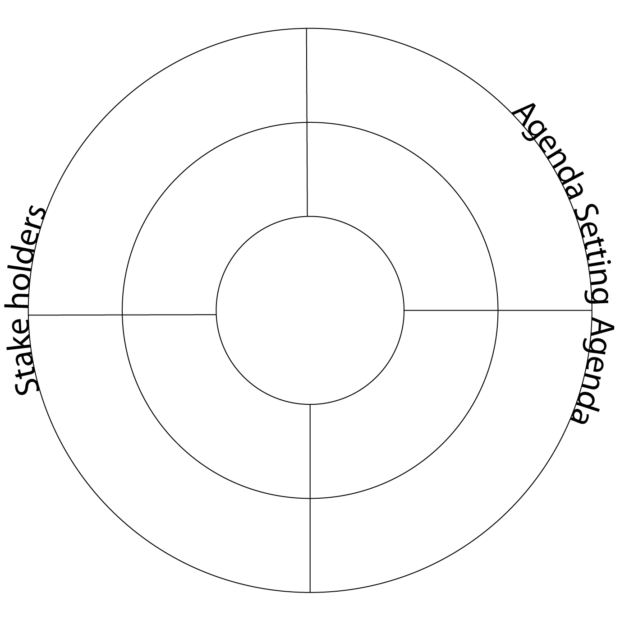

NEXT STEPS: Try to upload an image of your bullseye map to the shared Google Drive folder
- Take a picture of your Institutional Analysis bullseye map with your mobile device
- Use the barcode to the right and open with the Google Drive app, if possible.
- In Google Drive app, click Upload button and select the image from your camera app pictures.

