GARTNER 2011 HYPE CYCLE FOR EDUCATION
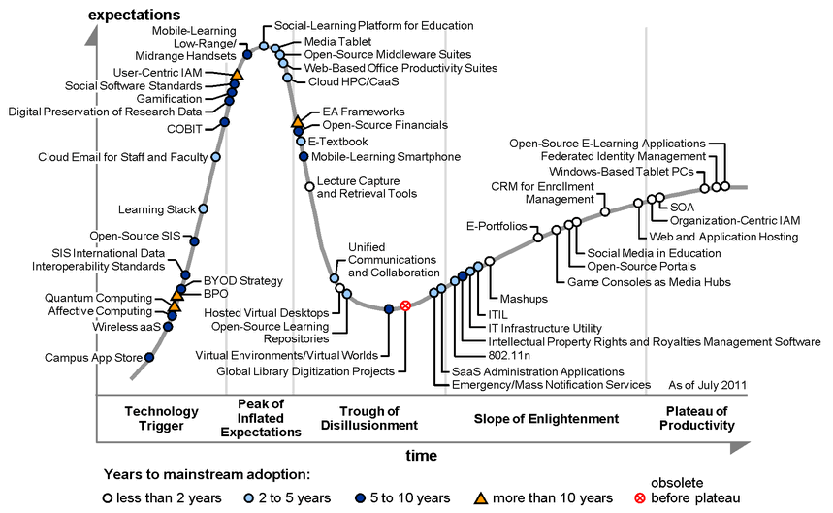
Jan-Martin Lowedahl, “Hype Cycle for Education, 2011.” Gartner, Inc. 29 July 2011. Used with permission.

