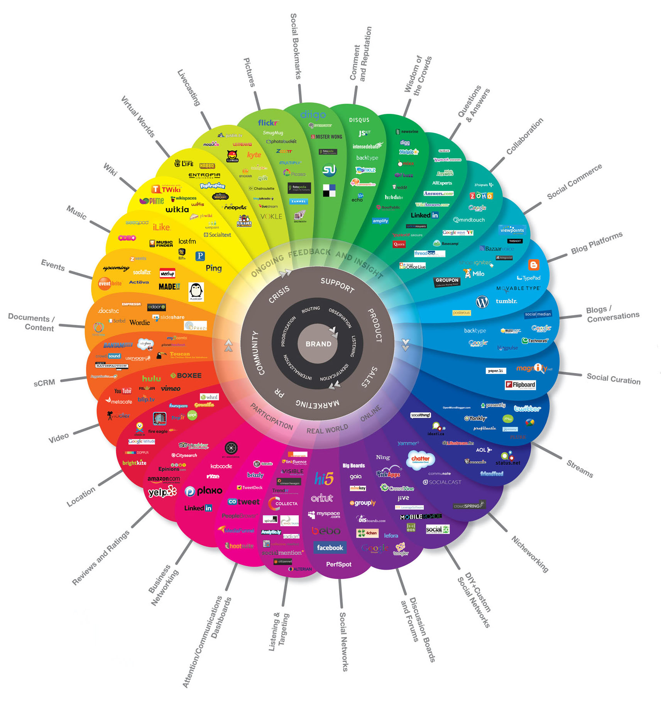

http://www.theconversationprism.com/

The Conversation Prism

Brian Solis & JESS3