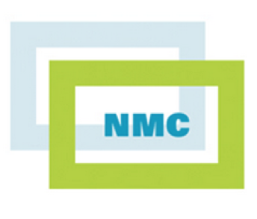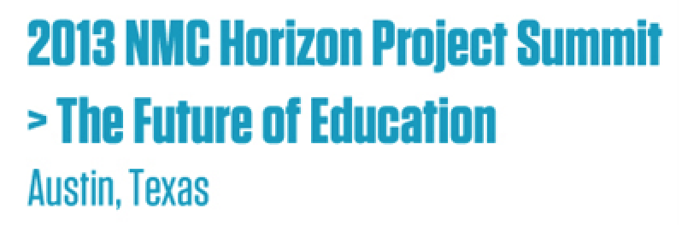

FLEXspace
Flexible Learning Environments eXchange

A Proposal to Refine a Wicked Idea

Submitted on behalf of the Emerging FLEXspace Vision Team by:
Lisa Stephens, PhD
Senior Strategist for Academic Innovation
SUNY Academic Technology & Information Services
Introduction
The State University of New York (SUNY) seeks key partners to sponsor the expansion of a successful proof-of-concept project that will enable open access sharing of flexible learning environment attributes and best practices. This robust, image-intensive database was piloted with ARTstor using their Shared Shelf platform, which now includes video and multiple file format options. Key partnerships are beginning to form in support of re-branding this effort as a service entitled FLEXspace: Flexible Learning Environments Exchange.

Background
The SUNY Provost charged a University-wide Learning Environments Task Group (LETG) to explore how to gain a better understanding of pedagogical needs when designing or renovating formal and informal learning spaces. Although defined as having the potential to include virtual learning environments, the initial exploration has been limited to physical space augmented by technology.

Considerable institutional investment is required to maximize the pedagogical effectiveness of learning environments. To the extent space can be designed (and assessed) as flexible and adaptable to emerging technologies (e.g., course content capture, gaming facilitation) and used as a planning resource, return on investment can be increased. Following considerable research, the SUNY LETG partnered with ARTstor to pilot an Innovative Instruction Space Repository (IISR) proof of concept to test how file records could be described and shared (see Figures 1-3).
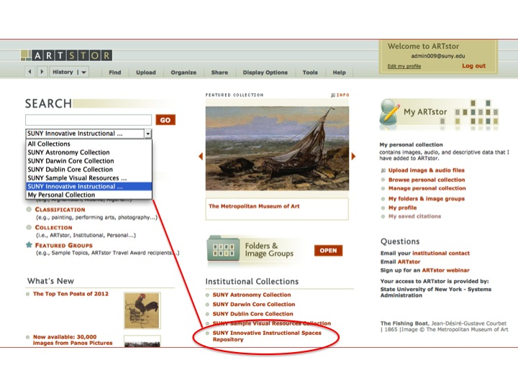
Figure 1: Screenshot of SUNY IISR Proof of Concept – ARTstor Shared Shelf™

Encouraged by the response from initial user testing, the LETG began seeking feedback from peers at SUNY conferences, who in turn added more records and ideas. Once satisfied that the “proof of concept” had been met, the LETG decided to share this proof-of-concept/prototype with other classroom and instructional support professionals to see how this repository may benefit their efforts as well.

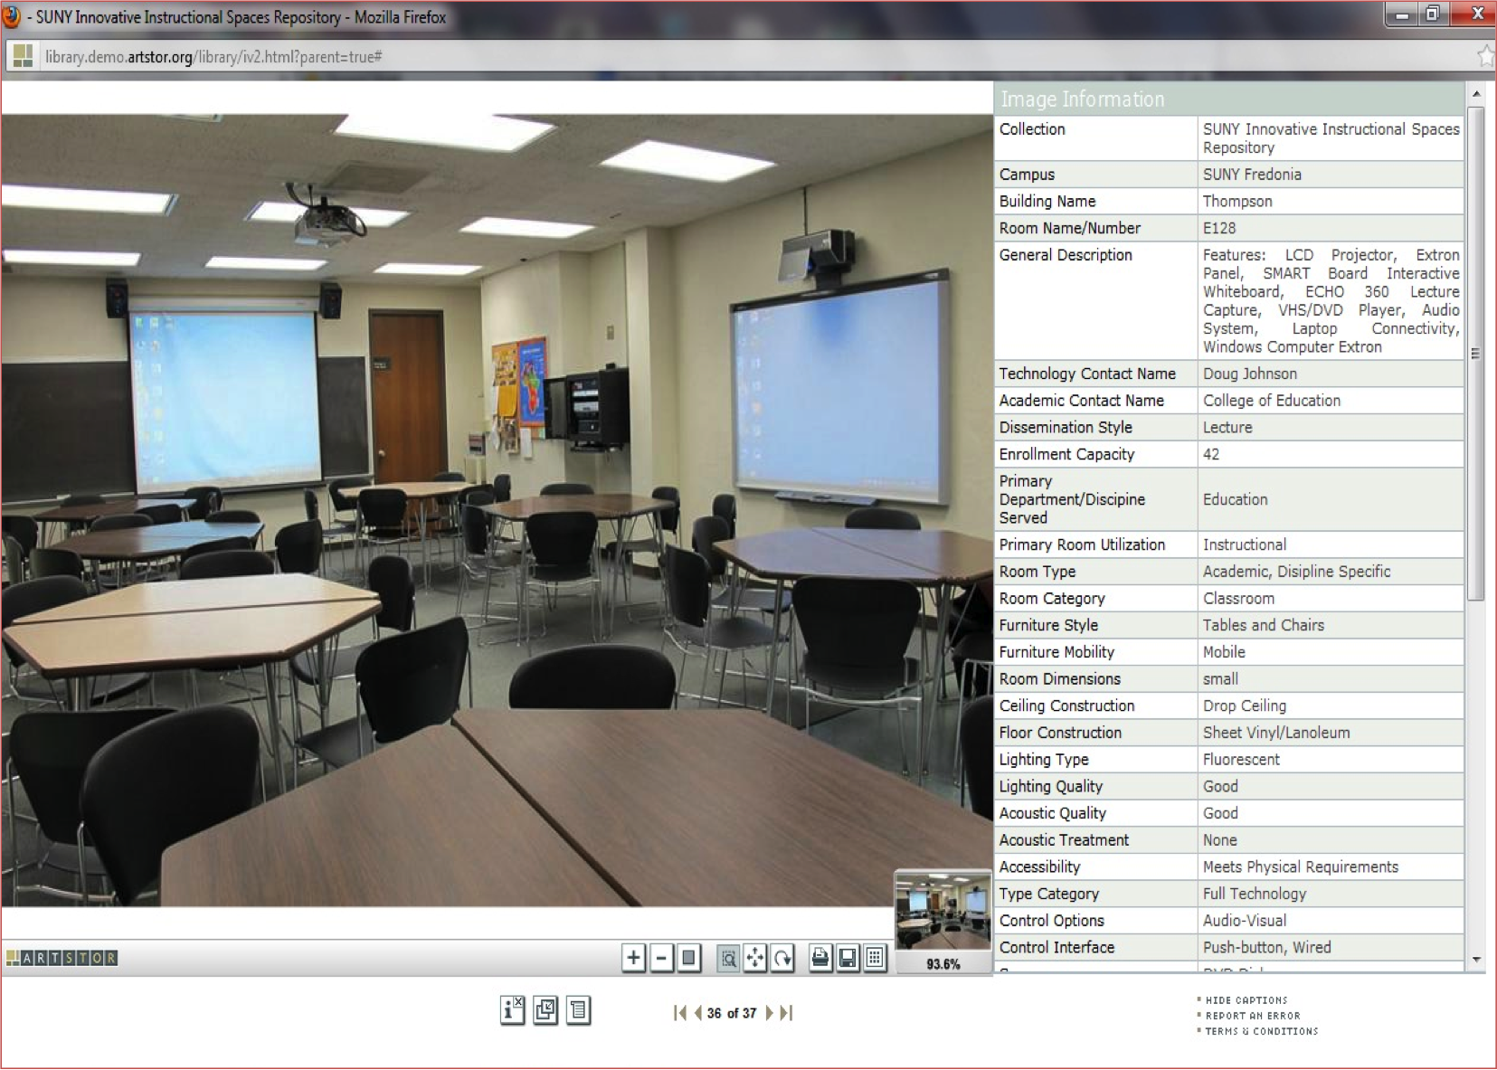
Figure 2: SUNY IISR Proof-of-Concept Side-by-Side Detailed Attributes View

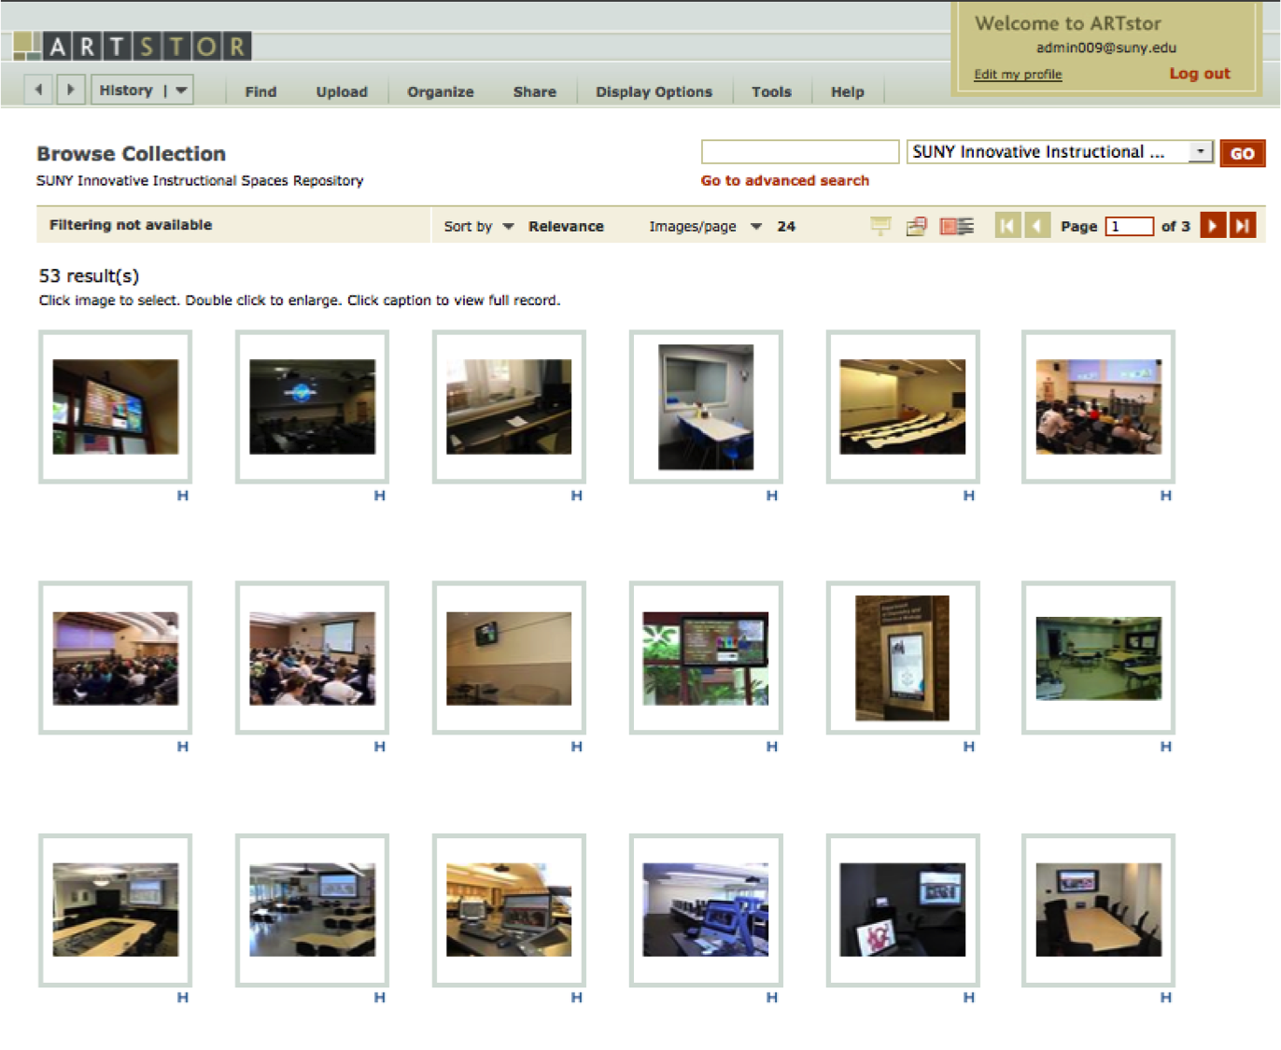
Figure 3: SUNY IISR Proof-of-Concept Tile View for Browsing

A Wicked Problem
The SUNY LETG prototype immediately demonstrated wickedness by fostering more questions that challenged the original project charge “comfort zone” such as:

- Is there a common definition for “Innovative” vs. “flexible” learning spaces?
- Who (or what body) determines/evaluates meeting those definitions (or best practices)?
- What parameters are currently excluded from our commonly accepted definitions?
- How might this solution be even more effective in demonstrating return on investment during institutional budget planning and assessment cycles?
Effective (physical) learning environments begin with sound architecture principles that allow for clear site lines, adjustable lighting and favorable acoustics, but higher education is now responding to mass adoption of digital content capture for online learning. This creates a fresh myriad of competing needs. For example:

- Are faculty and students well served by current design and renovation practices?
- How do we judge (and collect data) for whether a space promotes active learning?
- How might we consider space as part of a larger network that might easily be connected as a shared resource – particularly in emerging education gaming environments?
- As curricular needs change and new programs emerge, in what ways might instructional technologists, instructional designers and IT professionals collaborate to support faculty, students and administrators in responding to these emerging design needs?
- Finally, how do we effectively link the professionals and practitioners supporting instruction with those who are designing new solutions (e.g. manufacturers and vendors anxious to demonstrate value propositions)?

A Proposed Solution: FLEXspace – A Flexible Learning Environments eXchange

Members of the SUNY LETG presented a demonstration of the Innovative Instruction Space Repository (IISR) last October at the 2012 Consortium of College and University Media Centers (CCUMC) national conference (Please refer to Appendix 1 for the webcast summary, for use as a viewing guide to the video presentation). The presentation and subsequent discussion was very positive, generating a number of suggestions for further consideration – including identification of point people within organizations who may have interest in investigating, refining and expanding the prototype.

Capitalizing on CCUMC conference feedback, a small group representing some of the key organizations identified (to date) met at EDUCAUSE 2012 in Denver to build consensus on what a guiding framework might look like to move the project forward. The discussion can be summarized in four main principles:

- A robust, hosted, intuitive technology solution (ARTstor Shared Shelf or similar) must be used for upload/download and sharing of content. The content should be accessible in whatever format or “wrapper” the end-user or consumer organization prefers.
- Content will be Open Access, with a governance model that enables peer-reviewed content to be available to those registered with a .edu address free of charge. This governance model also enables key stakeholders to maintain system and service oversight.
- Content will be made available to non-.edu entities on a sponsorship/cost recovery basis, preferably through a self-service website transaction.
- Existing partnerships/resources/organizational best practices should be leveraged wherever possible.

Subsequent discussion found agreement that although the Innovative Instruction Space Repository (IISR) term was a thoughtful and accurate service description, it was difficult to speak, and didn’t lend to a “snappy” acronym. FLEXspace became the new brand – which also accurately described the service as a “Flexible Learning Environment eXchange.”

A number of organizations have been identified as potential FLEXspace key collaborators to offer a holistic solution by combining core organizational strengths and layering services to meet the FLEXspace goals emerging from formative discussions:

Higher  Education | Universities, colleges, K-12, continuing education and specialized training environments who will be the primary consumers of FLEXspace resources
CCUMC | Consortium of Colleges & University Media Centers – academic and corporate members who design, deploy, maintain, and support learning spaces.
ELI | EDUCAUSE Learning Initiative – Developers of the SEI Rubric for Active Learning Environments (and offers EDUCAUSE communication resources & publications).
MERLOT | Multimedia Educational Resource for Learning & Online Teaching – a peer reviewed open access learning object repository that may expand to include learning spaces.
ARTstor | Well-established hosted database environment that now offers flexible and open distribution models through the Shared Shelf application.

Figure 4: The FLEXspace Institutional/Organizational Core Strengths Stack

Considering the foundational base upward, ARTstor’s Shared Shelf (a newly released application in Beta) serves as the platform upon which other organizational strengths might be layered to form the holistic FLEXspace solution. ARTstor offers a proven, media rich, robust and reliable hosted environment that has recently expanded to include additional file formats and video content. Alternate hosting solutions may be considered during the FLEXspace listening tour phase, but the goal is to not burden any single higher education institution with hosting responsibilities for the tool/service.

MERLOT offers considerable expertise in management of peer review. This is key to the growth of the distribution model. MERLOT offers documented experience in adapting their peer review system to different types of content and applications. This process will qualify faculty and professionals to serve as peer reviewers of innovate learning spaces, perhaps forming a future FLEXspace Editorial Board.

The EDUCAUSE Learning Initiative (ELI) has been developing an evaluation rubric specifically to assess active learning within innovative and flexible learning environments. Either coupled with the MERLOT review process, or as a standalone evaluation tool, the ELI rubric could play a major role in a central portal to ensure consistency and credibility. This would be a key component in “Seeking Evidence of Impact” and responding to the very real challenge of limited resources available to institutions to “right size” their learning environments based on real data and curricular and program needs at that institution.

CCUMC members design, deploy, maintain, and support learning spaces on their campuses. Corporate members are well integrated into this professional organization and its projects, to the benefit of universities and companies alike. CCUMC offers a leadership role in FLEXspace adoption, application and content sharing (possibly as a member service). When coupled with MERLOT’s peer review process, and ELI’s evaluation rubric, CCUMC offers huge potential to tap into a strong base of classroom technology support professionals, instructional designers and Library media specialists to contribute to a field of study, and also offers the potential for closing the loop for companies seeking opportunities for product evaluation, lifecycle management and future product development.

In sum, this shared vision is in infancy! Each of these key organizations offers core strengths, but others (as yet unrecognized) may offer similar strengths to realize an even stronger vision. Governance will be the single most important issue and key to sustainability moving forward. While taking pride in the initial prototype, SUNY (collaborating with others) seeks to share these findings and prototype to promote efficiency and peer collaboration across all public and private institutions. This is why education rests at the top of the “shared strengths stack” – ensuring that all who desire to participate will benefit from adoption of the FLEXspace service vision.

Moving from Prototype to Production
In order to realize the potential of FLEXspace, a governance structure must be adopted to enable key stakeholders to launch this service. There is real work to be done, and resources must be identified to migrate this prototype into production. The Vision Statement drafted by key stakeholders (Appendix 2) offers an aggressive timeline to adoption and a more detailed timeline draft (which is obviously fluid until more dependencies can be agreed upon).

Project Milestones Summary:

General Timeframe | Milestone Title | Summary
Spring 2013 | Listening Tour | Receive feedback from conference presentations, draft ideas, gain support and identify governance/funding needs.
Summer 2013 | Draft Governance | Begin expanded testing, continue to draft workflow, refine process.
Fall 2013 | Begin formal content share, share updates | Migrate to full production environment while refining peer review process.
Spring 2014 | Share outcomes | Begin peer review in earnest
Summer 2014 | Survey contributors | Publish results, expand services.

Service cost is dependent upon the governance model adopted. ARTstor has indicated they are willing to continue hosting the proof of concept while under development, but it may be advantageous to migrate from a development to production platform as soon as practical to foster further refinement.

Early, non-binding estimates indicate an annual hosting cost (for up to 5,000 assets) of approximately $10,000 plus .23/asset (5000 – 50,000 images). SUNY and CCUMC have expressed a willingness to provide seed funds to get the project started as long as progress is demonstrated toward a self-sustaining and shared cost effort within a limited and defined timeframe. More formal agreements are under consideration at the time of this writing. Some institutions have expressed interest in purchasing “extra storage” to house their complete “in house” records to be filtered separately from FLEXspace.
The final principle discussed in deploying this solution is to, “accept that we must build and refine while moving forward” – which is to suggest that details/challenges will emerge and be addressed/refined as the service matures. This includes the need to consider a business model that will provide for staffing and resources to ensure the resource is sustainable over the “long haul” and remains open and nimble as technology and pedagogical practices evolve. It is possible that staffing may be leveraged from one of the key stakeholder organizations as long as funding is available to address the additional overhead, but again this is a fluid environment in these earliest of idea stages.

Ultimately, this will require patience and close collaboration among risk tolerant early adopters while additional partners and sponsors are identified and brought on board. We will engage in “perfection through production.”

Potential Benefit Realized as the Result of a Successful NMC FLEXspace Presentation
Should this proposal be accepted for presentation at the NMC Horizon Project – the Future of Higher Education Summit, the benefit would be immediate and significant! This conference audience is well suited and uniquely qualified to see potential in this collaborative solution and offer refinements that will strengthen the outcome.

Visionary leadership is required to move FLEXspace forward, and the NMC Summit provides for a unique perspective directly from those who have deployed very large scale and innovative projects. The input received from those present would be invaluable in bringing FLEXspace to all institutions and stakeholders who may benefit from the service.

Respectfully Submitted by:
Lisa Stephens, Senior Strategist, SUNY Academic Innovation
Lisa.Stephens@suny.edu
(716) 645-6522 Office
(716) 982-4771 Mobile

The proposal received significant input and support from “the early FLEXspacers” (although the proposal author accepts responsibility for any errors in adapting the Vision Statement and related materials):
- Carey Hatch, Vice Provost – SUNY Academic Technology & Information Services
- Joseph Moreau, Vice Chancellor of Technology – Foothill-De’Anza Community College District
- Brad Snyder, Associate Director – Classroom Technology Services – SUNY Cortland
- Clare van den Blink, Director of Academic Technology – Cornell University
- Kim Scalzo, Director-SUNY Center for Professional Development
- Mark McCallister, Associate Director, Office of Academic Technology – University of Florida
- Malcolm Brown, Director, EDUCAUSE Learning Initiative
- Gerry Hanley, Exec. Dir. – MERLOT and Sr. Director, Academic Technology Services, California State University

Appendix:

- CCUMC presentation video and summary notes. http://www.youtube.com/watch?v=Jm5zkp4Ks0o&feature=youtu.be

- FLEXspace Draft Vision Statement (as of 1/1/13)

Below is a summary table of the SUNY Innovative Instruction Space Repository (IISR) presentation at the 2012 CCUMC Conference. The complete video presentation is available on YouTube.

00:00-7:00  Introduction and Overview of Innovative Instruction Space Repository (IISR) | - Joe Moreau introduction and background. What we will see in the demo, how ARTstor & Shared Shelf pilot began, and the need for feedback to move the prototype forward.  - Lisa Stephens provides context for SUNY’s Learning Environments Task Group and why the SUNY Provost launched the initiative. Describes the vision for collecting & sharing specific information about learning environments and how to evaluate best practices in the form of a interactive repository. Began to consider how, if successful, could this be applied to any institution that may want to participate.  - (5:30) Joe: How Innovative Instruction Space Repository (IISR) began with reviewing institutional websites.  - (7:00) Joe: How ARTstor became involved. How the “self service” interface was developed – now branded “Shared Shelf” to enable faculty, librarians and researchers to augment large collections with local image databases created at the institutional level.  - (9:00) Joe: Used ARTstor’s Society of Architectural Historian database as an example to begin building the IISR. ARTstor then offered to begin supporting the SUNY effort to develop the prototype to help refine some Shared Shelf objectives during the Spring 2012 semester.
10:30 - 16:00  Brad Snyder’s Part 1 demo of the IISR Shared Shelf content upload | - (10:30) Two components to the database:  - Shared Shelf – where the content is developed and uploaded,  - and ARTstor, where the content is viewed on the public face.  - Images are database assets. There are three basic organizing principles:  - Pedagogical – type of teaching/faculty needs  - Facilities – attributes for fit & finish  - Technical IT & AV Infrastructure – “nuts & bolts” of the room technology  - (12:00) One need not have all the information when starting to enter the attributes fields.  - (12:40) Functions much like a “YouTube” interface, uploading assets (photos – and as of 11/12 – now media clips)  - (13:30) It is very important to provide contact information and key terms.  - (the prototype team worked to define attributes fields understanding this would require refinement).  - Q- are any fields required? There are none now, but they can be set up that way in the future.  - (15:00) One the attribute fields are complete, you need to publish the record (and you have the option to un-publish the record).  - (15:30) The data appears more elegant on the viewing side of ARTstor.

16:00  Q&A start  re: Shared Shelf file upload component | - -Future directions (ARTstor announced multimedia and multiple image types the day before Annual EDUCAUSE Meeting)  - -Can “cut & paste” attributes, or defined a master for multiple records.  - -File size limit? (not that we’re aware of) – may be some limits on file types, but that’s on their roadmap.  - -There may be options to upload control code strings in the future, there’s lots of opportunity.  - -Did Jim Twetten's folks (Iowa State) have any difficulty uploading content? (no, it was very intuitive without directions).
20:00 Part 2 Demo  ARTstor display and navigation | - Image display & features  - (20:48) Brad: When I attend conferences like this, one of the most valuable aspects is visiting other campuses to see how they solve problems that we face. (This tool becomes a way to efficiently replicate, in part, that experience.)  - (21:12) Here are some of the images uploaded from Iowa – they are decent sized images.  - (21:30) There are not a lot of images uploaded yet as part of the prototype, but they are high quality images (54 records uploaded at the time of this presentation)
22:30  Q - Do you need creds to search? | - Yes, but hopefully not once we get to production.  - Joe Moreau: Need some feedback to move forward on how to set this system up for expansion.  - The concept is to create a tool that is free resource to education where you do not need to be an ARTstor subscriber to have access to the published space.  - These are the logistical questions that need to be worked out as part of a future governance model.
23:20  Tools Tour on Interface | - Side-by-side view (compare and contrast)  - Can zoom in/out on the image while still viewing the attributes  - Would you like to see that in Khaki? (now THAT would be cool!)  - We gave the login information to the CCUMC board of directors, not everyone in the room has it.  - Information can be published to a free site where you don’t need to be ARTstor subscriber.
26:30 –  Q- is there a cost, how do I get started? | - That’s where we need your help, and the help of others to figure out how to move a good idea forward.  - Copyright? What if you want to protect something? (Well, the golden rule is don’t publish it if you really want to protect it.)

27:40 –  Q - Why ARTstor? | - (Joe Moreau) Partly through happy accident, but mostly because of a good fit. There are lots of talented developers around SUNY, but we wanted to make sure this idea was sustainable and not reliant upon us (any individual campus resources). Didn’t want to steal anyone’s “spare time.” Lots of people can do it, but it makes more sense to have a hosted solution with a core competency in these services.  - Foundation for moving toward broader exploration.  - Not locked into ARTstor, but it’s a very robust tool and should be considered.  - We need to develop the diversity of institutions, pedagogical practices and a more comprehensive resource – a larger critical mass as a national resource. Who should be the national custodian? CCUMC? EDUCAUSE? Somebody else? Someone other than SUNY? It could be a model similar to MERLOT.  - How do we make it fiscally sustainable? ARTstor has been committed to working with us, and have expressed commitment to help further develop the logistics, refining the record model, but at some point in time they will need to see a revenue stream. ARTstor is a not-for-profit corporation, but they have real costs as well.  - Need to have a governance structure to determine who is/are the custodian(s).
31:00 – Who decides what constitutes an “innovative design?” | - General discussion. Can anybody submit anything up and call it “innovative”? Or, should there be some kind of moderation model? A group of peers might review a submission and score it in some fashion.  - ARTstor has suggested from their experience with the architectural historians, there members upload any numbers of records, there is no peer review, but there is an “editors choice” where a panel decides what to escalate to a select list of samples. That might be a good model for this solution.
32:00- Peer Review Process? | - This the vision for where we hope to adapt MERLOT’s peer review process.  (NOTE: post CCUMC discussion. This is the vision for where we hope ELI’s active learning rubric under development can be helpful. )
33:00 - who can access/what should the governance be? | - This needs work and further input. Hopefully we can adapt a sponsorship model for a low cost or no cost model to higher edu.  - Will we moderate? Can we use a “Netflix” or “Amazon” type rating system?

34:00  Who should consume this resource? | - Some of suggested that they have no problem sharing their images and content with other higher edu peers, but express some reservation about whether architects should benefit from their investment.  - Who gets access at what cost? Perhaps there’s a model where higher education can have free access, but other parties need to pay a subscription cost to have access to the data. Architects and engineers could pay to access the resource that could offset the cost of administering the system over time.
35:00  Can pull records and publish in different environments | - Need to have a governance structure  - Can easily publish to other places, lots of options to publish to ARTstor, or to other places – open shelf resource – or any other place or combination of places.  - But we don’t know how to structure this without the governance structure to facilitate the conversations.  - Can be published to Flickr, or any other open resource.
36:00 “need a very friendly user interface “ | - How do we ensure that it's user friendly?  - Shared shelf is not yet familiar to people, but ARTstor has a pretty good reputation.  - Brad – only 8-10 schools have submitted samples, we did not train anyone; provided the creds and people figured it out.
37:00 - Any technical issues - ARTstor? | - At time of writing, need to use Firefox - IE has a javascript error)
38:30 – Can multiple images be tied to single data? | - Vision was to have a single record with all the data linked to that space,  - Looking to have multiple images tied to a single record. That’s not where it is today, but ARTstor is looking to update this. We’ll work with them to see if we can build out that functionality.
39:30  Can this be used to upload all institutional records? | - Looks great - can a campus use it as a repository for internal  - use? It would be great if we could use this from an institutional perspective to tag records and use for our campus alone.  - Brad – don’t know if you’d want to place all your images into this solution, but that’s an idea worth exploring - might be able to maintain content in one place, but publish in another - like a campus website.

41:00 – “ Can we upload all our institutional spaces to this tool?“  What is the definition of “Innovative.” | - Need a schema to describe classroom spaces to make it easier to exchange information  - (NOTE: Post Presentation Conversation – what is the status of the ELI Active Learning Rubric?)  - As a byproduct, if we could have something that’s interchangeable between the institutional level and this solution, that might be very helpful. We all have institutional solutions – (this might be more cost effective.)  - Lisa: We tend to think of Innovative as having “Wow factor”- but it’s also innovative to come up with a cost effective solution that can be replicated in a uniform manner. Perhaps an editorial board can help with that.
41:30  “CIC (Big 10) is looking for a similar solution, how can we help?“ | - Great start. As we begin to look at the flipped (classroom) model, we’re working more closely with our facilities people to explore all the attributes (change in seat counts, before/after renovations) as part of lifecycle.  - On the CIC committee, looking at how to best share innovations across multiple institutions. (Indiana U)  - Joe – well here you go!
43:00  Collaborating with facilities people – how it functioned as part of IISR development. | - We were often times working with 30 year old facilities standards. We found as a group that this tool would be helpful to both the construction fund stakeholders (system admin. Facilities design) and to faculty and instructional staff representatives within SUNY.  - We are excited to try and help with a resource that defines “an active learning classroom” we can update classroom standards (ELI Rubric?)
45:00  Challenge of renovating space | - Need Innovative Instruction Space Repository to help with multiple needs.  - The UNLV president described in his talk about difficult it is to envision the seat space and scaling to current needs. It’s powerful to see the images for (room configuration).
46:00  Evidence of Impact to campus leadership | - Love this idea, best part of coming to CCUMC is the campus tour, but this tool would help us stay competitive – to see what peers are doing. I want this to work.
46:30  Governance models next steps. | - (Joe) There needs to be a governance body - need a broader group of colleagues from a variety of institutions. The answer to some of these basic questions will help determine what we need in terms of financial resources and staffing needs.  - CCUMC might be a good partner, EDUCAUSE, others... these conversations will help guide the governance structure and sustainability.

48:30  Future sustainability issues around staffing/support/longer term | - Help through sponsorship model or similar. Might be a quarter to half FTE longer term to help maintain the system and validate users, etc. (Post discussion – much of this can be automated through subscription definition and secure web transactions).  - We might talk with about sponsorship, it wouldn't take a ton of money, there’s lots of interest, and it wouldn't cost a lot. The governance structure is key to next steps and adds credibility.
50:30  Sponsorship Issue Question | - Concern expressed about the type of sponsorship model (vs. commercials)  - Joe- I wasn’t suggesting they (sponsors) would upload content, we were thinking the sponsorship model would be limited to their logo, and opportunity to describe and display content to potential customers.
51:30  CCUMC vendor membership | - CCUMC has vendor members, provides an opportunity for feedback and potential integration of ideas into product development cycles. It’s a unique opportunity to potentially use this tool.
52:50  Potential value to sponsors | - Might be able to add or offer different levels of information. If there's a subscription based fee for a campus to upload their entire campus content, that might save a lot of trouble at the campus level;  - If institutions want to develop a new database, it might be more cost effective to migrate an entire database onto a hosted solution rather than internally developing a solution.
53:50  Wrap up | - Need to organizationally pursue. Please provide information back to the CCUMC board.

Appendix 2

DRAFT: FLEXspace Vision Statement
(Revised 1/1/13)

The State University of New York (SUNY) seeks key partners to sponsor the expansion of a successful Innovative Instruction Space Repository (IISR) proof-of-concept project that will enable open access sharing of flexible learning space attributes and best practices. This robust, image-intensive database was piloted with ARTstor using their Shared Shelf platform, now expanded to include video and multiple file formats. Once key partners are in place, it is proposed that this pilot be re-branded as FLEXspace: a Flexible Learning Environments Exchange.

Considerable institutional investment is required to maximize the pedagogical effectiveness of learning environments. To the extent space can be designed and assessed as flexible and adaptable to emerging (and immersive) technologies, and used as a planning resource, return on investment can be increased. Peer review will provide elements of categorization based on the application of evaluation rubrics to FLEXspace submissions.

EDUCAUSE 2012 served as a launch point when a small group of principles from potential stakeholder organizations met and reached consensus on four principles as a guiding framework:

- A robust, hosted, intuitive technology solution (ARTstor Shared Shelf or similar) must be used for upload/download and sharing of content. The content should be accessible in whatever format or “wrapper” the end-user or consumer organization prefers.
- Content will be Open Access, with a governance model that enables peer-reviewed content to be available to those registered with a .edu address free of charge. This governance model also enables key stakeholders to maintain system and service oversight.
- Content will be made available to non-.edu entities on a sponsorship/cost recovery basis, preferably through a self-service website transaction.
- Existing partnerships/resources/organizational best practices should be leveraged wherever possible.

Date | Description | Dependencies, Assumptions & Risks
Now through end of 2012 | - Key Stakeholders Review and Refine Draft via bi-weekly phone conferences.  - Determine WHO the key stakeholders are to meet (we have reps from SUNY, Cornell & CCUMC established, MERLOT? ELI? Others?)  - Individual Stakeholders internally review organizational commitment to moving forward with FLEXspace.  - Key stakeholder organizations provide minimum financial commitment to contract with ARTstor to move pilot into production (Moreau lead) | Assumes a financial commitment or significant in-kind contribution to support the launch of the next phase of a hosted environment. Does NOT assume a major stakeholder commitment at this time. This phase should be considered an expansion of the original pilot, rebranded to “FLEXspace” (or other) and testing of new Shared Shelf functionality.  Risk: very low. Limited to biweekly stakeholder staff time

January 2013 | - Continue meetings, report findings of ARTstor variables,  - Decision needed to move forward with ARTstor or explore other hosted service, get entry-level contract signed.  - Refine funding commitment language with CCUMC BoD (Con Call).  - Submit for NMC presentation as a “Wicked Problem” to seek feedback on funding and governance models | Assumes favorable balance between stakeholders and ARTstor.  Risk: minimal financial risk based on contract and number of key stakeholders. If it is determined that ARTstor is not the best solution, time will need to be invested for an alternative.  Risk: if CCUMC BoD (or SUNY) does not support or refine financial commitment language, it may slow the development pace.
Feb | - F2F meeting at ELI (Denver) – discuss and refine how SEI rubric can be applied to FLEXspace and integrated with MERLOT peer review process  - Complete business plan  - Consider policies that place copyright responsibility on sharing/uploading | Assumes ELI interest and commitment  Risk: Minimal. If it is determined that the ELI is not a good fit for this project, we fall back on MERLOT peer review process and work with partners to develop evaluation criteria.  Risk: Not enough data to refine/complete the business plan
March | - CCUMC F2F BoD meeting – finalize and endorse moving forward with project development. | Assumes CCUMC & SUNY commitment (with reasonable agreement clauses)  Risk: if CCUMC BoD (or SUNY) does not support or refine financial commitment language, it may slow the development pace.
April | - Review all material to date  - Review and refine MERLOT MOU to move forward with peer review component and support  - Ascertain longer term staffing requirements  - Develop membership/partnership levels | Assumes MERLOT interest and commitment  Risk: Minimal – MERLOT has already expressed strong commitment and offered support by forwarding MOU templates and suggestions for integration into their process where it makes sense.
Summer | - Draft a survey of the current users in the old or new environment.  - Expand potential user base through “letter of invitation”  - Figure out the financial needs necessary to scale solution  - Launch self-help, secure, transactional website (or leverage existing)  - Refine governance model for long term sustainability (“who has a seat at the table and under what conditions”) | TBD
Fall | - Announcements /Press Releases  - Ascertain staff needs (or leverage existing) through MOU and financial support | TBD

A number of key organizations have been identified that can offer a holistic solution by layering services and combining core organizational strengths:

Education | Higher Education, K-12, Continuing Education and Specialized Training Environments (upload/download and primary consumers of FLEXspace resources)
CCUMC | Consortium of Colleges & University Media Centers - academic and corporate members design, deploy, maintain, and support learning spaces.
ELI | EDUCAUSE Learning Initiative – Application of SEI Rubric for Learning Environments (and directly aligns with EDUCAUSE publications and communication resources).
MERLOT | Multimedia Educational Resource for Learning & Online Teaching (Peer reviewed open access learning object repository which is expanding to include learning spaces).
ARTstor | Well established hosted database environment that now offers flexible and open distribution models through their new Shared Shelf service.

Each of these key organizations offers core strengths. Among higher education institutions, SUNY is the largest, most comprehensive University system in the USA, having launched and initially testing this proof of concept to promote efficiency and model best practices among its campuses. ARTstor’s Shared Shelf product is a proven, robust and reliable hosted environment. MERLOT offers considerable expertise in peer reviewer management and a distribution model for FLEXspace. EDUCAUSE Learning Initiative (ELI) has been developing evaluation rubrics specifically to assess active learning in innovative and flexible learning environments. CCUMC members design, deploy maintain, and support learning spaces on their campuses. Corporate members are integrated into organization and projects, to the benefit of universities and companies alike – offering a potential leadership role in FLEXspace adoption, application and content sharing as a member service.

Proposed Timeline and Key Milestones

Based on early results, this expansion appears promising – with lots of opportunity for partners to enjoy a leadership role in realizing this service for the greater benefit of students, faculty and administrators for public, private and proprietary educational environments.

The final principle discussed in deploying this new solution is that of, “accept that we must build and refine while moving forward” – which is to suggest that details and challenges will emerge and be addressed and refined as the service matures. This includes the need to consider a business model that will provide for staffing and resources to ensure the resource is sustainable over the “long haul” and remains open and nimble as technology and pedagogical practices evolve. It is entirely possible that staffing may be leveraged from one of the key stakeholder organizations as long as funding is available to address the additional overhead.

Ultimately, this will require patience and close collaboration among early adopters as additional partners and sponsors are identified and brought on board. We will engage in “perfection through production” and clearly communicate that those who support the project will be receiving a gift and strong return on investment.

For more information, contact:
Dr. Lisa Stephens
Senior Strategist, SUNY Academic Innovation
Lisa.Stephens@SUNY.edu
(716) 645-6522

FLEXspace Project Collaborators at present include:
- Joseph Moreau, Vice Chancellor of Technology – Foothill-De’Anza Community College District
- Brad Snyder, Associate Director – Classroom Technology Services – SUNY Cortland
- Clare van den Blink, Director of Academic Technology – Cornell University
- Kim Scalzo, Director-SUNY Center for Professional Development
- Mark McCallister, Associate Director, Office of Academic Technology – University of Florida
- Malcolm Brown, Director, EDUCAUSE Learning Initiative
- Gerry Hanley, Exec. Dir. – MERLOT and Sr. Director, Academic Technology Services, California State University
- Jim Twetten, Director, Academic Technologies - Iowa State University
- Carey Hatch, Associate Provost for Academic Technologies and Information Services, SUNY

Revisions & Notes
Brad Snyder – grammatical (11/26/12) – FLEXspace: Flexible Learning Environments eXchange. Cap the X in exchange?
Lisa Stephens – email exchange Tim Tomlinson, Brent Mundy from Bb – potential of Bb xpLor for hosting?
Joe Moreau – grammatical (12/3/12), re-affirmed ARTstor’s commitment
Susan Brower-Lisa Stephens (1/1/13), updated CCUMC definition & text, updated timeline for possible NMC proposal

ARTstor is a not-for-profit service that specializes in image repositories.

