Learning Tool Pilot Checklist
Prepare
- Research many different tools based on both real and perceived needs
- Form a cross-functional pilot team that includes instructional, technical, and functional expertise; course/subject-matter expertise; and support
- Consider organizational culture and risk tolerance in pilot design
- Identify evaluation criteria up-front (this is important!)
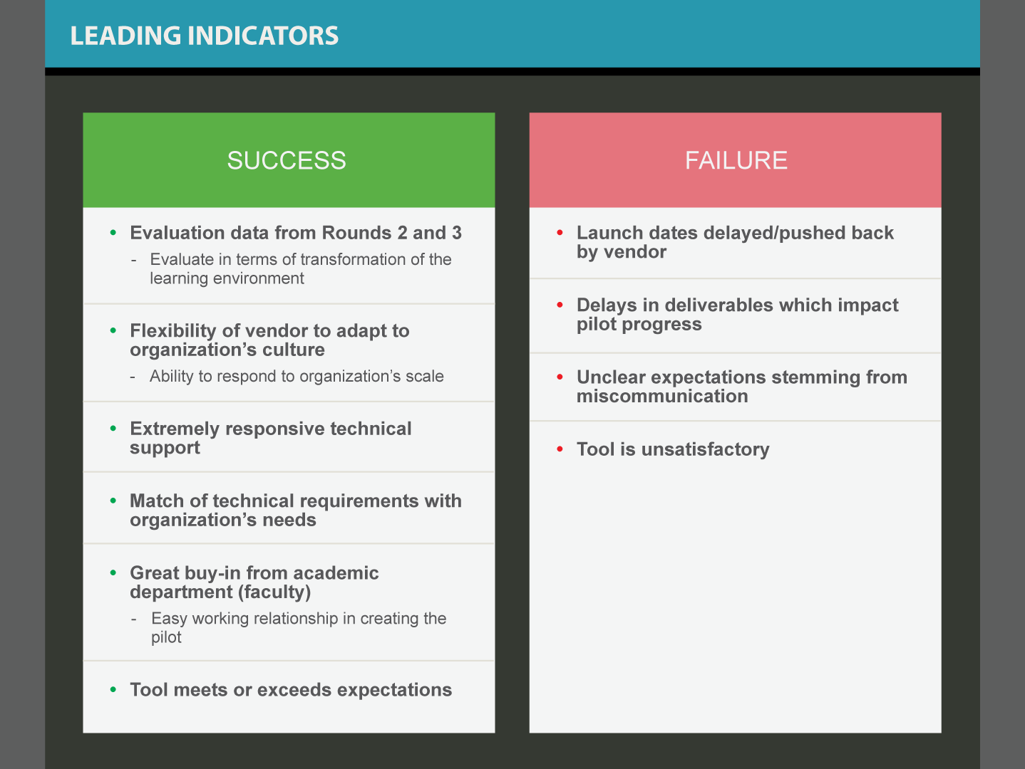
Implement
- Try the tool before committing to determine fit for purpose (don’t be afraid to back-out)
- Attempt to use built-in vendor integrations (for example, with your LMS) and interoperability features such as Learning Tools Interoperability (LTI) to accelerate installation and adoption
- Use a separate test and production environment to avoid surprises
- Focus pilot efforts in one course to start
- Adequately monitor and support the tool through normal channels
- Seek vendor support during pilot to evaluate responsiveness
Evaluate
- Use surveys and usage data provided by the vendor to evaluate against original criteria
- Hold a debriefing meeting to learn from the experience
- Determine whether to discontinue, continue iterating to improve design, or launch broadly
- Determine if A / B testing in future terms could be appropriate

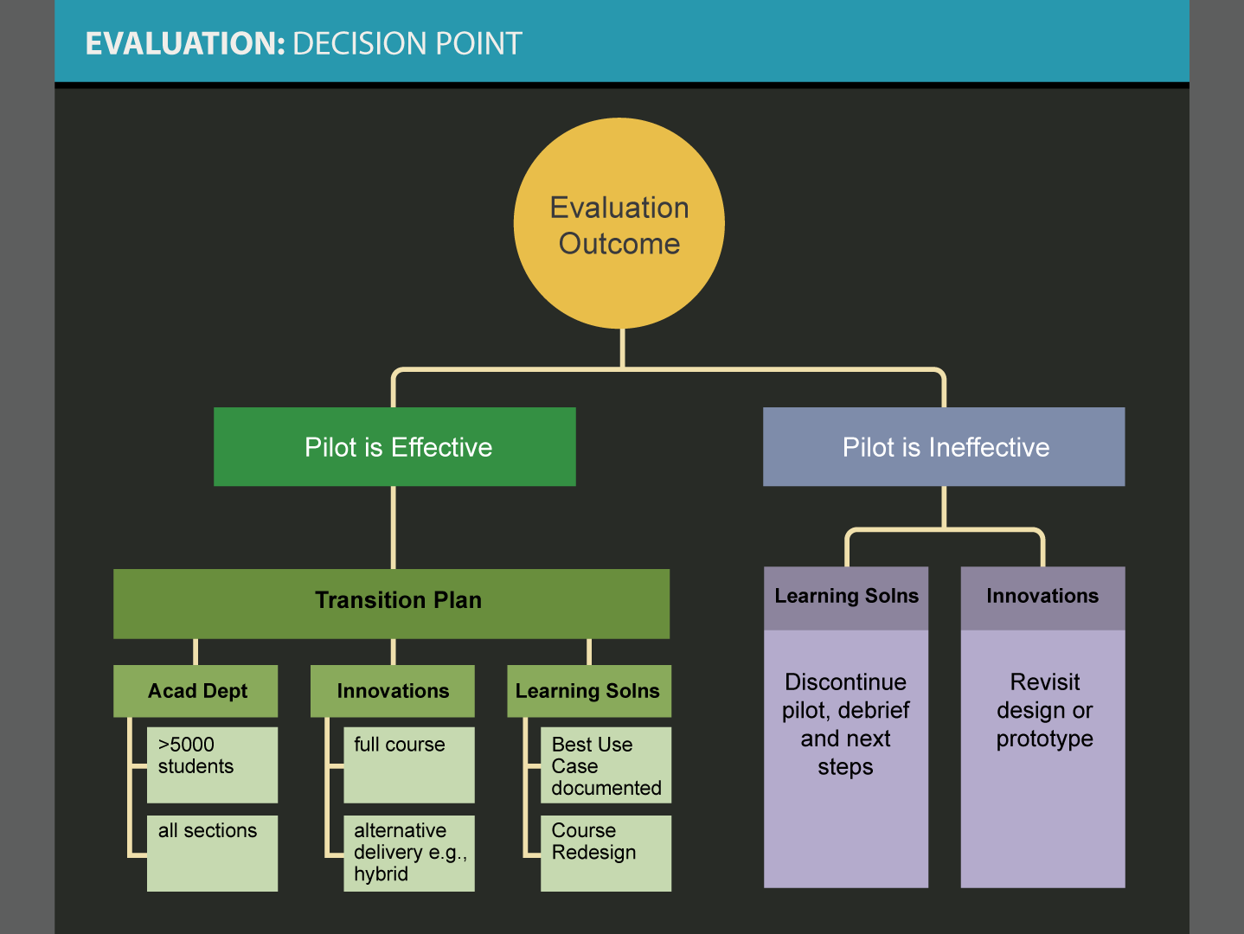
Prepared by:
Sharon Goodall (Sharon.Goodall@umuc.edu) and George Kroner (George.Kroner@umuc.edu)
EDUCAUSE ELI Conference 2016

