“Building a University Portal: One Place, All Mason”

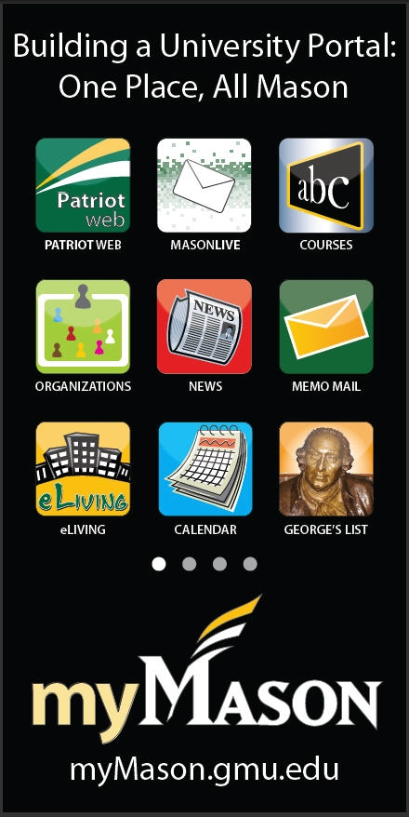

Courses - Upgrading LMS - Both versions are currently available and co-running through Summer 2011.

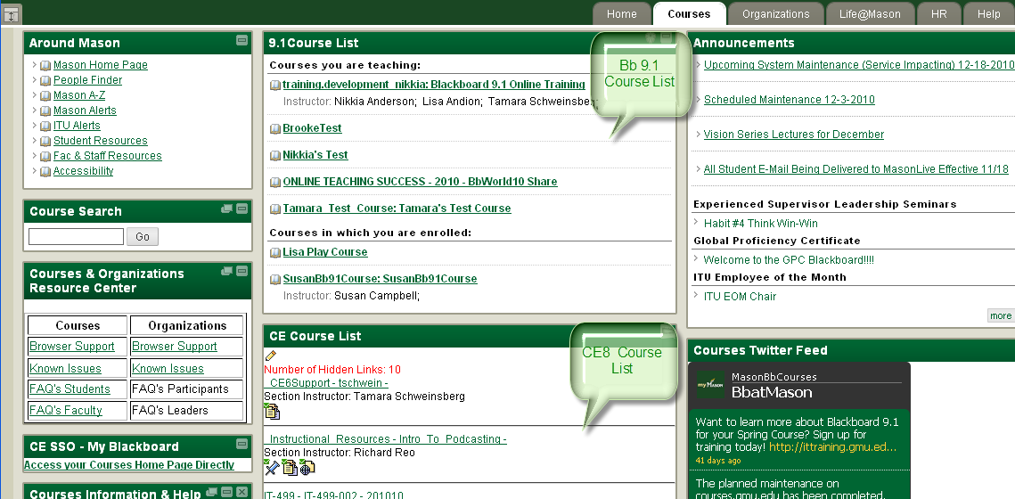

Organizations – Organizations are open to external and internal users used by our faculty and staff to collaborate, this environment is different from courses.

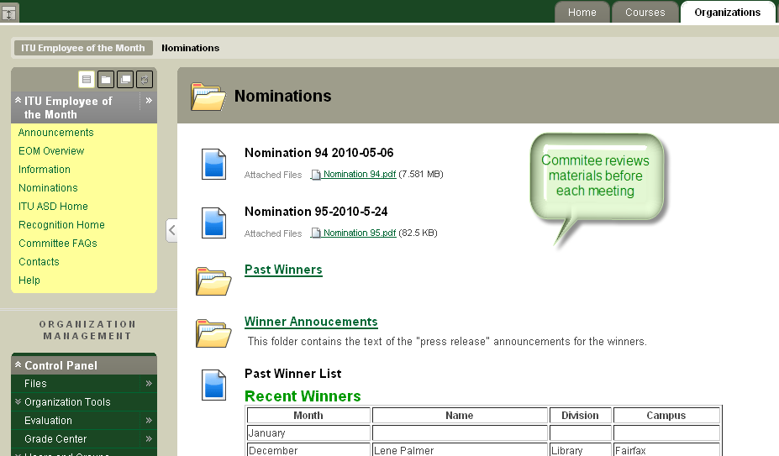

Life at Mason Tab – (Sub Tab: Services Marketplace, Connect2Mason, Weekends, Traffic and Construction). This tab contains content for all things ‘Mason’ that a student, staff or faculty member might need.

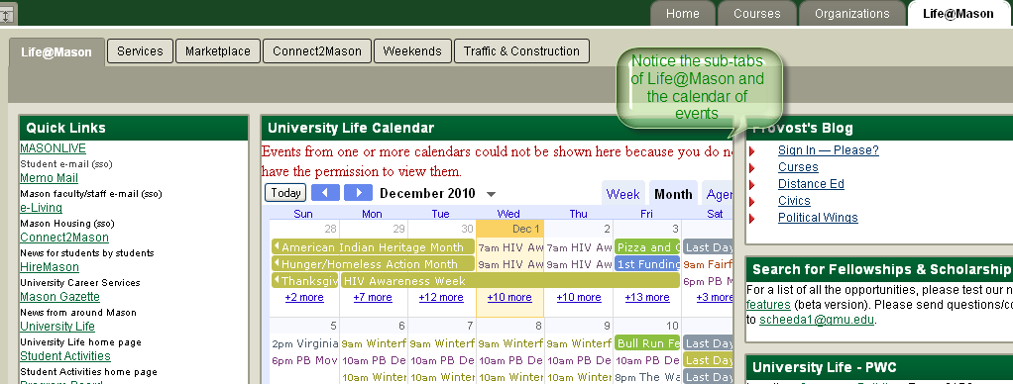

Overall points:
SSO integrations with the following:

Student Email  Faculty/Staff Email  Oracle Time calendar  Courses  George’s List  e-Living  myMason HR  Course Evaluations  iTunes  myParking | 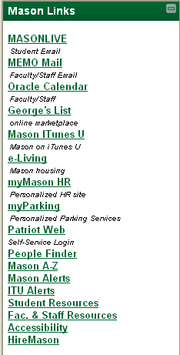

Users own their content and maintain it on campus or off.
Content within the portal is pushed out to our community based on roles (faculty, staff or student).

The Portal was launched with input from various stakeholders across the entire university from the Provost Office, University Life, and the Information Technology Unit just to mention a few.
Open and secure content all in one place.

