**Presentation Style Feedback Form**

Name of the Presenter: ___________________________________

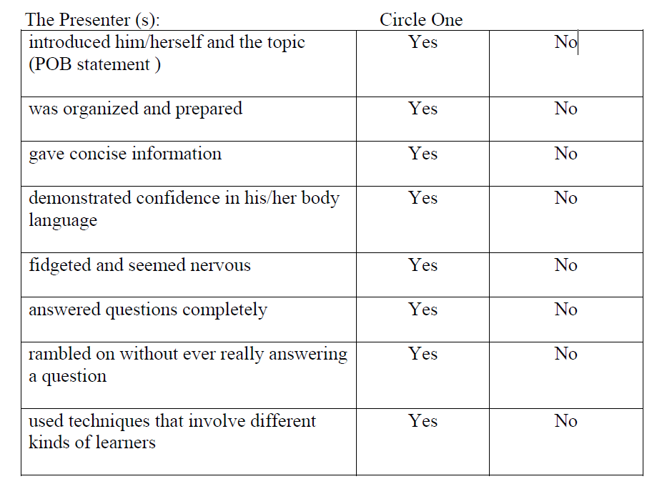

Describe what the presenter did that was particularly impressive:

Suggestions for improvement, if any: