Service Component Handbook

This is an internal IS&T document that provides a high-level overview of this Service Component:

|  |  |
| --- | --- |
| Service Component: |  |
| Service Component Manager: |  |
| Client Service: |  |
| Service Owner: |  |

Table of Contents

Key People 2

Clients and Client Representatives 2

Service Component Stakeholders 2

Stakeholders Meeting Schedule 2

Service Component Team 2

Service Component Team Meeting Schedule 3

Roles and Responsibilities 3

Service Component Dependencies 3

“One-Down” Services that this Service Component depends on: 3

“One-Up” Services that depend on this Service Component: 3

Key Vendors 4

High-Level Context Diagram 4

Service Component Reporting and Monitoring 6

What is Reported Today? 6

Additional Reports Needed or Desired for the Future 7

What is Monitored Today? 7

Additional Monitoring Needed or Desired for the Future 7

Backup Plan 8

Location of Service Component Documentation 8

Version History 8

# Key People

## Clients and Client Representatives

List the groups of Clients who use the service and their Client Representative.

|  |  |
| --- | --- |
| Client | Client Representative |
|  |  |
|  |  |
|  |  |

## Service Component Stakeholders

The Service Component Stakeholders are external to IS&T and provide ongoing strategic business requirements.

|  |  |
| --- | --- |
| Stakeholder | Reason for Inclusion |
|  | e.g. provide legal guidance |
|  | e.g. provide finance |
|  | e.g. compliance perspective |

## Stakeholders Meeting Schedule

There should be a minimum of one stakeholder meeting per year, which includes the client representatives. This meeting is the forum to review service performance, gather any forthcoming service requirements and discuss strategic direction for the service component. All stakeholder meetings should be listed on the [Service Review Meeting Calendar](https://share.bu.edu/sites/ist/service/Lists/Calendar/calendar.aspx) under the IS&T Service Management SharePoint site.

|  |  |
| --- | --- |
| How frequently will the stakeholders (including the client representatives) meet? |  |
| Where is the agenda/minutes from the last meeting(s) located? | [Link to client service document library in “Service Management” section in SharePoint. Content Type = Minutes] |

## Service Component Team

The Service Component Team is a cross-functional group of IS&T members that can provide technical subject matter expertise to the Service Owner.

|  |  |  |  |
| --- | --- | --- | --- |
| Name of Functional Team | Name of Individual | Area of Expertise | Estimated Effort per Month |
| E.g., Help Center |  |  |  |
| E.g., [Application Team]* |  |  |  |
| E.g., [Engineering/Operations]* |  |  |  |

* Use an asterisk to indicate who is a key contact for support SMEs. If the key contact is not available, escalate up their management chain.

## Service Component Team Meeting Schedule

|  |  |
| --- | --- |
| How frequently will the Service Component team meet? |  |
| Where is the agenda/minutes from the last meeting(s) located? | [Link to client service document library in “Service Management” section in SharePoint. Content Type = Minutes] |

## Roles and Responsibilities

* Option 1: If this service component has few assets and you do not plan to create any run books, you should describe here the teams responsible for specific day-to-day operational activities.
* Option 2: Conversely, if you are providing run books for various asset classes enabling this service component, you might find it more useful to provide any overall team and responsibility information here and provide asset class team and responsibility information in the appropriate run book.

|  |  |
| --- | --- |
| Team Name | Responsibilities |
| [Team 1] | [e.g. monitor and respond to these types of events] |
| [Team 2] | [e.g. check this log file or look for an email indicating that a data feed occurred successfully] |
| [Team 3] | [e.g. check that this batch job ran on a daily basis] |
|  |  |

# Service Component Dependencies

## “One-Down” Services that this Service Component depends on:

List key client services and service components.

|  |
| --- |
|  |
|  |
|  |

## “One-Up” Services that depend on this Service Component:

List key client services and service components.

|  |
| --- |
|  |
|  |
|  |

# Key Vendors

* Option 1: If this service component has few assets and you do not plan to create any run books, you should list all vendor information here.
* Option 2: Conversely, if you are providing run books for various asset classes enabling this service component, you might find it more useful to provide only overall service vendor information here and provide asset class vendor information in the appropriate run book.

|  |  |  |
| --- | --- | --- |
| Vendor | Technology / Service Provided | Support Contact Information |
|  |  |  |
|  |  |  |

# High-Level Context Diagram

Provide a high-level diagram illustrating how the service component serves different clients, with other client services and service components, and with key vendors. The purpose of the diagram is to explain the service component “at a glance”. It is not meant to be a detailed technical architecture diagram.

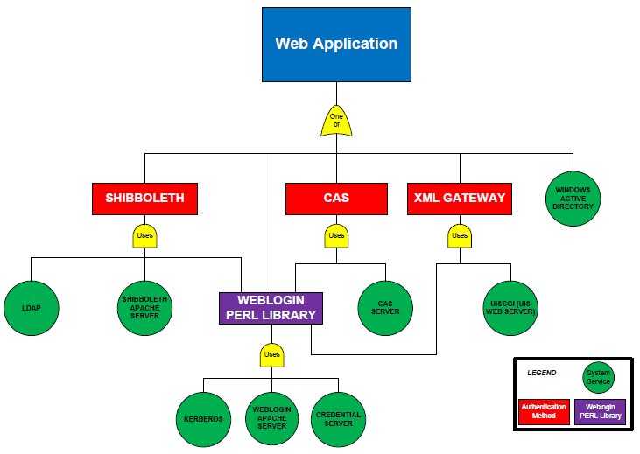

Example diagram

# Service Component Reporting and Monitoring

* Required – End-to-end: Regardless of whether you provide run books for asset classes enabling this service component, you should include all information on end-to-end reporting and monitoring for the service component here. Examples of end-to-end service reporting topics that might be useful include reports related to ticket handling, end-to-end service availability, capacity, performance, and security information. Many end-to-end reports are appropriate and useful discussion points for service reporting agenda items in stakeholder meetings.
* Plus choose one:
  + Option 1: If this service component has few assets and you do not plan to create any run books, you should also include all other information on reporting and monitoring here.
  + Option 2: Conversely, if you are providing run books for various asset classes enabling this service component, you might find it more useful to provide the detailed reporting and monitoring information in the appropriate run book.

## What is Reported Today?

|  |  |  |  |  |
| --- | --- | --- | --- | --- |
| Name of Report | Purpose of report | Reporting Tool | Who creates the report? | Who is the audience? |
| Incident Aging (end-to-end service component example) | Determine Incidents that have been unresolved for a long period of time for this service component. | ServiceNow |  |  |
| Incident Trend Report (end-to-end service component example) | Determine if the number of Incidents is increasing or decreasing month-over-month | ServiceNow |  |  |
|  |  |  |  |  |
|  |  |  |  |  |

## Additional Reports Needed or Desired for the Future

|  |  |  |  |  |
| --- | --- | --- | --- | --- |
| Name of Report | Purpose of report | Reporting tool | Who is the audience? | Priority |
|  |  |  |  |  |
|  |  |  |  |  |

## What is Monitored Today?

|  |  |  |  |
| --- | --- | --- | --- |
| What is monitored (actionable/alerting) | Monitoring Tool | Purpose of monitoring | Action taken (manual or automated; who is alerted when an event occurs?) |
| Synthetic application transaction (end-to-end service component example) | Homegrown | Determine if end-to-end service is available | Automated alert to Operations to initiate manual intervention |
| CPU utilization (asset class example) | Nagios | Determine if there are any performance issues | Automated event logging only |
| Available disk space (asset class example) | Big Brother | Determine if service will run out of disk space | Automated logging and remediation, with informational notification to Operations |
|  |  |  |  |

## Additional Monitoring Needed or Desired for the Future

|  |  |  |  |
| --- | --- | --- | --- |
| What needs to be monitored | Monitoring tool (if known) | Purpose of monitoring | Priority |
|  |  |  |  |
|  |  |  |  |

# Backup Plan

* Option 1: If this service component has few assets and you do not plan to create any run books, describe here the backup schedule, the tool used, and the backup retention procedures, e.g., how many days/weeks onsite versus offsite storage.
* Option 2: Conversely, if you are providing run books for various asset classes enabling this service component, you might find it more useful to provide the detailed backup information in the appropriate run book.

# Location of Service Component Documentation

|  |  |
| --- | --- |
| Type of Document | Location |
| TechWeb Service Definition | See TechWeb Service Catalog |
| Architecture Diagrams |  |
| Service Level Agreement (if applicable) |  |
| Tier 1 Troubleshooting Guide | Refer to ServiceNow Knowledgebase article #____. |
| Run Books |  |
| SOPs |  |
| Service Level Reports (if available) |  |

# Version History

|  |  |  |  |
| --- | --- | --- | --- |
| Version | Date | Author | Summary of changes |
|  |  |  |  |
|  |  |  |  |