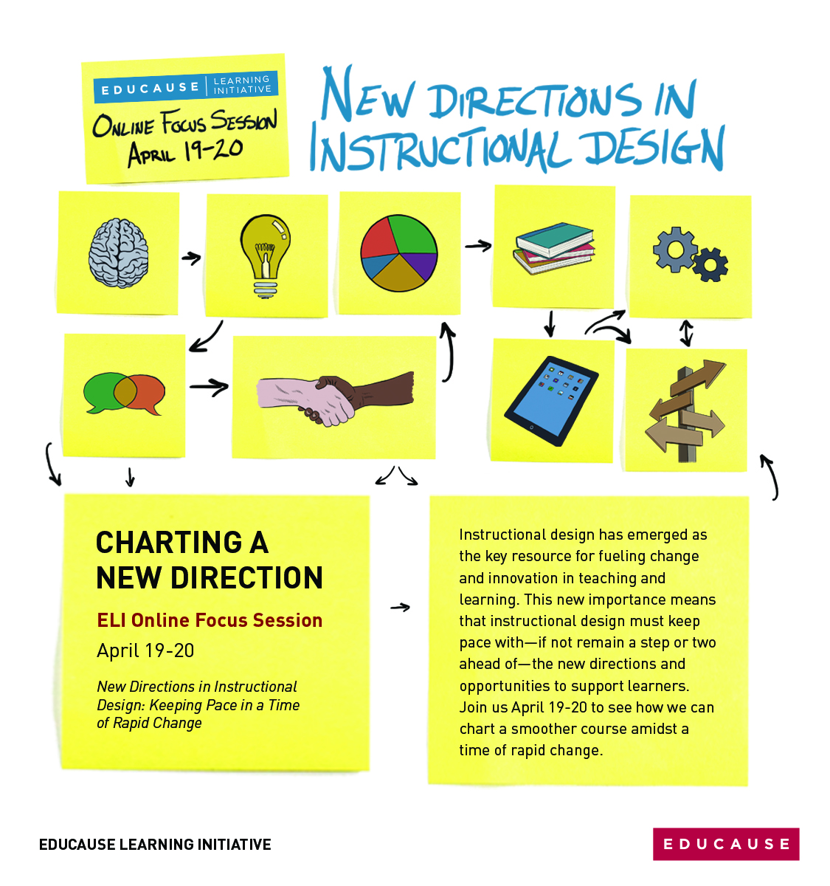

**Place   
School   
Logo   
Here**

**On Campus**

**When:­­­­**

**Where:**

**Contact:**